

**DOCUMENTATION ON WEBSITE DEVELOPMENT OF ORGANOCITY.COM**

**BY TEAM 2**



AMIT KUMAR KARN

SAURAV SHRESTHA

KRITIKA THAPA

RAM BABU SHAH

SAUGAT ADHIKARI

YOGESH SHRESTHA

**STUDENT ID**: c7202819

**STUDENT NAME:** Kritika thapa

**MODULE NAME:** PROJECT MANAGEMENT

**MODULE TUTOR:** ROHIT RAJ PANDEY

**LEVEL:** 5 ‘E’

**Abstract:** This documentation was created to record the various phases of the development process of organocity’s website in a single file. The documentation contains data regarding project initiation, project planning, project execution, and project monitoring and control as well as project closure.

# **TABLE OF CONTENTS**

1 Project Initiation

* 1. Project Charter
     1. Project Charter Version 1
  2. Team Contract
  3. Meeting Minutes

1. Project Planning
   1. Belbin Analysis
      1. Team Belbin Analysis
      2. Individual Belbin Analysis
         1. Amit Kumar Karn BA
         2. Saurav Shrestha BA
         3. Kritika Thapa BA
         4. Ram Babu Shah BA
         5. Saugat Adhikari BA
         6. Yogesh Shrestha BA
   2. Skill Audit
      1. Team Skill Audit
      2. Individual Skill Audit
         1. Amit Kumar Karn SA
         2. Saurav Shrestha SA
         3. Kritika Thapa SA
         4. Ram Babu Shah SA
         5. Saugat Adhikari SA
         6. Yogesh Shrestha SA
   3. Project Management (MS Project)
      1. Task Sheet
      2. Gantt Chart
      3. Network Diagram
      4. Timeline
      5. Calendar
      6. Resource Sheet
   4. Communication Tool Used
      1. Slack
2. Project Execution
   1. Entity Relationship Diagram
      1. ERD
      2. EERD
      3. Final Composite ERD
      4. Logical Design
   2. Use Case Diagram
      1. Overview Use Case
      2. Customer Use Case
      3. Trader Use Case
      4. Admin Use Case
   3. Requirement Catalogue
      1. Functional Requirement
      2. Non-Functional Requirement
   4. Logo Design
   5. Wireframe
      1. Homepage
      2. User Login
      3. User Sign Up
      4. Shop
      5. Invoice
      6. Admin Dashboard
      7. Customer Backend
      8. Product Backend
   6. Product Development
      1. Screenshots
      2. Homepage
   7. Product Testing
      1. Customer Interface Test
      2. Trader Interface Test (PHP)
      3. Trader Interface Test (APEX)
      4. Admin Interface Test (APEX)
3. Frequently Asked Questions (FAQ’s)

# **Project Initiation**

### **1.1 Project Charter**

### **1.1.1Project Charter Version 1**

**Project Charter**

|  |
| --- |
| **Project Title:** Organocity.comE-Commerce Portal  **Project Sponsor:** The British College, Kathmandu, Nepal  **Project Date:** 30/04/2020 |

**Version Control**

|  |  |  |
| --- | --- | --- |
| Version | Date | Summary of changes |
| 1 | 25/02/2020 | This is the initial version of the project on the basis of the case study. The further amendments will be made on the following versions. |
|  |  |  |
|  |  |  |

**Project Justification**

|  |
| --- |
| Traders based in the area of Cleckhuddersfax aim to build an e-commerce website that will help the traders in their business. The traders currently have high quality and popular goods’ but the sales do not meet their expectations. This is due to the overlapping work hours of the traders and local customers. So, to increase sales the traders must work outside their work hours which will hamper their personal life. This system will allow the traders to make their products available online to the customers at all time and hence the sales won’t depend upon either the traders or customers’ working hours.  The system will be targeted at the local market as per the request of the initial traders, so the local people can easily buy goods without even having to visit the stores. The system contains a simple user interface which will be based on a click and collect system. This system will act as the balancing point for the traders work and life. The system will also help increase the market for the traders and help extend their business outside of the local market. The system will contain register and login system for the traders as well as customers. The customers will be able to browse goods based on different categories as well as the type of the product. While registering or making any purchase, the customers will be verified through a link sent directly to their emails. Only the registered customers will be able to make purchases. After making the payment through PayPal or any other potential services, the customers will be asked to select the available time slots to collect their respective products.  The traders plan to maintain and increase their business by the use of the system. They also plan to increase the influences and audiences of their business to regions outside of the local market in the near future. |

**Project Scope**

|  |
| --- |
| * Allow the traders to sell their goods to the locals without impeding on their personal time. * Make purchases of fresh goods possible for locals at all time as well as extend the range of the market. * Increase the sales of the traders’ stores resulting in a positive turnover. |
| *High level requirements of the product or service should be identified here****.***  **Customer Interface**   1. Products grouped into various categories. 2. Search option to find goods based on name, type or shop. 3. Responsive interfaces across different browsers and devices. 4. Cart facility for viewing and shopping goods. 5. Registration and login systems. 6. Collection slots selection. 7. Payment through PayPal but may get updated in future. 8. Altering designs according to the heritage of the area. 9. Initially five traders but more can be added later.   **Trader Interface**   1. Management system for products. 2. Individual products should be associated with only one trader. 3. Products’ Database containing order reports and stocks. 4. Login system for separate traders.   **Management Interface**   1. Main dashboard that shows various records. 2. Regular updates on the dashboard based on activities performed by users or traders. 3. Weekly finance report of the collected orders for the traders. 4. Monthly product sales report for traders. |
| *Major deliverables should be identified here*   1. API for PayPal or other potential payment services will be made. 2. The frontend part of the website will be designed using HTML, CSS and Bootstrap and backend will be devised using PHP, JavaScript, Oracle Apex and JQuery. 3. All the webpages will be customizable and can be viewed across cross platforms like browsers and devices. |

**Duration**

|  |
| --- |
| *Identify the key milestones and overall timeline for the project*  Project Initiation – 6th February, 2020  Work In Progress – 19th March, 2020  Final Presentation – 30th April, 2020  Final Portfolio Submission – 7th May, 2020 |

**Estimated Budget**

|  |
| --- |
| *Estimate the hours of efforts that will be required to deliver the project and any costs associated with the purchase of equipment*  Hours Per Week : 5 to 7  Team of 6  Hence Total Hours  MIN : 5*6*12= 360 hours  MAX : 7*6*12= 504 hours |

**Roles and Responsibilities**

|  |  |
| --- | --- |
| Name | Role |
| Amit Kumar Karn | *Primary*: Plant => He is good at logical thinking and solving complex problem.  *Secondary*: Specialist => He is skilled in coding in PHP.  *Least Potential*: Shaper => He will be shaping the team’s activities to achieve the project’s outcome in the most effective and efficient way. |
| Saurav Shrestha | *Primary*: Co-ordinator => He will be responsible for organising the team in a way that gets the best performance with the available resources.  *Secondary*: Specialist => He specialises in handling databases and working in oracle apex.  *Least Potential*: Plant => He is good at providing innovative ideas to the team by generating new proposals. |
| Kritika Thapa | *Primary*: Team-worker => She will be able to readily adapt to different situations and also help other team members to achieve and maintain team effectiveness.  *Secondary*: Resource Investigator => She has an extroverted, enthusiastic and curious personality who likes to explore new opportunities and resources that may be useful to the team.  *Least Potential*: Completer Finisher => She will be ensure that nothing is overlooked and try to make everyone’s efforts as near perfect as possible. |
| Yogesh Shrestha | *Primary*: Resource Investigator => He has an extroverted, enthusiastic and curious personality who likes to explore new opportunities and resources that may be useful to the team.  *Secondary*: Specialist => He is skilled in designing efficient layouts and webpages.  *Least Potential*: Implementer => He will be regularly checking if the ongoing project is sustainable in practical terms. |
| Ram Babu Shah | *Primary*: Implementer => He will be regularly checking if the ongoing project is sustainable in practical terms.  *Secondary*: Monitor-evaluator => He will be analysing problems and evaluating ideas as well as passing logical judgements on various situations.  *Least Potential*: => Specialist => He is good at working with oracle apex. |
| Saugat Adhikari | *Primary*: Completer Finisher => He will be ensure that nothing is overlooked and try to make everyone’s efforts as near perfect as possible.  *Secondary*: Team-worker => He will be able to readily adapt to different situations and also help other team members to achieve and maintain team effectiveness.  *Least Potential*: Resource Investigator => He has an extroverted, enthusiastic and curious personality who likes to explore new opportunities and resources that may be useful to the team. |

**Communication and Collaboration Tools**

|  |
| --- |
| * Documentation: All documentation generated for the project will be stored and shared through Google Drive and/or through the Slack app. * Team Meetings: Up-to 3 meetings will be held per week depending on the availability of the group members. * Communication: A group in the Slack app will be used for all communication. |

**1.2 Team Contract**

# Team Contract

This contract was made for the ‘Organocity’ team of ‘The British College’ to initiate their project of the ‘Project Management’ module. The main purpose of this contract is to maintain balance and ensure the equal participation and involvement of all the members of the team.

Project Team Name: Organocity

|  |  |  |  |
| --- | --- | --- | --- |
|  | Team Member Name | Email | Phone |
| 1 | Amit Kumar Karn | [amit.karn98@gmail.com](mailto:amit.karn98@gmail.com) | 9816810976 |
| 2 | Saurav Shrestha | [sauravshrestha28@gmail.com](mailto:sauravshrestha28@gmail.com) | 9803340359 |
| 3 | Kritika Thapa | [thapakritika019@gmail.com](mailto:thapakritika019@gmail.com) | 9813135616 |
| 4 | Yogesh Shrestha | [Yogess.stha63@gmail.com](mailto:Yogess.stha63@gmail.com) | 9860411254 |
| 5 | Ram Babu Shah | [rambabushah@hotmail.com](mailto:rambabushah@hotmail.com) | 9860927134 |
| 6 | Saugat Adhikari | [Saugat98adhikari@gmail.com](mailto:Saugat98adhikari@gmail.com) | 9803224567 |

## A. Team Structure:

1. Leadership structure

* Our team will have a shared leadership structure between two members i.e. Amit Karn and Saurav Shrestha.
* Having a larger group, two leaders will be necessary to ease the pressure which will help the leaders to focus on their primary roles more.

2. Decision-making policy

* The decisions of the team will be made via majority votes on most of the topics.
* Team’s consensus will be used where required.

3. Who is the team Recorder/Documentation Manager/Maintainer of team activity?

* Amit Karn will be the team recorder, Kritika Thapa will be the documentation manager and Saurav Shrestha will be the maintainer of the team.

4. Day, time, and place for regular team meetings:

* There will be 3 team meetings per week: A mandatory one on Sunday at 11:00 am and the other two will be held appropriately after the end of regular classes throughout the week where majority of members are present to attend the meeting. All meetings will be held at The British College and a secondary place will be decided if the college is not available.

5. Usual method of communication

* The main method of re communication will be Slack. Some form of communication will also be done via Google Mail and transferring files and project related data will also be done through Slack and Google Drive.

## B. Team Procedures:

1. Method for setting and following meeting agendas

* Meeting agendas will be set by Saurav Shrestha and Kritika Thapa. The agendas will be set on Saturday and other days if they cannot be covered fully on the decided dates. Each member will be notified and reminded via Slack and phone calls. Amit Kumar Karn and Saurav Shrestha will be responsible for directing the meeting.

2. Method of record keeping

* Amit Karn and Saurav Shrestha will also be responsible for recording the project’s progress data as well as disseminating actions to the group members equally. The actions will be disseminated according the potential as well as consents of the team members during the team meetings primarily on Sundays. The agendas and actions of the projects will be stored using a software called Microsoft Project.

3. Procedures in the absence of a team member

* A team meeting will take place if at least 4 members are present with the absentee(s) needing to put forth a reason for their unavailability and the absence needs to be approved by the team.

## C. Team Participation:

6. Strategies to ensure cooperation and equal distribution of tasks

* The members will put forth what parts they are most likely to work on and those roles will be assigned to the members accordingly. After which, the remaining parts of the project will be analysed by the team and assigned appropriately by observing how much and how difficult a members’ part is and how much the member can handle.

7. Strategies for encouraging/including ideas from all team members

* Sunday will be a mandatory team meeting where majority of the team members will be present. This will include a brainstorming session where all members present will put forth ideas and those ideas will be evaluated by all members. The ideas that get majority vote will be applied in the project.

8. Strategies for keeping on task

* Meeting will be essential for the task to be completed as they will act as a check point for all task being handled by the members. Each member will need to show how much they have completed of their given task and how much more time is needed for them to complete the task. If a task proves too much for a member, the work will be divided and handed off to other team members who are able to take on the additional work.

## D. Personal Accountability:

1. Expected individual attendance, punctuality, and participation at all team meetings

* Each member is expected to attend every meeting. Meetings can only be skipped if the member gives a reason (particularly medical reasons) prior to the day of the meeting which is approved by the team. Scanned proof of the reason (such as medical bills) for being absent must also be provided to the team’s digital storage facilities. All members are expected to be punctual to the meeting time with delays of up to 15 minutes being accepted. Longer than a 15-minute delay needs an appropriate reason. A member can also inform the group that a delay might occur prior to the meeting. Each member needs to have at least 80% attendance on the group meetings.

2. Expected level of responsibility for fulfilling team assignments, timelines, and deadlines:

* Members must show professional level responsibility while performing their tasks and always meet the deadlines. All requirements that need to be fulfilled must be completed before handing the task to the group. All tasks need to follow a specific timeline of which one day of leniency will be allowed. All tasks done should have a professional look to them.

3. Expected level of communication with other team members

* There must be a high level of communication between members both in person as well as on the Slack app. If a member is asked something, a reply should be given within 1 hour.

4. Expected level of commitment to team decisions and tasks

* As almost every decision of the team will be made by majority vote, a member is expected to be highly committed to whatever task is assigned to them. Assigned tasks must be fully completed and members should consult the group if they require assistance.

## E. Consequences of breach of contract:

* In the case of the member deviating from the contract, the member(s) will have to state their reason in front of the team and a chance will be given to the member(s) if decided by the team after which if the same member(s) deviate from the contract again, the matter will be subjected to verdict by the project manager.

## F. Certification by team members:

In appending your signatures below, you are stating that:

a) You participated in formulating the standards, roles, and procedures of this contract.

b) You have agreed to abide by these terms and conditions of this contract.

c) You understand that you will be subject to the consequences specified above and may be subject to reduction in overall grade in the event that you do not fulfil the terms of this contract.

|  |  |  |  |
| --- | --- | --- | --- |
| Name | Amit Kumar Karn |  |  |
| Signature |  | Date | 4/1/2020 |
| Name | Saurav Shrestha |  |  |
| Signature |  | Date | 4/1/2020 |
| Name | Kritika Thapa |  |  |
| Signature |  | Date | 4/1/2020 |
| Name | Yogesh Shrestha |  |  |
| Signature |  | Date | 4/1/2020 |
| Name | Ram Babu Shah |  |  |
| Signature |  | Date | 4/1/2020 |
| Name | Saugat Adhikari |  |  |
| Signature |  | Date | 4/1/2020 |

G. Acceptance of contract by tutor:

|  |  |  |  |
| --- | --- | --- | --- |
| Name | Rohit Raj Pandey |  |  |
| Signature |  | Date |  |

|  |  |  |  |
| --- | --- | --- | --- |
| Name | Arun Lal Joshi |  |  |
| Signature |  | Date |  |

**1.3 Meeting Minutes**

**a. Meeting Agenda for ERD**

**Meeting Agenda**

Location: The British College, Thapathali, Kathmandu

Time: 11:00 am

Date: 8th feb-2020

Team: Team 2(ORGANOCITY.COM)

**Objectives of ERD**

* Identify attributes and primary keys that adequately describe the entities.
* Identify main entities and relationships.
* Adding suitable attributes to the entities.
* It allow us to see a high-level view of our database before we actually get to creating it.
* It helps you to communicate a proposed design.
* ERD is used to communicate the logical structure of the database to users.

**ERD (ENTITY RELATIONSHIP DIAGRAM)**

|  |  |  |
| --- | --- | --- |
| **Date** | **Work done** | **Agenda** |
| 03/09/2020 | Planning | We held the team meeting and discussed the possible entity and attributes and problems that might come across the ERD following the case study. We discussed about ERD, Composite model, EERD and MoSCoW We planned and divided work for each team member. |
| 03/10/2020 | Implementation | While planning and work was divided on Monday. So we implemented entity, attribute and possible outcome in QSEE application on Tuesday. We solved problems that came through MoSCOW. We asked help to module tutor for some problems came while implementing ERD. |
| 03/13/2020 | Conclusion | In Friday we held the team meeting before the class in college and discuss about the case study again and finalize the ERD, EERD, composite model and Moscow. And one zip folder was made consisting all of them and Screenshot of ERD, EERD, Composite model and zip folder was submitted to VLE on 13th march. |

|  |  |
| --- | --- |
| **Name** | **Signature** |
| Saurav Shrestha | P |
| Kritika Thapa | P |
| Amit Kumar Karn | P |
| Yogesh Shrestha | P |
| Saugat Adhikari | P |
| Rambabu shah | P |

**Attendance record**

**b. Meeting Agenda for Skill Audit and Belbin Analysis**

**Meeting Agenda**

Location: The British College, Thapathali, Kathmandu

Time: 11:00 am

Date: 28th feb-2020

Team: Team 2 (Organocity.com)

**Objectives of the Meeting**

* To identify and discover the skills and knowledge that the Skill audit and Belbin Analysis requires.
* To record the skills of an individual as well as group.
* To find out the Belbin team role profile that our team need to complete the Belbin self-Perception.
* Skill audit help us in determining our current skills, and diagnose what skills we need to accomplish our task which helps us to plan more effectively.

**Belbin Analysis and Skill Audit**

|  |  |  |
| --- | --- | --- |
| **Date** | **Work done** | **Agenda** |
| 02/27/2020 | Planning | We held the team meeting and Planning the main activities of this week. Refreshing the main topic of the project. Overview of the main task of Belbin analysis and skill audit. Clarify outline the purpose and objective of the meeting. |
| 02/28/2020 | Implementation | Discuss about all the information of the task that what are the things that we should be done in Belbin analysis and skill audit. Distributing the tasks and responsibilities between the team members. Discuss each and every part of Belbin analysis and skill audit that needs to discussed and debated in the meeting. We discussed about what the skills are required that we need to make our website desirable. |
| 02/28/2020 | Conclusion | At the final stage, main task is all about merging every divided task given by team member, finalizing that and submitting. |

**Attendance record**

|  |  |
| --- | --- |
| **NAME** | **Attendance** |
| Saurav Shrestha | P |
| Kritika Thapa | P |
| Amit Kumar Karn | P |
| Yogesh Shrestha | P |
| Saugat Adhikari | P |
| Rambabu shah | P |

**c. Meeting Agenda for Use Case Diagram**

**Meeting Agenda**

Location: The British College, Thapathali, Kathmandu

Time: 11:00 am

Date: 12th feb-2020

Team: Team 2(ORGANOCITY.COM)

**Objective of Use case**

* Use case diagram specify the events of a system and their flows.
* It helps us to gather requirements and actors.
* It provides us a graphical overview of goals used by system.
* It developed at different levels of abstraction.

**Use Case**

|  |  |  |
| --- | --- | --- |
| 03/13/2020 | Planning | Team meeting was done on Friday after the college where we discuss about the system, actors, use cases and relationship according to case study. UML use case diagram was planned focusing the case study and every member was given their task. |
| 03/15/2020 | Implementation and Conclusion | Our team members stayed for hours and we finalized the UML Use case diagram solving error and updating use case diagram because of submission date. |

**Attendance Record**

|  |  |
| --- | --- |
| **NAME** | **Signature** |
| Saurav Shrestha | P |
| Kritika Thapa | P |
| Amit Kumar Karn | P |
| Yogesh Shrestha | P |
| Saugat Adhikari | P |
| Ram Babu shah | p |

1. Project Planning
   1. Belbin Analysis
      1. Team Belbin Analysis

|  |  |  |
| --- | --- | --- |
| Version:1.0 **Belbin’s Analysis** Date reviewed:2nd March 2020 | | |
| Primary role | Amit Kumar Karn | Plant |
| Saurav Shrestha | Co-ordinator |
| Kritika Thapa | Team-worker |
| Yogesh Shrestha | Resource Investigator |
|  | Ram Babu Shah | Implementer |
|  | Saugat Adhikari | Completer Finisher |
| Secondary role | Amit Kumar Karn | Specialist |
| Saurav Shrestha | Specialist |
| Kritika Thapa | Resource Investigator |
| Yogesh Shrestha | Specialist |
|  | Ram Babu Shah | Monitor-evaluator |
|  | Saugat Adhikari | Team-worker |
| Least likely role | Amit Kumar Karn | Shaper |
| Saurav Shrestha | Plant |
| Kritika Thapa | Completer Finisher |
| Yogesh Shrestha | Implementer |
|  | Ram Babu Shah | Specialist |
|  | Saugat Adhikari | Resource Investigator |
| Do you think the descriptions of these roles are an accurate description of your behaviour in teams? How do you see yourself differently? | Amit Kumar Karn | Yes, because I have always been inclined  towards the problem-solving domain in my previous group and individual projects and I believe those experiences that I gained in the past is going to help the team in many ways  making me a suitable plant for the team. I  was also involved in an individual website project where I picked up some good skills on back-end mechanism of a website, particularly PHP and MySQL. Lastly, I think I will be well suited to be the shaper of the team because I always tend to be motivated towards a goal at any given time and I also have some experiences of completing tasks under pinch situations. Hence, I think, with these characteristics of mine, I will be able to influence my team positively to some extent  throughout the course of the project. |
| Saurav Shrestha | Yes, I think the roles fit me perfectly in a team setting. I feel like I am focused and can appropriately direct a team towards its goal by delegating work and drawing out a persons’ full capabilities. I also have in-depth knowledge about databases related to this project, so the role of specialist also suits me well. Along with directing the team and specializing in a specific area. Also having a creative mind allows me to view problems from another perspective and help me to solve problems which might not be solved by conventional means. Hence, the role of plant also suits me. |
| Kritika Thapa | Yes, I think the descriptions of these roles are an accurate description of my behaviour in teams because being myself a team worker I pleased to adapt in different situations and like to help  other team members to achieve and  maintain team effectiveness as well as I  like to listen and respect the opinions  , input of team members. And likes to  explore new opportunities and resources |
| Yogesh Shrestha | Yes, I am sure that these roles are perfect  for me according to my behaviour.  I am the resource investigator of my  team I chose it because I am enthusiastic about my work. I want to give my best on my work. I don’t want to follow or want to make my work similar to others so I do research and try find new ways to explore my work and search opportunities to make best, different and unique from other works. Similarly, as I choose another role as specialist on front end, the frontend all about the graphic and designing and I am good at graphic and designing so I can explore my idea and I can show my uniqueness through work on the front end which is the attractive part of website. We can show our creativity and we can attract customers through the front end. |
|  | Ram Babu Shah | Yes, the above descripted roles are an  accurate description of my behaviour in  team. I can make plans and works with  strategies and, I can carry out the  project effectively in everything. Since, I  am an optimist thinker I believe to rise the  confidence level of my team and make  the team to complete the project done in  a possible way. |
|  | Saugat Adhikari | The roles surely define everyone  according to the role they will have for  the team. It can’t be said to be  particularly accurate but the different  roles help to bring the best possible  qualities in oneself depending upon the  role they have for the team. |
| Are there roles identified by Belbin that you might like to develop in yourself more? Which ones and why? | Amit Kumar Karn | Yes, I would like to see myself as a better  leader or shaper after the completion of  this project because this role will help  me to perform qualitatively and  overcome different kind of challenges  under immense pressure.  I would also like to develop enough  coding skills in PHP through this project  so that I could earn the tag of a specialist  in this domain |
| Saurav Shrestha | Shaper and Resource Investigator are role that I want to develop in myself because I tend not to be outgoing and keep myself away from interaction. So, I would like to develop a Shaper role in me to be able to encourage and give motivation to a team to succeed. The role of Resource Investigator is also something I want to develop as it will help me more outgoing and enthusiastic as a person. |
| Kritika Thapa | Yes, resource investigation role  identified by Belbin like to develop  myself more because I am extroverted,  enthusiastic and curious personality who  like to explore new opportunities and able to extend the range of the team’s useful contacts and partnerships outgoing  and inquisitive. |
| Yogesh Shrestha | Plant is the role which I would like to develop on myself because I think I am creative, imaginative and a free-thinking person who can generate new ideas but, in this project, I am not fit for solving difficult problems. For solving problems, we must know more about the subject have to do research, experiment etc. where in this condition my knowledge is not enough to solve problem. Through Belbin analysis I learnt that I must develop my skill I have to do lots of research for solving problem. |
|  | Ram Babu Shah | Yes, there is a role identified by Belbin  that I like to develop in myself. I would  like to develop Team Worker. As being a  person who loves to do work in team my  qualities would surely help my team to  polish and also help them using their  versatility to identify the work required  and complete the project on the behalf  of my team. |
|  | Saugat Adhikari | Yes, there is a role in Belbin which I  would love to develop in myself like  specialist. Being able to have in depth  analysis and polish my team with any  kind of specialism would be something  I would cherish. |
| What possible situations in the coming months can you identify where you could work on developing these skills? | Amit Kumar Karn | I’ll be focussing on the situations where  the context will be new and challenging  to our group. I will try to solve those  problems in the best possible way while  exploring plethora of other solutions simultaneously. I will also try to develop  my leadership skills and guide the team  to accomplish the best results at their  individual parts of the project. |
| Saurav Shrestha | In the coming months, situations might arise where frustrations might pile up and a driving force is needed to push ahead so I could develop the Shaper role if such a situation arises. I could develop Resource Investigator if the data we collect for the project is not sufficient and we need to get some new ideas or get data through different means which would make me be more interactive towards people and help me explore my opportunities. |
| Kritika Thapa | Since, I believe that I am a completer  finisher I have determination of finishing  any kind of task that gets into my way.  For instance, if there is some kind of  natural calamities occurring next month,  I can assist there with my team and do as  possible things as no work is smaller. |
|  | Yogesh Shrestha | Situations might arise where the members of my group won’t be able to solve certain problems. So, in case that situation arrives, I will get a chance to develop my plant role skills. |
|  | Ram Babu Shah | At the time of project submission, if any  member of my team cannot complete  their project I will plan a workable  strategy and make them help to complete  their part in a possible way. |
|  | Saugat Adhikari | The situation where the team would  need the slightest push in the necessary  roles, I would be more than happy to  step up and make sure our project works  are finished on time. |
| Considering your team working, how do you think you could improve your effectiveness in group work and in contributing to the success of teams that you work in? | Amit Kumar Karn | I believe I can fill in the gaps for other  team members, in case they couldn’t  complete their part of work in the  allocated time due to some emergencies  or unavoidable reasons. I can also help  the team to always be inclined towards  the main goal and meet the requirements  before deadlines. |
| Saurav Shrestha | I could improve my teamwork by not focusing on only my work but help my team members with what they might be struggling with. I could also use the perspective of another person to enhance my work and accept positive criticism. |
| Kritika Thapa | Well as a team worker I can listen other  point of view regarding our project in  which we are working firstly I can divide  my team according to their working skill  in which they are active so that our project will run smoothly I will research  on the project which is based on the  topic if there are any circumstances than  we can further discuss on the project |
| Yogesh Shrestha | Being a part of the team, I will be ready to help in every situation. And I will do everything for best result. As my role is Resource Investigator, I am the enthusiastic person creating and sharing ideas through this I want to improve the effectiveness in group work. |
|  | Ram Babu Shah | I think, I can improve the effectiveness  in group by doing hard work and prepare  each and every responsibility given to  me. If any of my team member need my  kind of help I will be available any time  to set a good example of Monitor  Evaluator and Implementer. |
|  | Saugat Adhikari | Team work purely depends on every  individual bringing the best out of  themselves so I would be motivated to do my absolute best in my allocated  project works and simultaneously  ending any kind of communication  barrier that comes within our team. |
| Are the results of this inventory consistent with how you worked in the Foundation Project in your small groups for discussions and presentations? | Amit Kumar Karn | No, because this is the first time that I’ve  been involved in a project of this calibre  having separate roles and responsibilities  assigned to each member of the team.  During my foundation project, the work  was shared quite evenly and the roles  weren’t assigned to any team member  either. |
| Saurav Shrestha | No, the Foundation project was a simple one where no roles needed to be assigned and all the work could be completed without much planning. So, this is a totally new area of managing projects. |
| Kritika Thapa | My previous project was quite beneficial  for me because due to that project I can  present myself as confident presenter  which I was not before and it has  increased my leadership quality too. |
|  | Yogesh Shrestha | Yes, through the foundation project I got to learn that how projects are done in a group, due to that, today I am able and confident about how to work in any group or with any companies. Foundation project built my confident level and increased my leadership quality too. So, I can handle any situation happening in group. |
|  | Ram Babu Shah | Yes, the results of this inventory are consistent with how I worked in the  Foundation Project in my small group  for discussions and presentations Since,  my team has been properly coordinated  to ensure everything is right on track. |
|  | Saugat Adhikari | Yes, the results of this inventory are consistent with the work in Foundation Project that we did in small groups for discussions and presentations because we have made sure every essential and requirements are compulsorily put together to make our project a grand success. |
| How well do you want to  contribute to group  presentations? | Amit Kumar Karn | I want to contribute as much as I can in  the group presentations from building the  slides to helping with the team’s mock  ups for the demonstration of the  presentation. |
|  | Saurav Shrestha | I want to be a big part of the presentations and contribute as much as I can which will help to increase the quality of the project. |
|  | Kritika Thapa | Well, being myself a team worker group  presentation is very important to me so,  must bring my team to be glow and grow  don't panic instead, embrace the  opportunity to learn and  demonstrate my abilities properly  as well as speak confidently |
|  | Yogesh Shrestha | I choose as resource investigation specialist & implementer but i am good at to motivate the person. In my team if I feel anyone get nervous at the time of  presentation then before presentation I will give some tips to build there confident according of my experience and i will not leave his/her hand until they feel confident. |
|  | Ram Babu Shah | I will give my full effort to prepare all  the topic given to me for the presentation  since, I am average at giving  presentation, I will practice as much as  possible to give complete presentation in  a best way so that our team can score  good mark. |
|  | Saugat Adhikari | Confidence is what should drive our  group presentation and I wouldn’t leave  a stone unturned to make sure our  project is properly presented.  Presentation is what defines how our  team has performed so I will make sure  the team gets deserving marks. |

**2.1.2 Individual Belbin Analysis**

**2.1.2.1 Amit Kumar Karn**

|  |  |  |
| --- | --- | --- |
| Version:1.0 **Belbin’s Analysis** Date reviewed: 01/03/2020 | | |
| Primary role | Amit Kumar Karn | Plant |
| Secondary role | Amit Kumar Karn | Specialist |
| Least likely role | Amit Kumar Karn | Shaper |

**Name: Amit kumar karn**

|  |  |  |
| --- | --- | --- |
| Do you think the descriptions of these roles are an accurate description of your behaviour in teams? How do you see yourself differently? |  | Yes, because I have always been inclined towards the problem solving domain in my previous group and individual projects and I believe those experiences that I gained in the past is going to help the team in many ways making me a suitable plant for the team. I was also involved in an individual website project where I picked up some good skills on back-end mechanism of a website, particularly PHP and MySQL. Lastly, I think I will be well suited to be the shaper of the team because I always tend to be motivated towards a goal at any given time and I also have some experiences of completing tasks under pinch situations. Hence, I think, with these characteristics of mine, I will be able to influence my team positively to some extent throughout the course of the project. |
| Are there roles identified by Belbin that you might like to develop in yourself more? Which ones and why? |  | Yes, I would like to see myself as a better leader or shaper after the completion of this project because this role will help me to perform qualitatively and overcome different kind of challenges under immense pressure.  I would also like to develop enough coding skills in PHP through this project so that I could earn the tag of a specialist in this particular domain. |
| What possible situations in the coming months can you identify where you could work on developing these skills? |  | I’ll be focussing on the situations where the context will be new and challenging to our group. I will try to solve those problems in the best possible way while exploring plethora of other solutions simultaneously. I will also try to develop my leadership skills and guide the team to accomplish the best results at their individual parts of the project. |
| Considering your team working, how do you think you could improve your effectiveness in group work and in contributing to the success of teams that you work in? |  | I believe I can fill in the gaps for other team members, in case they couldn’t complete their part of work in the allocated time due to some emergencies or unavoidable reasons. I can also help the team to always be inclined towards the main goal and meet the requirements before deadlines. |
| Are the results of this inventory consistent with how you worked in the Foundation Project in your small groups for discussions and presentations? |  | No, because this is the first time that I’ve been involved in a project of this calibre having separate roles and responsibilities assigned to each member of the team. During my foundation project, the work was shared quite evenly and the roles weren’t assigned to any team member either. |
| How well do you want to contribute to group presentations? |  | I want to contribute as much as I can in the group presentations from building the slides to helping with the team’s mock ups for the demonstration of the presentation. |

* + - 1. **Saurav Shrestha**

|  |  |  |
| --- | --- | --- |
| 1. Version:1.0 **Belbin’s Analysis** Date reviewed: 01/03/2020 | | |
| Primary role | Saurav Shrestha | Co-Ordinator |
| Secondary role | Saurav Shrestha | Specialist |
| Least likely role | Saurav Shrestha | Plant |

**Your Name: Saurav Shrestha**

|  |  |  |
| --- | --- | --- |
| Do you think the descriptions of these roles are an accurate description of your behaviour in teams? How do you see yourself differently? |  | Yes, I think the roles fit me perfectly in a  team setting. I feel like I am focused and  can appropriately direct a team towards  its goal by delegating work and drawing  out a persons’ full capabilities. I also have in-depth knowledge about databases related to this project, so the role of specialist also suits me well. Along with directing the team and specializing in a specific area. Also having a creative mind allows me to view problems from another perspective and help me to solve problems which might not be solved by conventional means. Hence, the role of  plant also suits me. |
| Are there roles identified by Belbin that you might like to develop in yourself more? Which ones and why? |  | Shaper and Resource Investigator are role that I want to develop in myself because I tend not to be outgoing and keep myself away from interaction. So, I would like to develop a Shaper role in me to be able to encourage and give motivation to a team to succeed. The role of Resource Investigator is also something I want to develop as it will help me more outgoing  and enthusiastic as a person. |
| What possible situations in the coming months can you identify where you could work on developing these skills? |  | In the coming months, situations might  arise where frustrations might pile up and a driving force is needed to push ahead so I could develop the Shaper role if such a situation arises. I could develop Resource Investigator if the data we collect for the project is not sufficient and we need to get some new ideas or get data through different means which would make me be more interactive towards people and help me explore my opportunities. |
| Considering your team working, how do you think you could improve your effectiveness in group work and in contributing to the success of teams that you work in? |  | I could improve my teamwork by not  focusing on only my work but help my  team members with what they might be  struggling with. I could also use the perspective of another person to enhance my work and accept positive criticism. |
| Are the results of this inventory consistent with how you worked in the Foundation Project in your small groups for discussions and presentations? |  | No, the Foundation project was a simple  one where no roles needed to be assigned  and all the work could be completed without much planning. So, this is a totally new area of managing projects. |
| How well do you want to contribute to group presentations? |  | I want to be a big part of the  presentations and contribute as much as I  can which will help to increase the quality of the project. |

* + - 1. **Kritika Thapa BA**

|  |  |  |
| --- | --- | --- |
| 1. Version:1.0 **Belbin’s Analysis** Date reviewed: 01/03/2020 | | |
| Primary role | Kritika thapa | Team worker |
| Secondary role | Kritika thapa | Resource investigation |
| Least likely role | Kritika thapa | Completer finisher |

**Your Name: kritika thapa**

|  |  |  |
| --- | --- | --- |
| Do you think the descriptions of these roles are an accurate description of your behaviour in teams? How do you see yourself differently? |  | Yes, I think the descriptions of these roles are an accurate description of my behaviour in teams because being myself a team worker I pleased to adapt in different situations and also like to help other team members to achieve and maintain team effectiveness as well as I like to listen and respect the opinions ,input of team members. And likes to explore new opportunities and resource and I helps to identify the work required ,complete it on behalf of the team. |
| Are there roles identified by Belbin that you might like to develop in yourself more? Which ones and why? |  | Yes, resource investigation role identified by Belbin like to develop myself more because I am extroverted, enthusiastic and curious personality who like to explore new opportunities and able to extend the range of the team’s useful contacts and partnerships outgoing and inquisitive |
| What possible situations in the coming months can you identify where you could work on developing these skills? |  | Since, I believe that I am a completer finisher I have determination of finishing any kind of task that gets into my way. For instance, if there is some kind of natural calamities occurring next month, I can assist there with my team and do as possible things as no work is smaller. |
| Considering your team working, how do you think you could improve your effectiveness in group work and in contributing to the success of teams that you work in? |  | Well as a team worker I can listen other point of view regarding our project in which we are working firstly I can divide my team according to their working skill in which they are active so that our project will run smoothly I will research on the project which is based on the topic if there is any circumstances than we can further discuss on the project |
| Are the results of this inventory consistent with how you worked in the Foundation Project in your small groups for discussions and presentations? |  | My previous project was quite beneficial for me because due to that project I can present myself as confident presenter which I was not before and it has increased my leadership quality too. |
| How well do you want to contribute to group presentations? |  | Well, being myself a team worker group presentation is very important to me so, must bring my team to be glow and grow don't panic instead, embrace the opportunity to learn and demonstrate my abilities properly as well as speak confidently |

* + - 1. **Ram Babu Shah BA**

|  |  |  |
| --- | --- | --- |
| 1. Version:1.0 **Belbin’s Analysis** Date reviewed: | | |
| Primary role | Ram Babu Sah | Implementer |
| Secondary role | Ram Babu Sah | Monitor-Evaluator |
| Least likely role | Ram Babu Sah | Specialist |

**Your Name: Ram Babu Sah**

|  |  |  |
| --- | --- | --- |
| Do you think the descriptions of these roles are an accurate description of your behaviour in teams? How do you see yourself differently? |  | Yes, the above descripted roles are an accurate description of my behaviour in team. I can make plans and works with strategies and also I can carry out the project effectively in everything. Since, I am an optimist thinker I belive to rise the confidence level of my team and make the team to complete the project done in a possible way. |
| Are there roles identified by Belbin that you might like to develop in yourself more? Which ones and why? |  | Yes, There is a role identified by Belbin that I like to develop in myself. I would like to develop Team Worker. As being a person who loves to do work in team my qualities would surely help my team to polish and also help them using their versatility to identify the work required and complete the project on the behalf of my team. |
| What possible situations in the coming months can you identify where you could work on developing these skills? |  | At the time of project submission, if any member of my team cannot complete their project I will plan a workable strategy and make them help to complete their part in a possible way. |
| Considering your team working, how do you think you could improve your effectiveness in group work and in contributing to the success of teams that you work in? |  | I think, I can improve the effectiveness in group by doing hard work and prepare each and every responsibility given to me. If any of my team member need my kind of help I will be available any time to set a good example of Monitor Evaluator and Implementer. |
| Are the results of this inventory consistent with how you worked in the Foundation Project in your small groups for discussions and presentations? |  | Yes, the results of this inventory are consistent with how I worked in the Foundation Project in my small group for discussions and presentations Since, my team has been properly coordinated to ensure everything is right on track. |
| How well do you want to contribute to group presentations? |  | I will give my full effort to prepare all the topic given to me for the presentation since, I am average at giving presentation, I will practice as much as possible to give complete presentation in a best way so that our team can score good mark. |

* + - 1. **Saugat Adhikari BA**

|  |  |  |
| --- | --- | --- |
| 1. Version:1.0 **Belbin’s Analysis** Date reviewed: | | |
| Primary role | Saugat Adhikari | Completer Finisher |
| Secondary role | Saugat Adhikari | Team Worker |
| Least likely role | Saugat Adhikari | Resource Investigator |

**Your Name: Saugat Adhikari**

|  |  |  |
| --- | --- | --- |
| Do you think the descriptions of these roles are an accurate description of your behaviour in teams? How do you see yourself differently? |  | The roles surely define everyone according to the role they will have for the team. It can’t be said to be particularly accurate but the different roles helps to bring the best possible qualities in oneself depending upon the role they have for the team. |
| Are there roles identified by Belbin that you might like to develop in yourself more? Which ones and why? |  | Yes, there is a role in Belbin which I would love to develop in myself like specialist. Being able to have in depth analysis and polish my team with any kind of specialism would be something I would cherish. |
| What possible situations in the coming months can you identify where you could work on developing these skills? |  | The situation where the team would need the slightest push in the necessary roles, I would be more than happy to step up and make sure our project works are finished on time. |
| Considering your team working, how do you think you could improve your effectiveness in group work and in contributing to the success of teams that you work in? |  | Team work purely depends on every individual bringing the best out of themselves so I would be motivated to do my absolute best in my allocated project works and simultaneously ending any kind of communication barrier that comes within our team. |
| Are the results of this inventory consistent with how you worked in the Foundation Project in your small groups for discussions and presentations? |  | Yes, the results of this inventory are consistent with the work in Foundation Project that we did in small groups for discussions and presentations because we have made sure every essentials and requirements are compulsorily put together to make our project a grand success. |
| How well do you want to contribute to group presentations? |  | Confidence is what should drive our group presentation and I wouldn’t leave a stone unturned to make sure our project is properly presented. Presentation is what defines how our team has performed so I will make sure the team gets deserving marks. |

* + - 1. **Yogesh Shrestha BA**

|  |  |  |
| --- | --- | --- |
| 1. Version:1.0 **Belbin’s Analysis** Date reviewed: 01/03/2020 | | |
| Primary role | Yogesh Shrestha | Resource Investigator |
| Secondary role | Yogesh Shrestha | Specialist |
| Least likely role | Yogesh Shrestha | Implementer |

**Your Name: Yogesh Shrestha**

|  |  |  |
| --- | --- | --- |
| Do you think the descriptions of these roles are an accurate description of your behaviour in teams? How do you see yourself differently? |  | Yes I am sure that these role are perfect for me according to my behaviour.  I am the resource investigator of my team I choose it because I am so enthusiastic about my particular work  I want to give best on my work I don’t want to follow or want to make my work similar like others so i do research and  I try find new way to explore my work and search opportunities to make best ,differently and uniquely then other work  , Similar as I choose another role as specialist on front end in here front end all about the graphic and designing  and I am good at graphic and designing in here I can explore my idea and i can show my uniqueness through work  front end is the attractive part of website we can show our creativity and we can attract customer through the work |
| Are there roles identified by Belbin that you might like to develop in yourself more? Which ones and why? |  | Plant is the role which I like to develop on myself because I think, I am creative imaginative free-thinking person  with generating new idea but in the condition of this project i am not fit for solves difficult problems for solving problem  we have to know more knowledge about the subject have to do research experiment etc. where in this condition my knowledge is not  Enough to solve problem. Through Belbin analysis I learn that I have to develop my skill I have to do lots of research for solving  Problem. |
| What possible situations in the coming months can you identify where you could work on developing these skills? |  | I think there will be the possible to not finding out the solution of some problems and the person who take plant can’t solve the problem than being a resource investigator i will help him/her to find problem |
| Considering your team working, how do you think you could improve your effectiveness in group work and in contributing to the success of teams that you work in? |  | Being a part of team i will ready to help in every situation. And i will do everything for best result. As a my role is resource  Investigator where i am the enthusiastic person creating and sharing ideas through this i want to improve the effectiveness in group work. |
| Are the results of this inventory consistent with how you worked in the Foundation Project in your small groups for discussions and presentations? |  | Yes through foundation project i got & learn that how works are done in group, due to that today i am able and confident about to do work in any group of numbers or with any companies foundation project builds my confident level and increased my leadership quality too where i can handle any situation happening in group. |
| How well do you want to contribute to group presentations? |  | I choose as resource investigation specialist & implementer but i am good at to motivate the person. In my team if i feel anyone get nervous at the time of presentation then before presentation i will give some tips to build there confident according of my experience and i will not leave his/her hand until they feel confident. |

* 1. **Skill Audit**
     1. **Team Skill Audit**

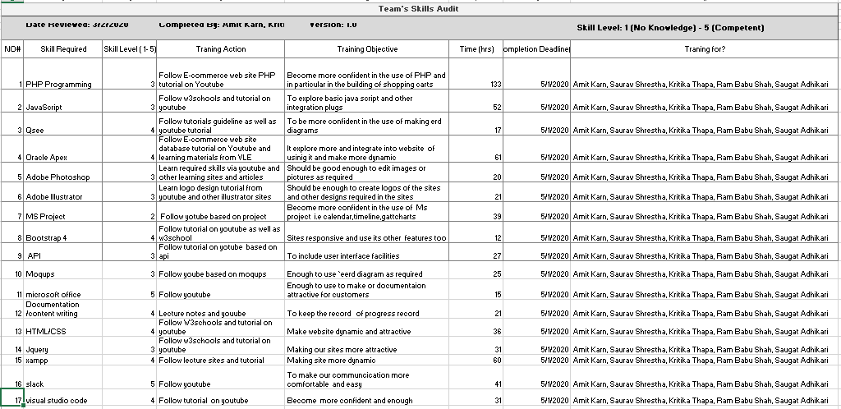

* + 1. **Individual Skill Audit**
       1. **Amit Kumar Karn SA**

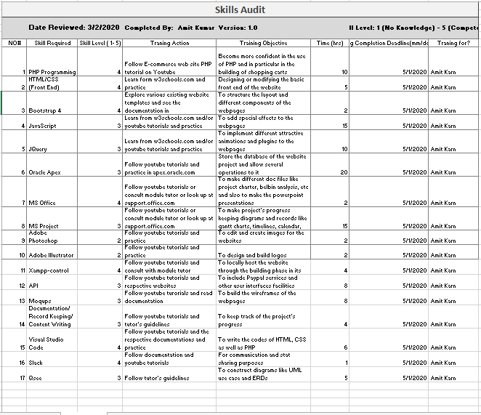

* + - 1. **Saurav Shrestha SA**

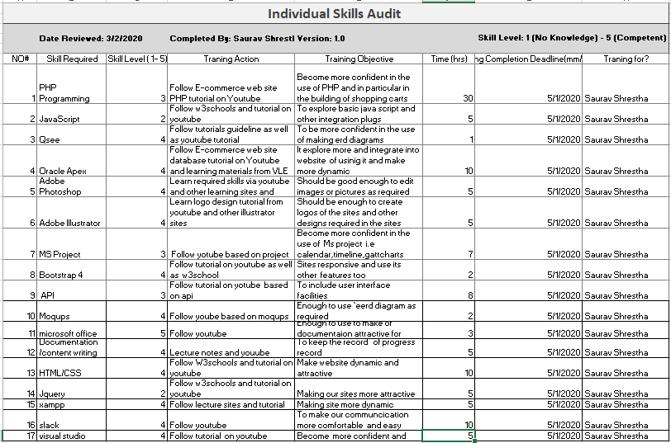

* + - 1. **Kritika Thapa SA**

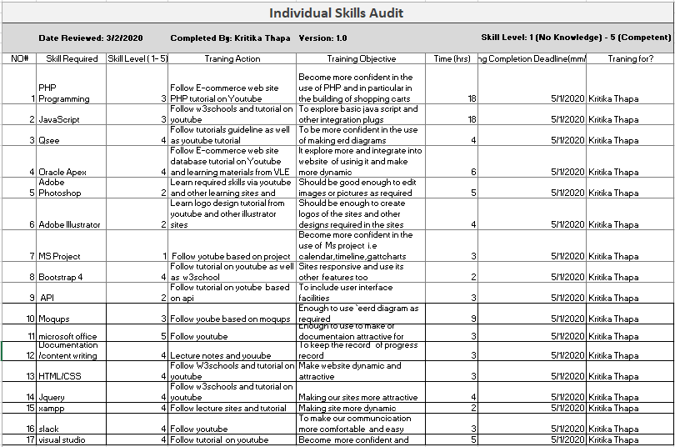

* + - 1. **Ram Babu Shah SA**

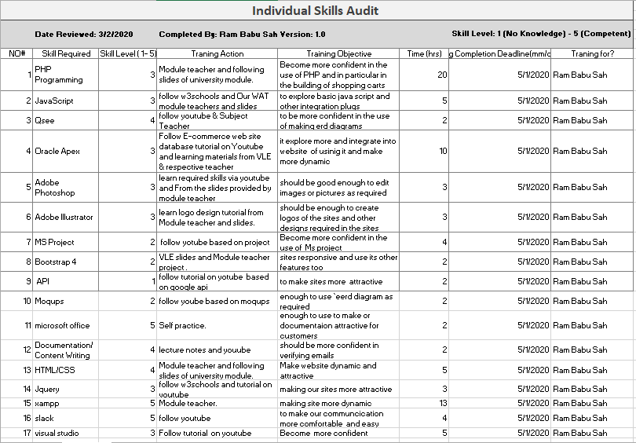

* + - 1. **Saugat Adhikari SA**

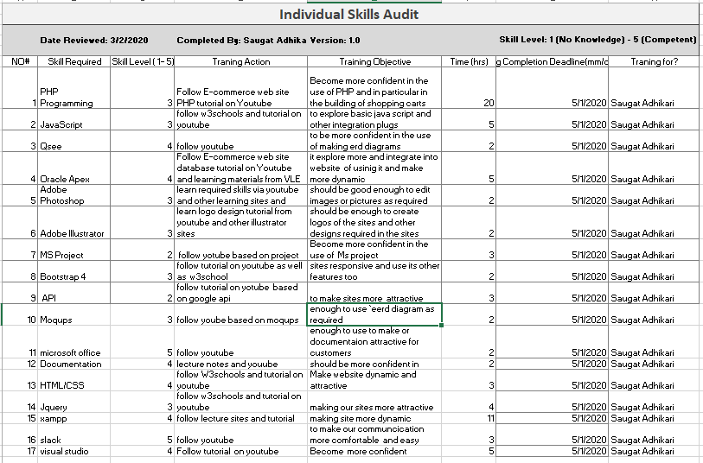

* + - 1. **Yogesh Shrestha SA**

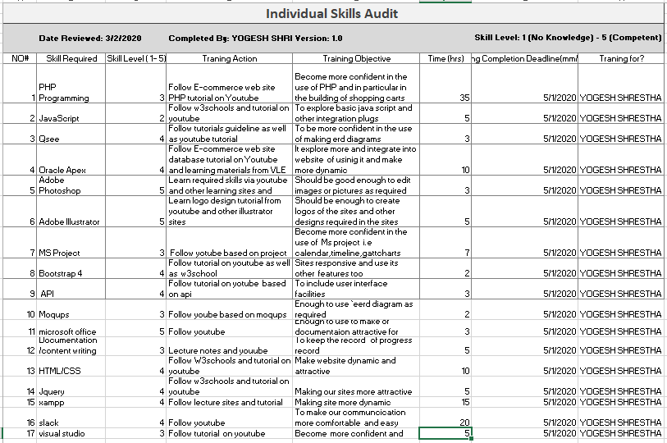

* 1. **Project Management (MS Project)**
     1. **Task Sheet**

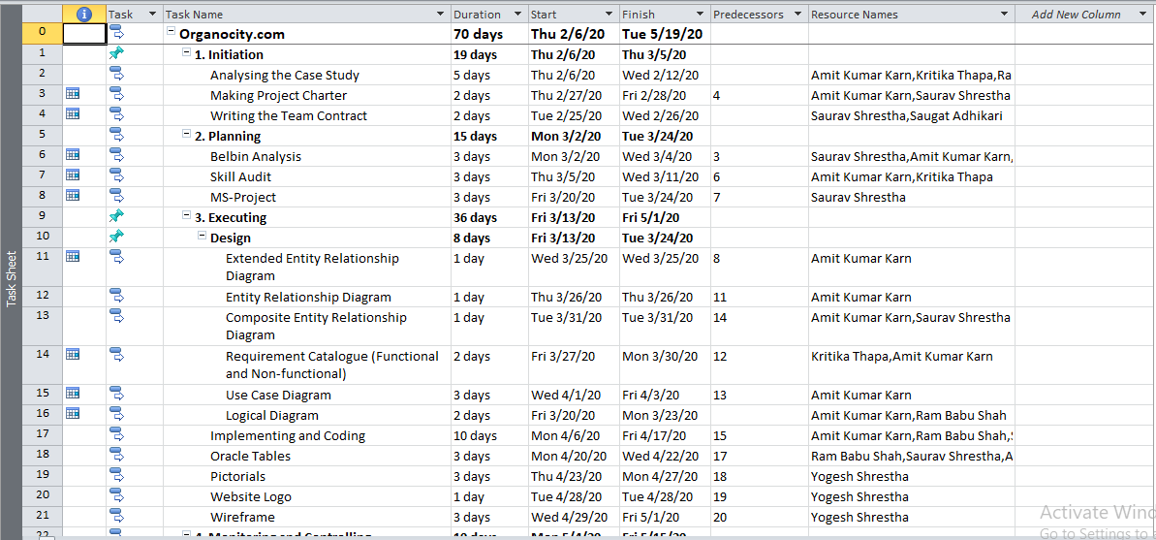

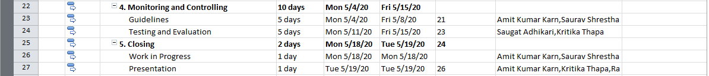

* + 1. **Gantt Chart**

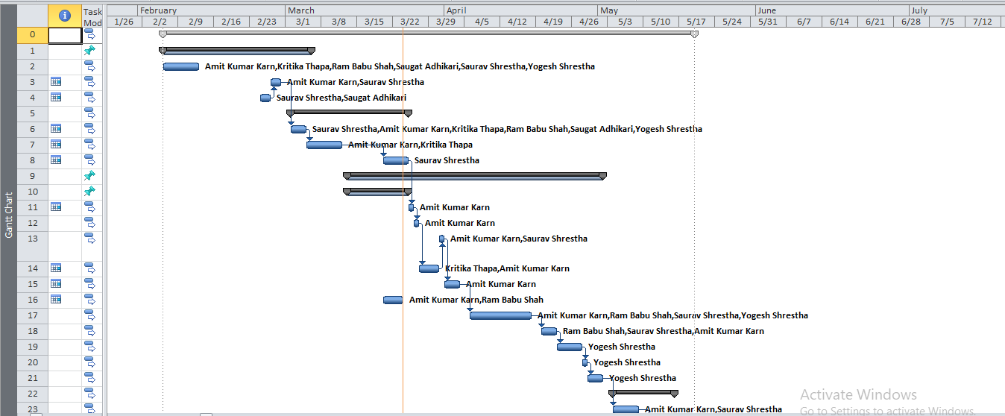

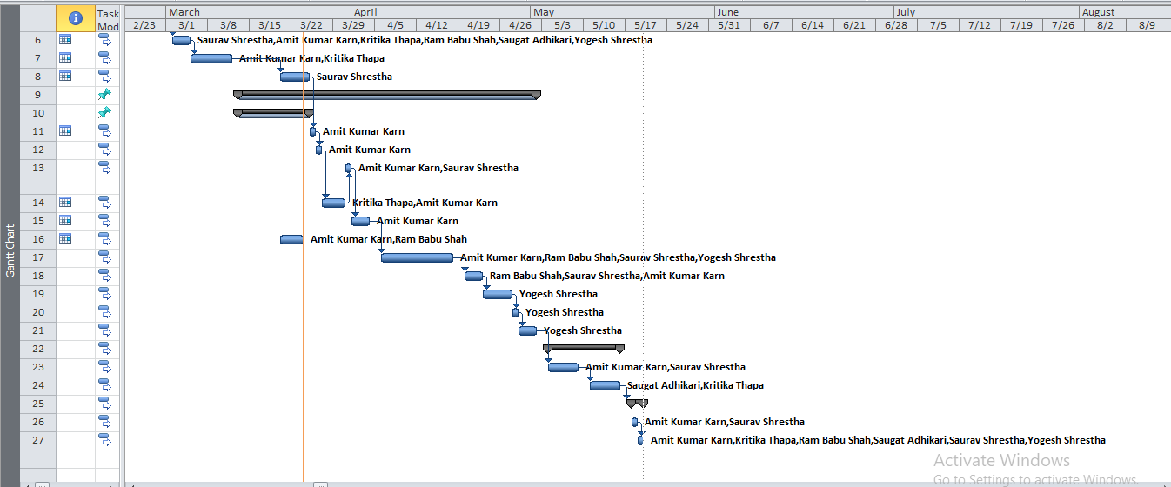

* + 1. **Network Diagram**

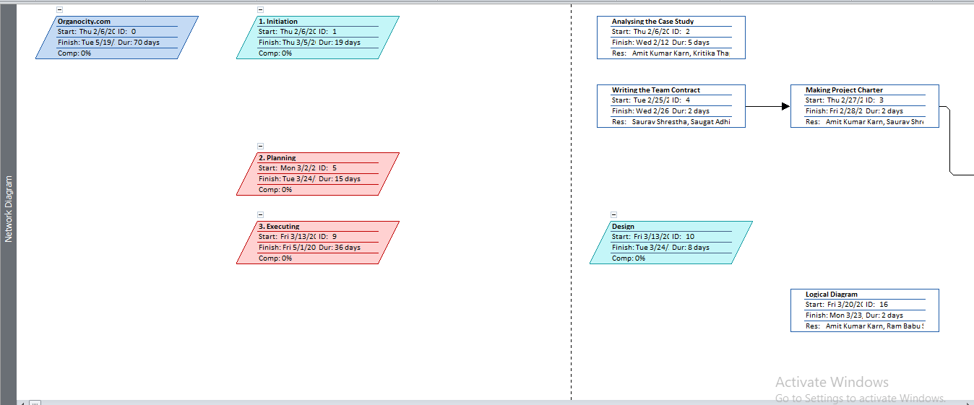

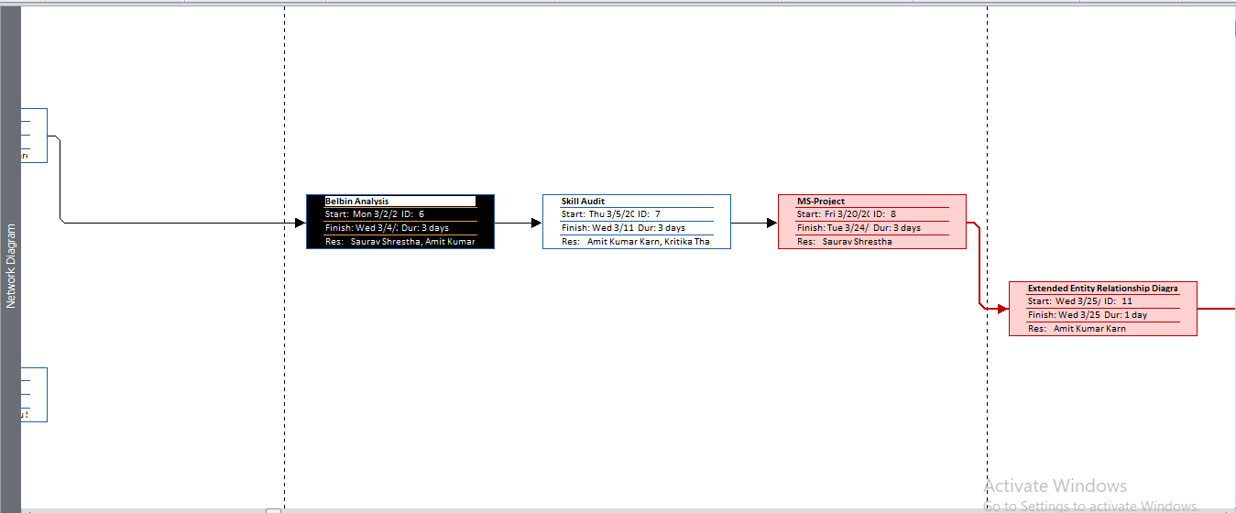

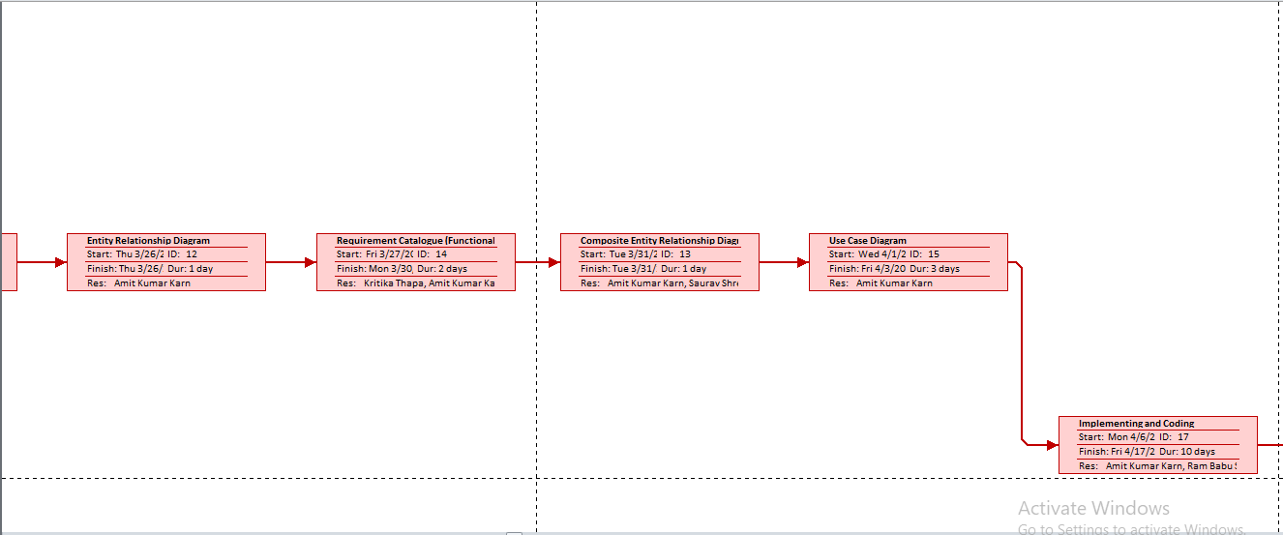

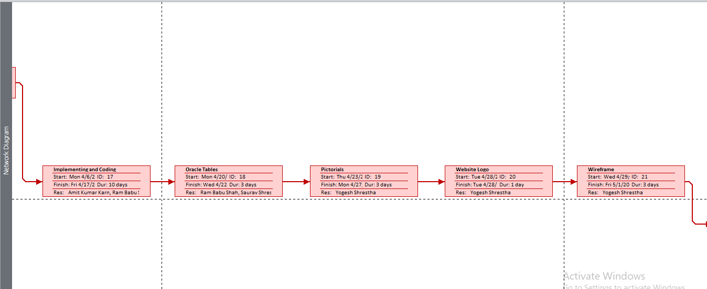

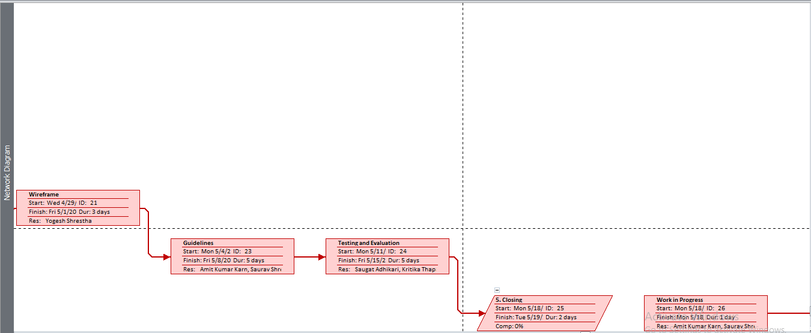

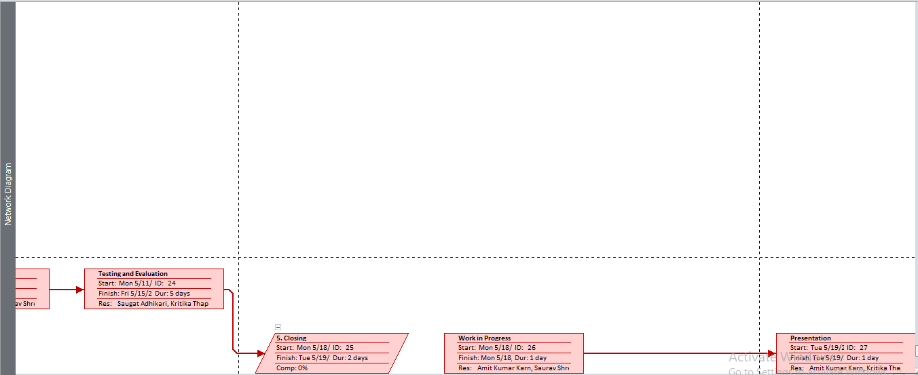

* + 1. **Timeline**

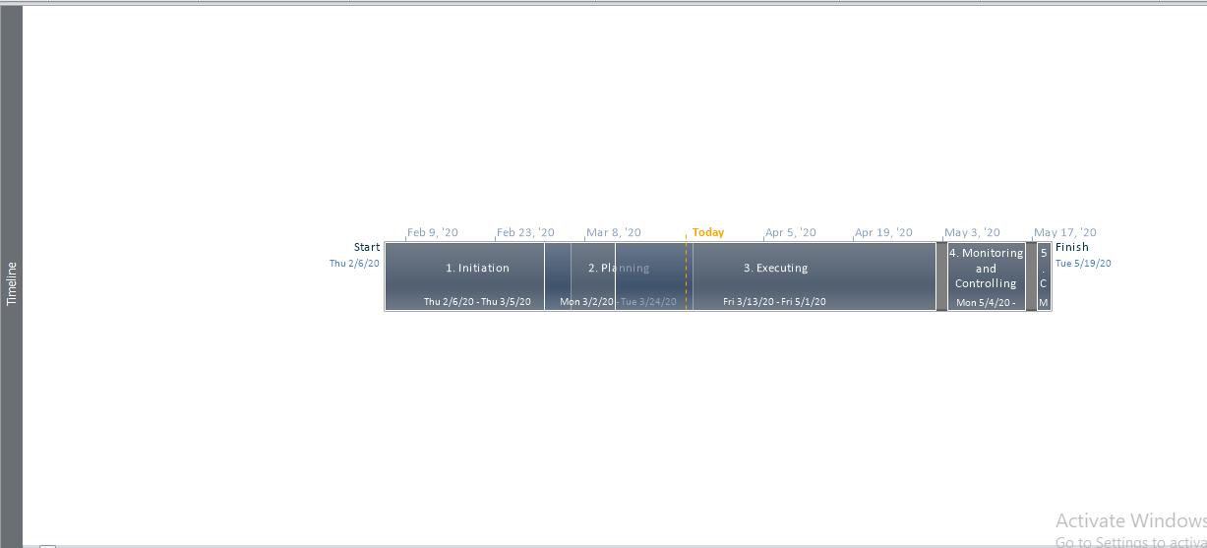

* + 1. **Calendar**

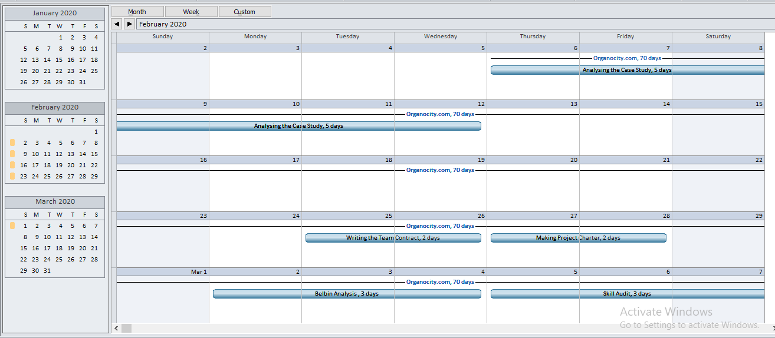

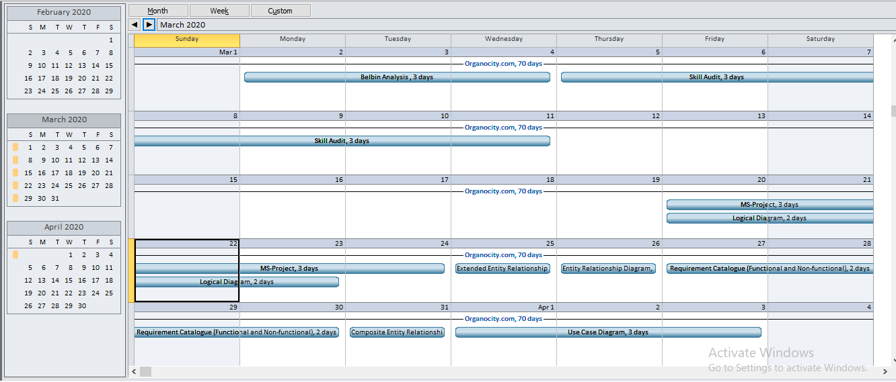

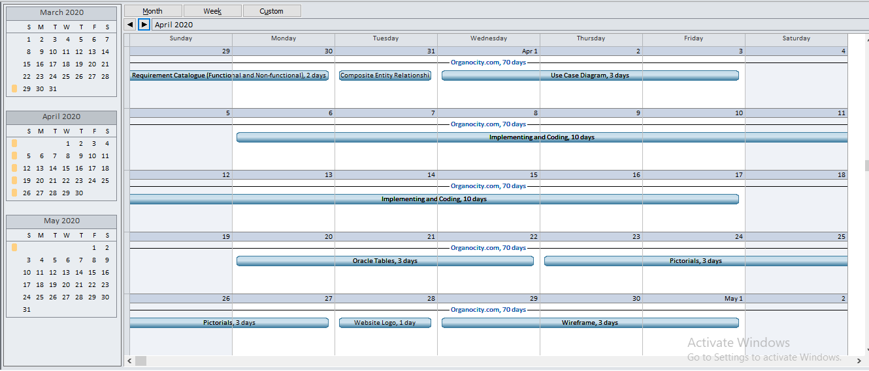

* + 1. **Resource Sheet**

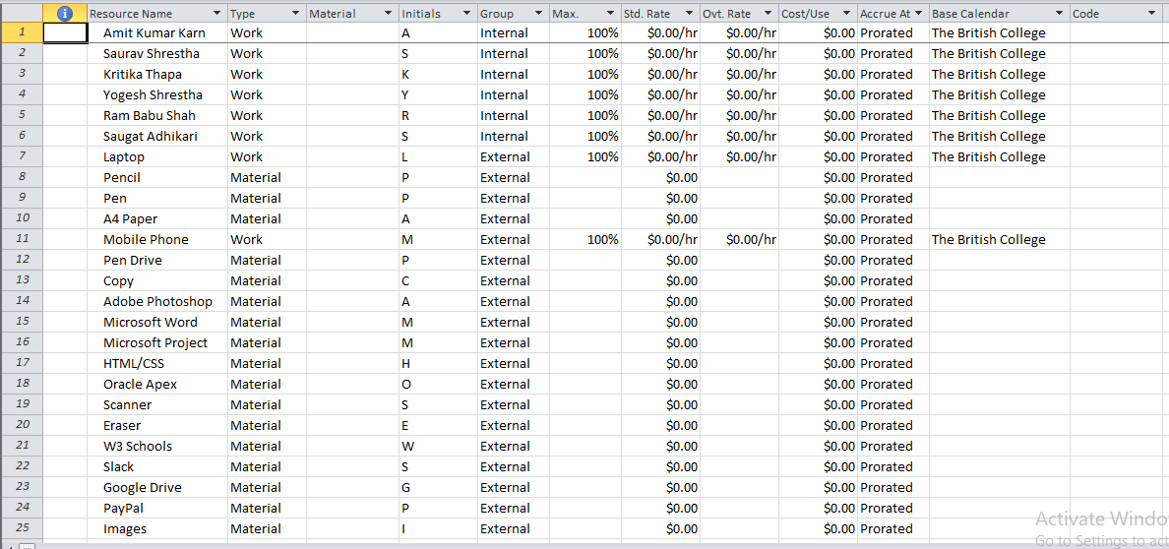

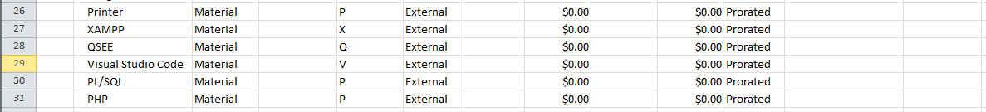

* 1. **Communication Tool Used**
     1. **Slack**

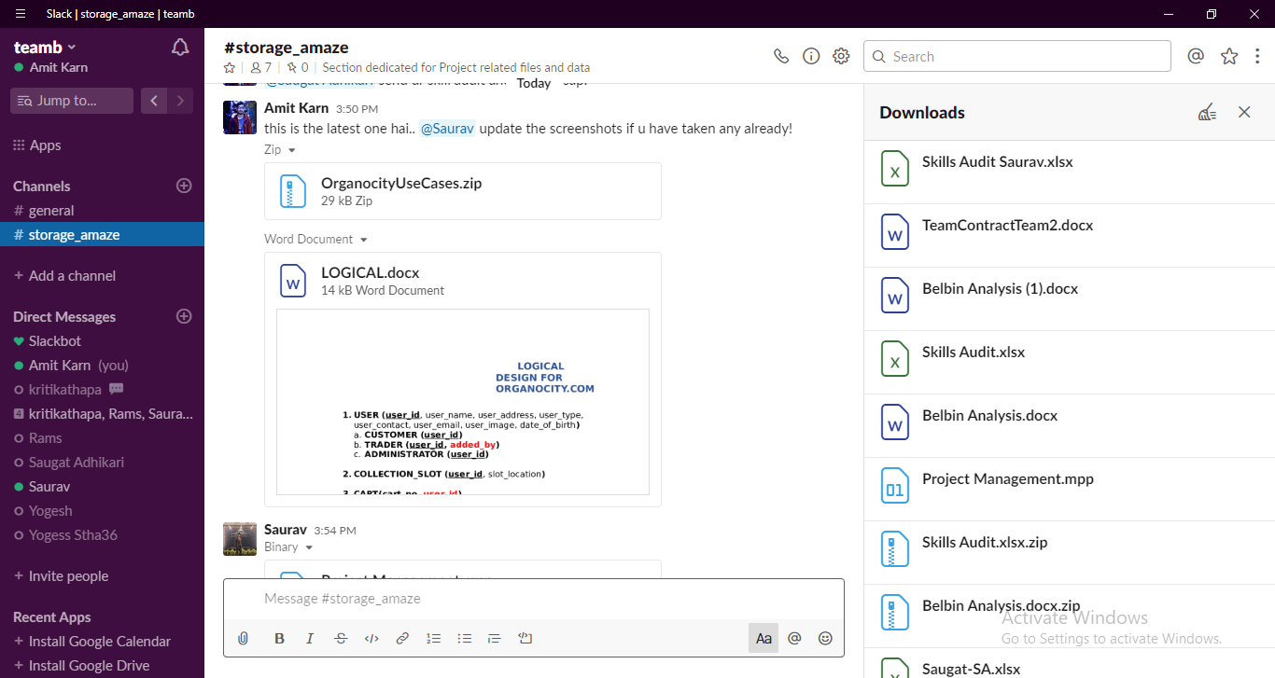

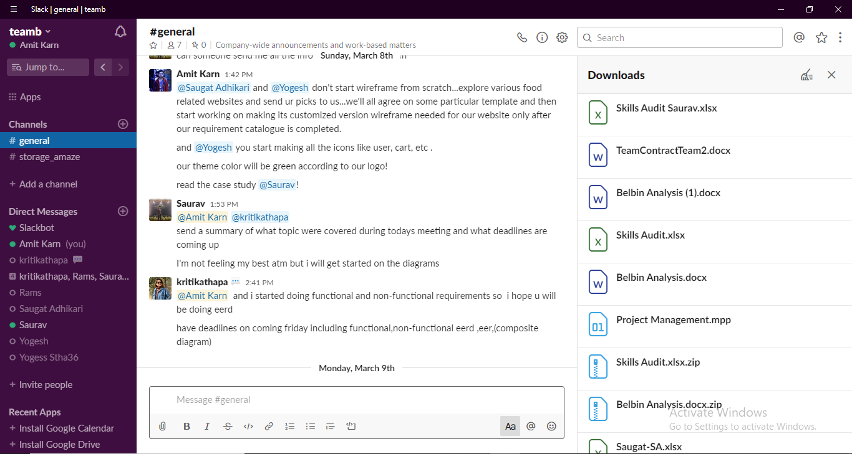

1. **Project Execution**
   1. **Entity Relationship Diagram**
      1. **ERD**



* + 1. **EERD**



* + 1. **Final Composite ERD**



* + 1. **Logical Design**

# **LOGICAL DESIGN FOR ORGANOCITY.COM**

1. **USER** **(user_id**, user_name, user_address, user_type, user_contact, user_email, user_image, date_of_birth**)**
   1. **CUSTOMER** **(user_id)**
   2. **TRADER** **(user_id, added_by)**
   3. **ADMINISTRATOR** **(user_id)**
2. **COLLECTION_SLOT** **(user_id**, slot_location**)**
3. **CART(cart_no,** **user_id)**
4. **PAYMENT (payment_id,** payment_status, payment_type, payment_date, payment_time, payment_amount, **user_id)**
5. **ORDER(order_id,** product_quantity, order_status, order_date, order_time, **user_id**, **payment_id**, **slot_no**, **cart_no)**
6. **REVIEW(review_no,** review_date, rating, **product_id**, **user_id)**
7. **DISCOUNT(disount_id,** discount_name, discount_amount, **user_id)**
8. **CATEGORY(cat_id,** cat_name, cat_image**)**
9. **SHOP(shop_id,** shop_name, shop_location, **user_id)**
10. **PRODUCT(product_id,** product_name, product_type, product_price, product_image, **discount_id, cat_id, shop_id)**
11. **PRODUCT_CART(product_id, cart_id)**
    1. **Use Case Diagram**
       1. **Overview Use Case**

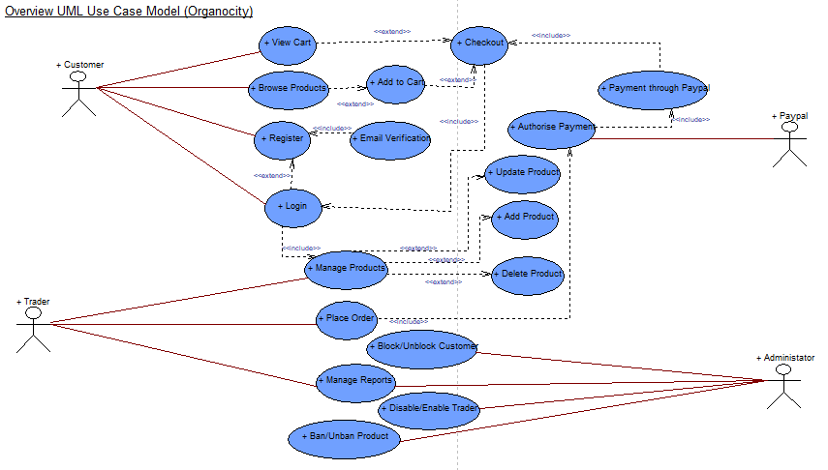

* + 1. **Customer Use Case**

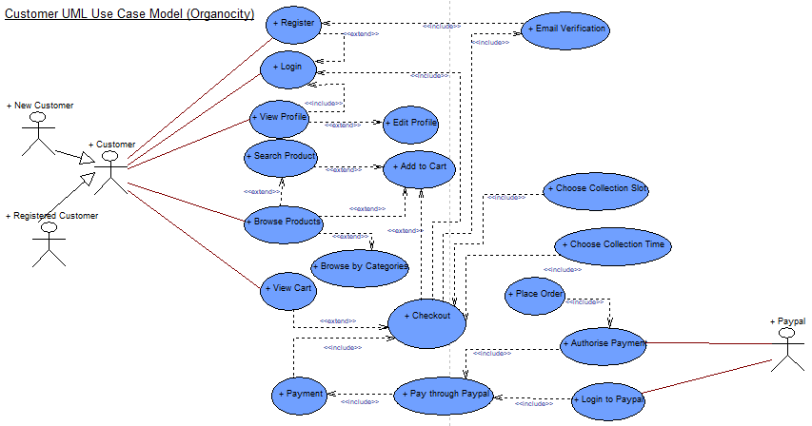

* + 1. **Trader Use Case**

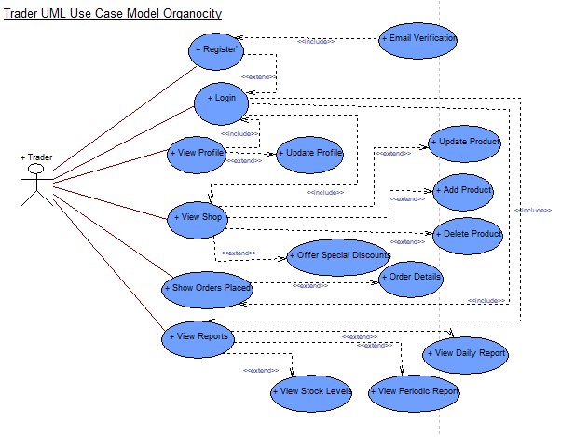

* + 1. **Admin Use Case**

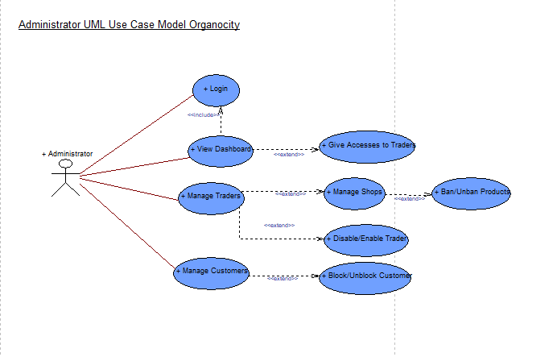

* 1. **Requirement Catalogue**
     1. **Functional Requirement**

**PART A – PRODUCT INTERFACE**

|  |  |  |
| --- | --- | --- |
| **REQUIREMENT ID** | **DESCRIPTION** | **MoSCoW** |
| **A1** | **An interface to allow customers to view and buy products.** | **M** |
| A1-01 | Products should be viewable according to their shop or product type. | M |
| A1-02 | The products will minimally have details like unique id, short name, description, price, quantity per item, stock available, minimum order and maximum order, allergy information and a link associated with a unique trader. | M |
| A1-03 | Review of the product of the basket and put their comment on their basket | C |
| A1-04 | Discount is included in every product which is placed on featured, which can also be added in the cart. | c |
| A1-05 | Customers after signing in, get to add the products in favorites after viewing all the products. | M |
| **A2** | **The web interface will allow customers to select products to carts and checkout.** | **M** |
| A2-01 | A form details to input PayPal account while checking out. | M |
| A2-02 | Facility to provide users to choose their desired collection slot. | S |
| A2-03 | An invoice of the total amount of the products checked out by the customer. | S |
| A2-04 | A breakdown of invoice to trader invoice to the traders according to the items brought by customers. | S |
| A2-05 | Admin invoice about the transaction for full management. | S |
| **A3** | **An offer option for regular purchasing customers** | **C** |
| A3-01 | Checkout option will be displayed after customers add products to cart. | M |
| A3-02 | The heritage theme of the suburb can represent through the website. | M |
| A3-03 | Device friendly interface that can be accessed through mobile, desktop, and other most popular browser. | M |

**PART B – CUSTOMER INTERFACE**

|  |  |  |
| --- | --- | --- |
| **REQUIREMENT ID** | **DESCRIPTION** | **MoSCoW** |
| **B1** | **A facility that allows new customer to register an account or login to their existing ones.** | **M** |
| B1-01 | Full name, email address, contact number and password are minimally required for a user to register. | M |
| B1-02 | Date of birth, gender, profile photo, address could be additionally added to the user’s profile. | C |
| B1-03 | The user will be verified through email for security. | M |
| B1-04 | Login link will be displayed throughout every pages of the site. | C |
| B1-05 | Server-side validation of all form objects to ensure none of the fields are empty | S |
| B1-06 | Passwords should be encrypted before storing in the database | C |
| **B2** | **A facility to allow registered users to login.** | **M** |
| B2-01 | An email verification will be done while checkout. | C |
| B2-02 | Server validation that informs users if they attempt to log in using incorrect details | M |
| B3-03 | Forget password option to redirect a link for password change to user e-mail or OTP code to the phone number. | S |
| B4-04 | A stay signed-in checkbox for customers to easily access to their accounts | C |
| B3-05 | A facility for users to sign-in using QR-code | W |

**PART C – TRADER INTERFACE**

|  |  |  |
| --- | --- | --- |
| **REQUIREMENT ID** | **DESCRIPTION** | **MoSCoW** |
| **C1** | T**raders should be able to register new accounts.** | **M** |
| C1-01 | Minimally shop name, product type, shop address should be provided to create an account. | S |
| C1-02 | Traders will be verified with an official email id for their shop while registering. | C |
| C1-03 | A login interface that allows each traders to login and get access to their distinct details. | M |
| C1-04 | Traders account interface that allows trader to view and update the details of the account. | S |
| C1-05 | Each trader will be associated with different product type. | M |
| C1-06 | Ensure validity of data entered including valid e-mail, names-alpha only | S |
| **C2** | **The trader’s interface will be facilitated with daily reports on orders, sales as well as stocks on their particular products.** | **M** |
| C2-01 | The reports will reveal the customer ID, order ID as well as product details like product ID, quantity and the collection slot where the product need to be sent. | C |
| C2-02 | A weekly finance report will be generated and will be viewable to the trader’s interface. | M |
| C2-03 | The weekly finance report will identify the payment to receive by the trader from previous 7 days orders which have been delivered. | S |
| C2-04 | A monthly report on sales will be generated and will be viewable to the trader’s interface. | M |
| C2-05 | The monthly report should contain all product sales’ information of the past month. | S |
| C2-06 | The monthly report should be viewable alphabetically, by total number of orders per product and by total income per product. | C |

**PART D – ADMINISTRATOR INTERFACE**

|  |  |  |
| --- | --- | --- |
| **REQUIREMENT ID** | **DESCRIPTION** | **MoSCoW** |
| **D1** | **An admin login facility that gives access to all traders’ account details as well as activities within the site.** | **M** |
| D1-02 | A login form to collect username and password | M |
| D1-03 | A facility for the admin to disable any product from selling | C |
| D1-04 | The admin’s landing interface will contain a dashboard which shows summary of all key entities of the site. | C |
| D1-05 | The dashboard will allow or block traders’ access to daily and periodic reports. | S |
| D2 | **Management Dashboard for admin.** | M |
| D2-01 | Daily and periodic reports on orders and quantities to traders | M |
| D2-02 | Weekly and monthly finance reports to traders | M |
| D2-03 | Sorting of reports according to alphabet, by total number of orders per product, by total income per product | M |

* + 1. **Non-Functional Requirement**

|  |  |  |
| --- | --- | --- |
| **REQUIREMENT ID** | **DESCRIPTION** | **MoSCoW** |
| E1-001 | HTML/CSS template suited to requirements | M |
| E1-002 | Template applied consistently thought out the size | M |
| E1-003 | Site built for maintainability: ( Files organized, comments added, HTML ) | S |
| E1-004 | The software should be portable. so, moving from one OS to other OS does not create any problems | S |
| E1-005 | The website should be capable enough to handle 1 million users without affecting its performance | C |
| E1-006 | Auto Bot Notification | C |

* 1. **Logo Design**



* 1. **Wireframes**
     1. **Homepage**

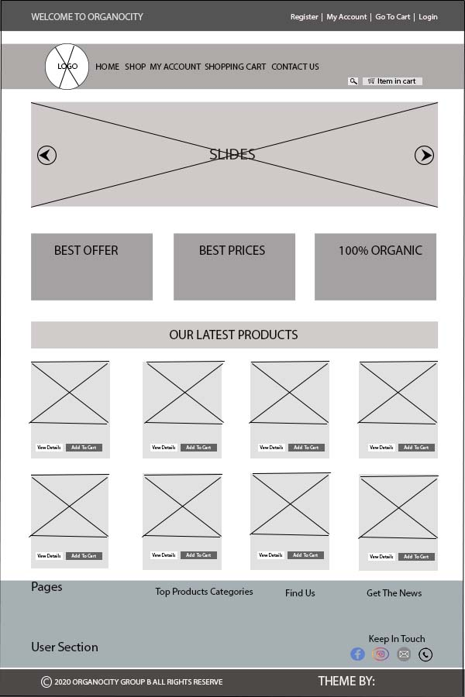

* + 1. **User Login**

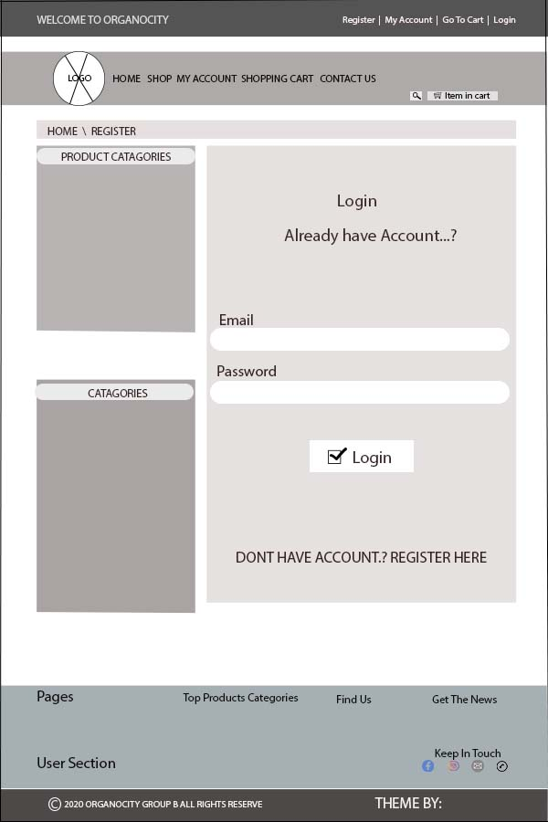

* + 1. **User Sign Up**

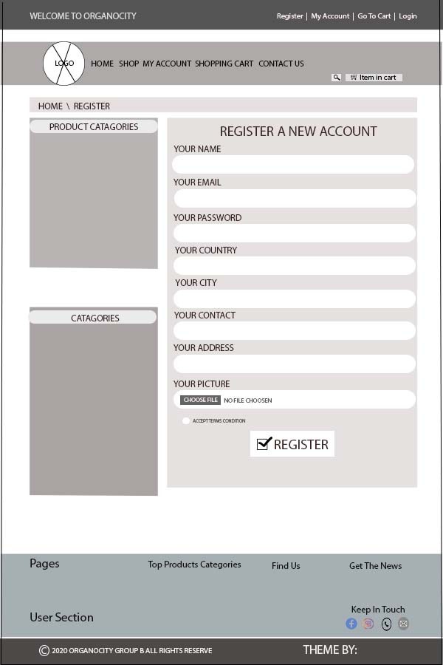

* + 1. **Shop**

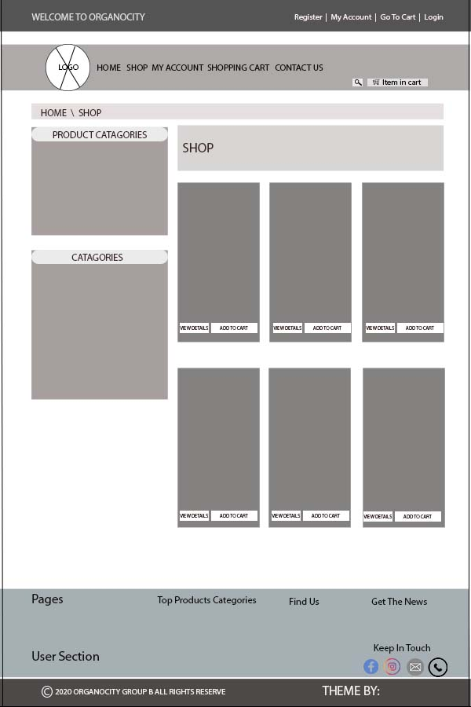

* + 1. **Invoice**

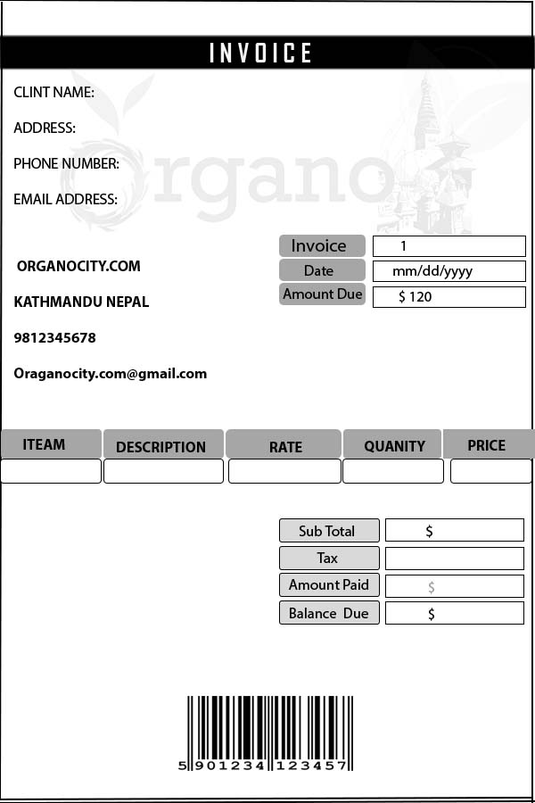

* + 1. **Admin Dashboard**

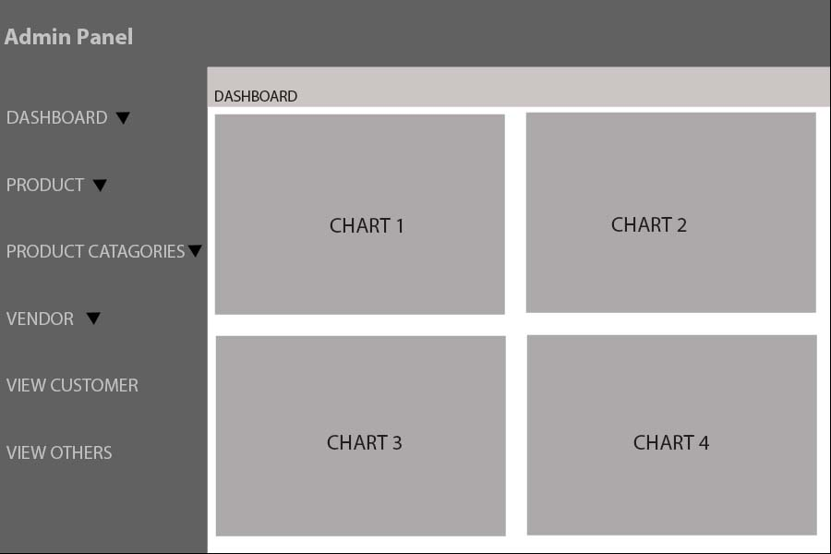

* + 1. **Customer Backend**

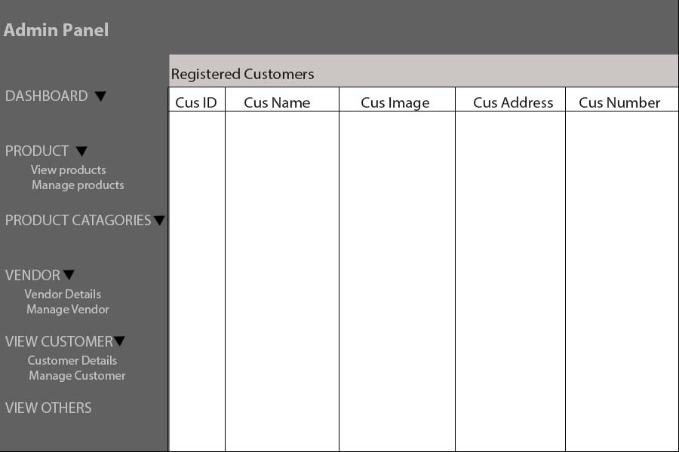

* + 1. **Product Backend**

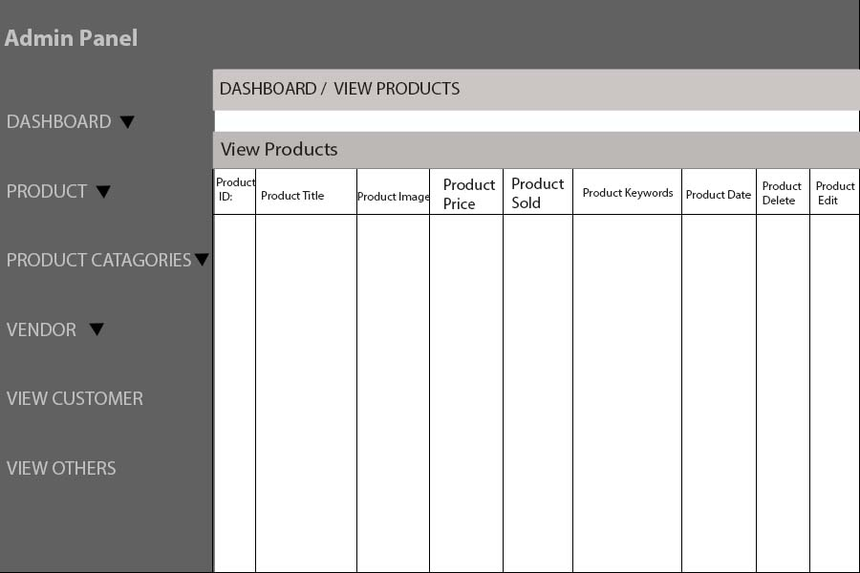

* 1. **Product Development**
     1. **Screenshots**

**Admin**

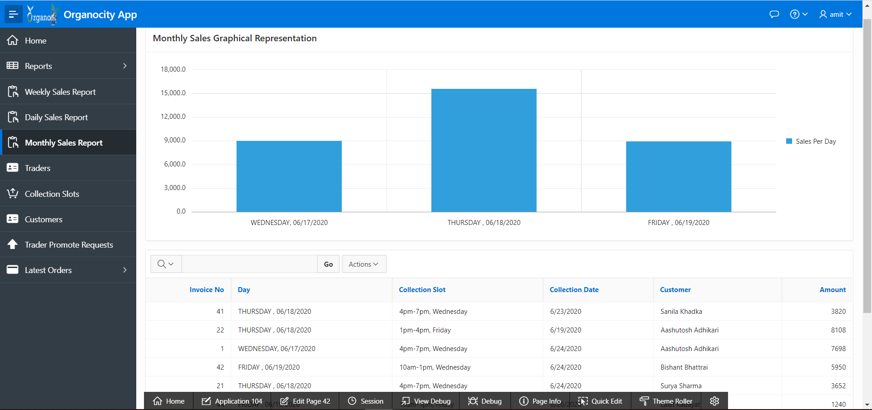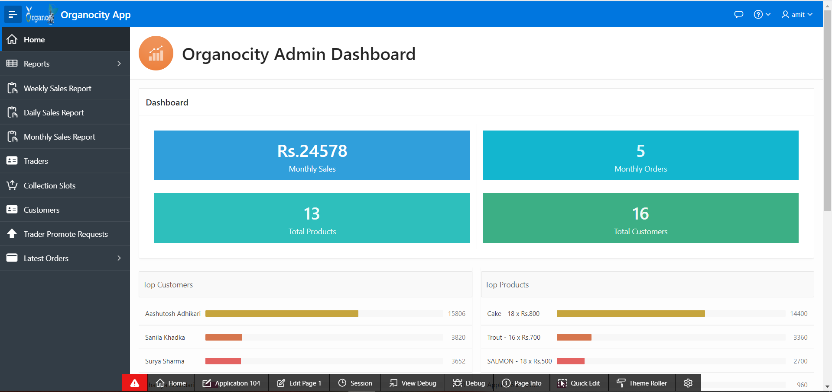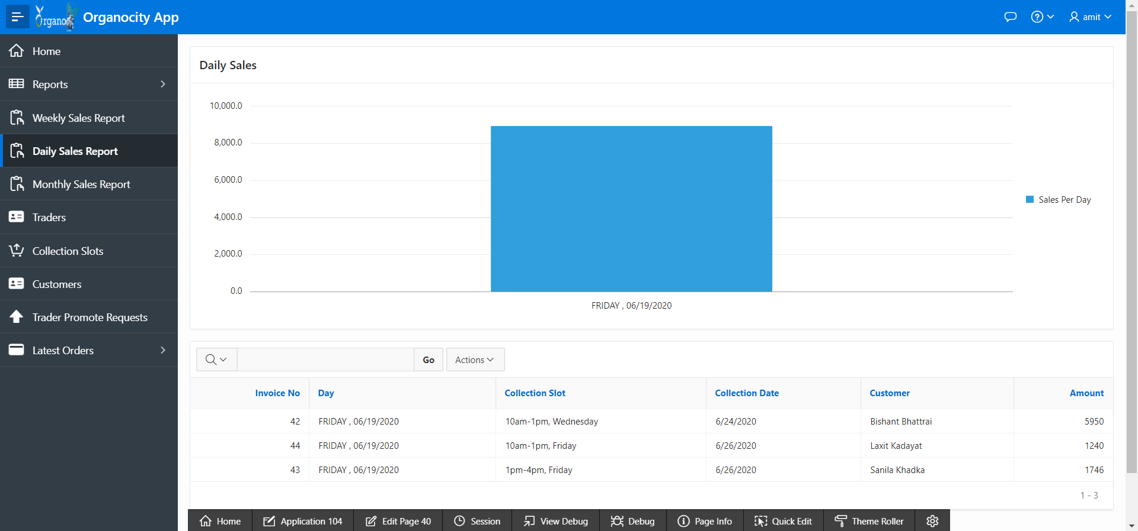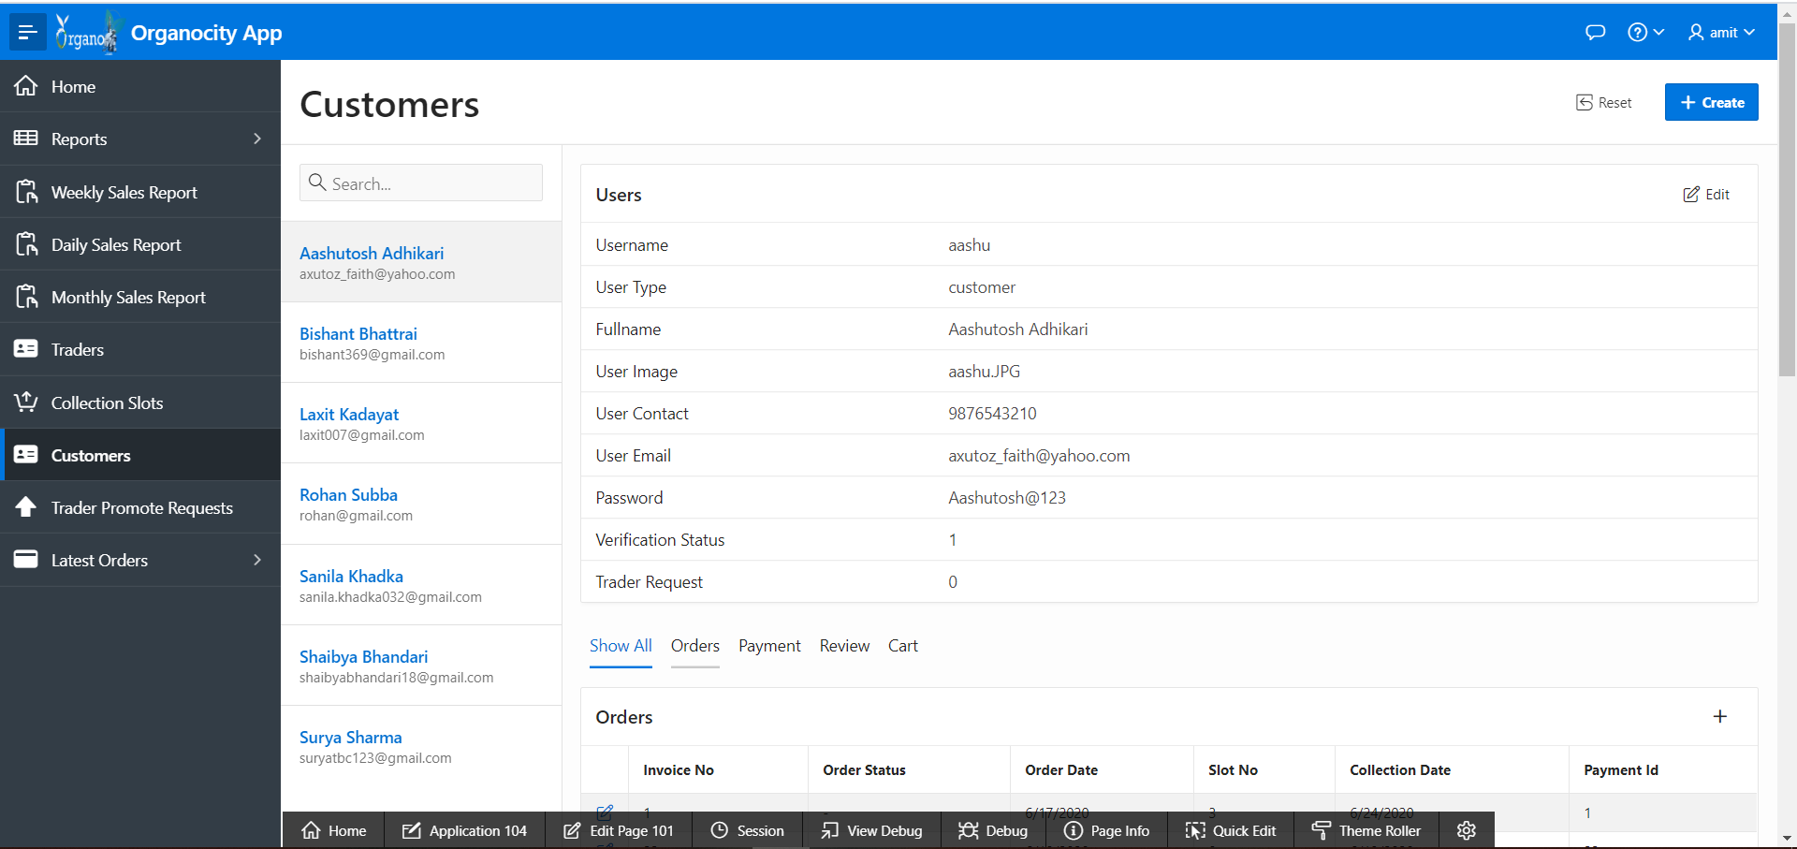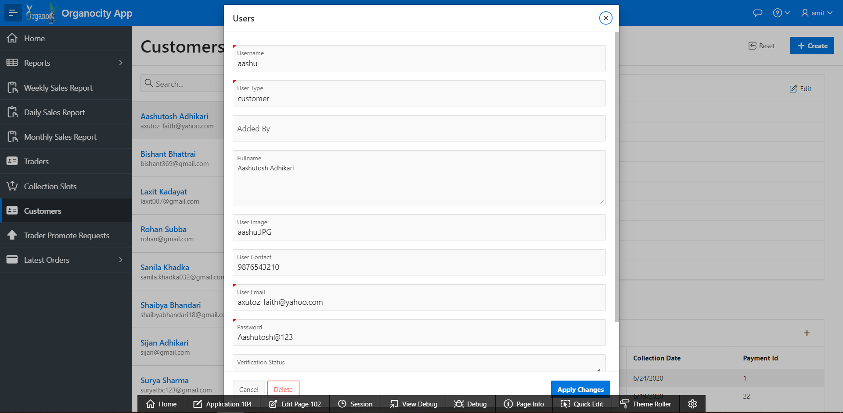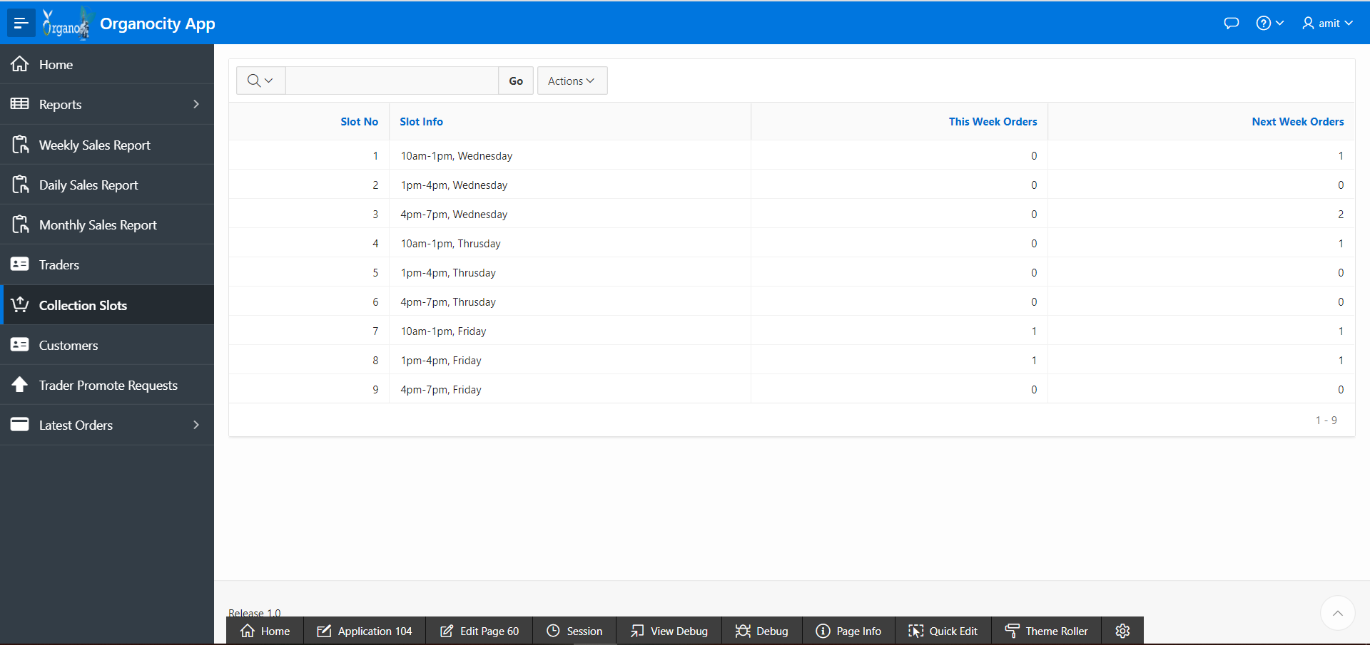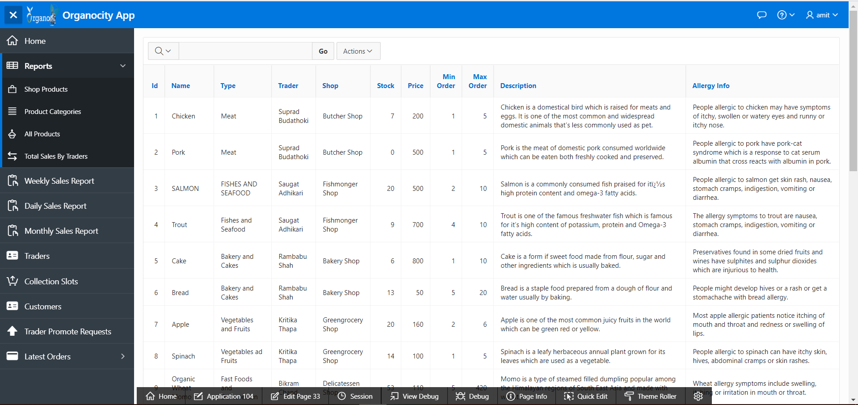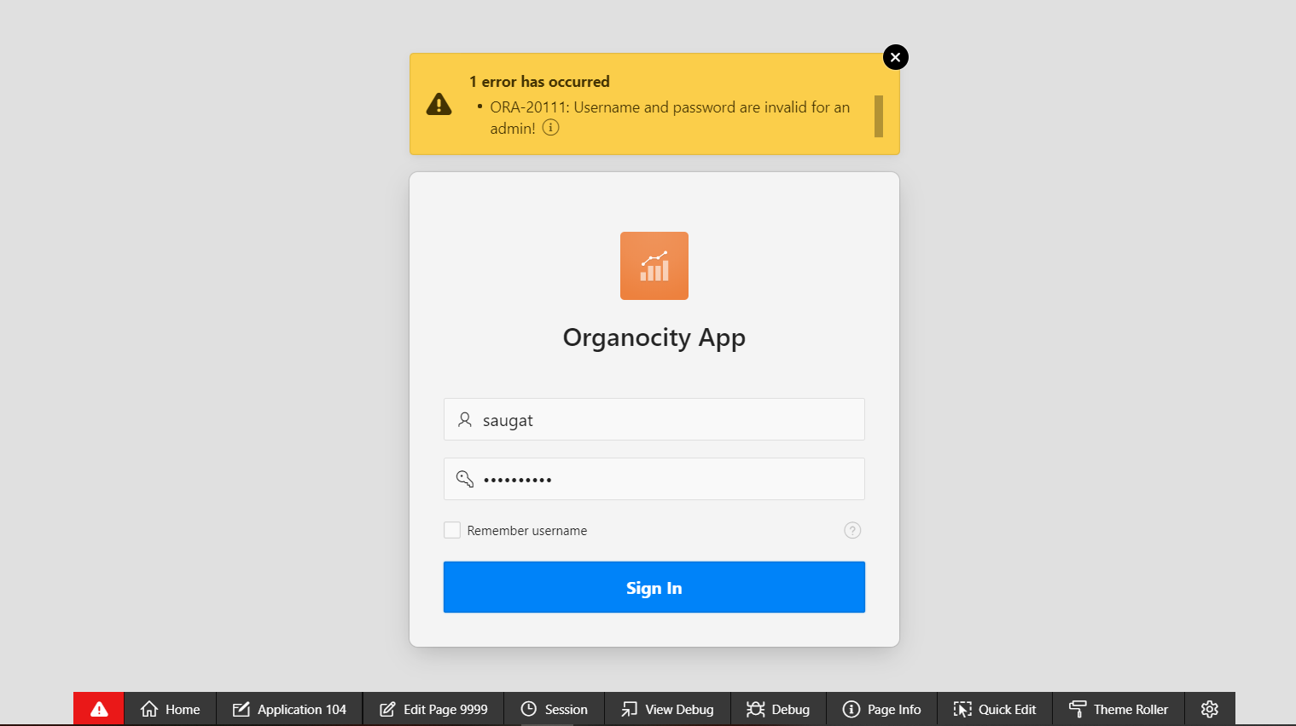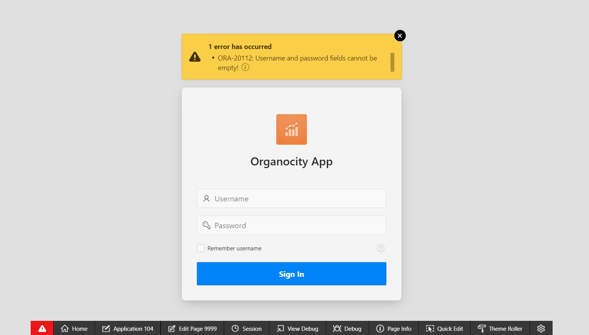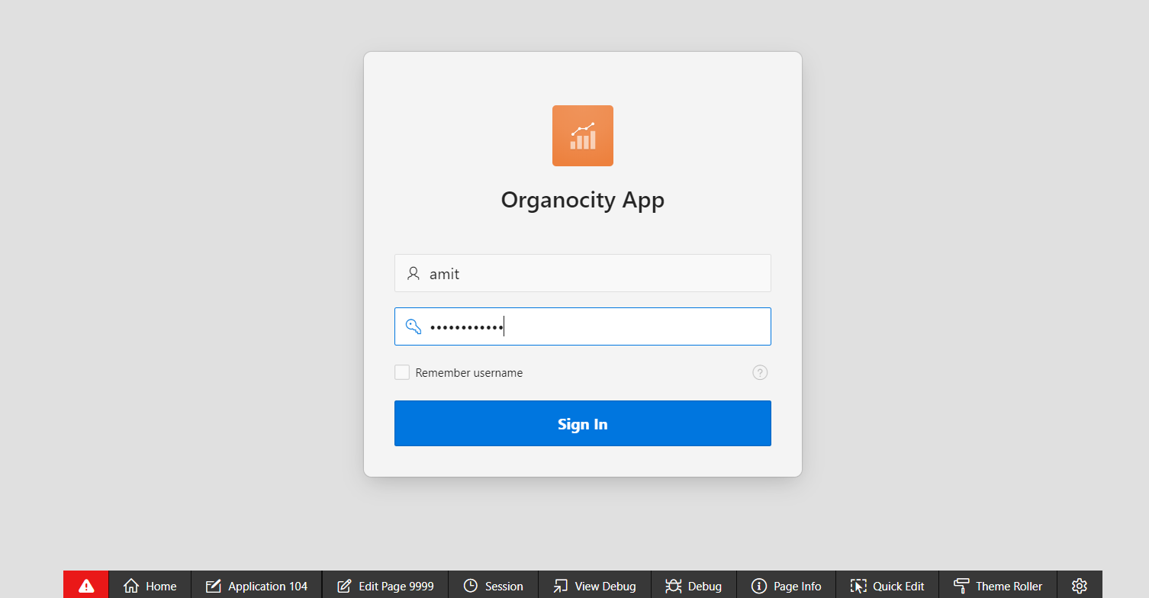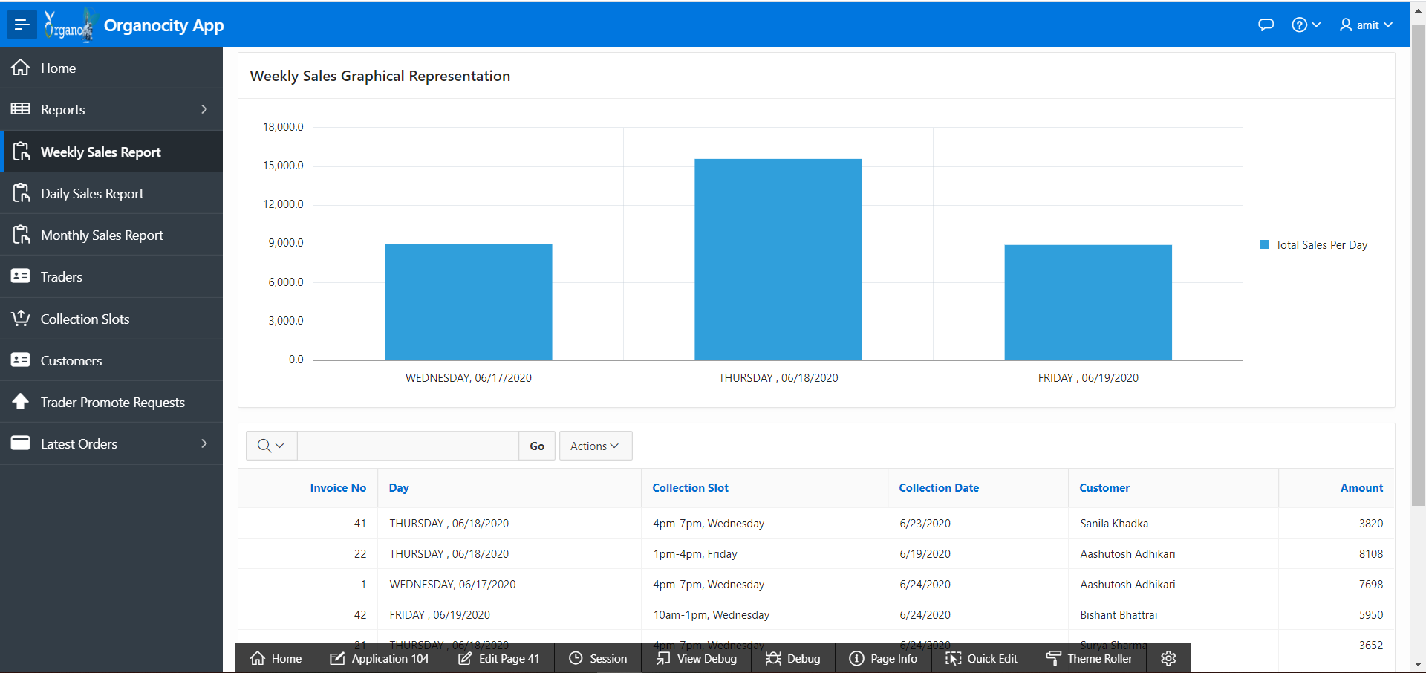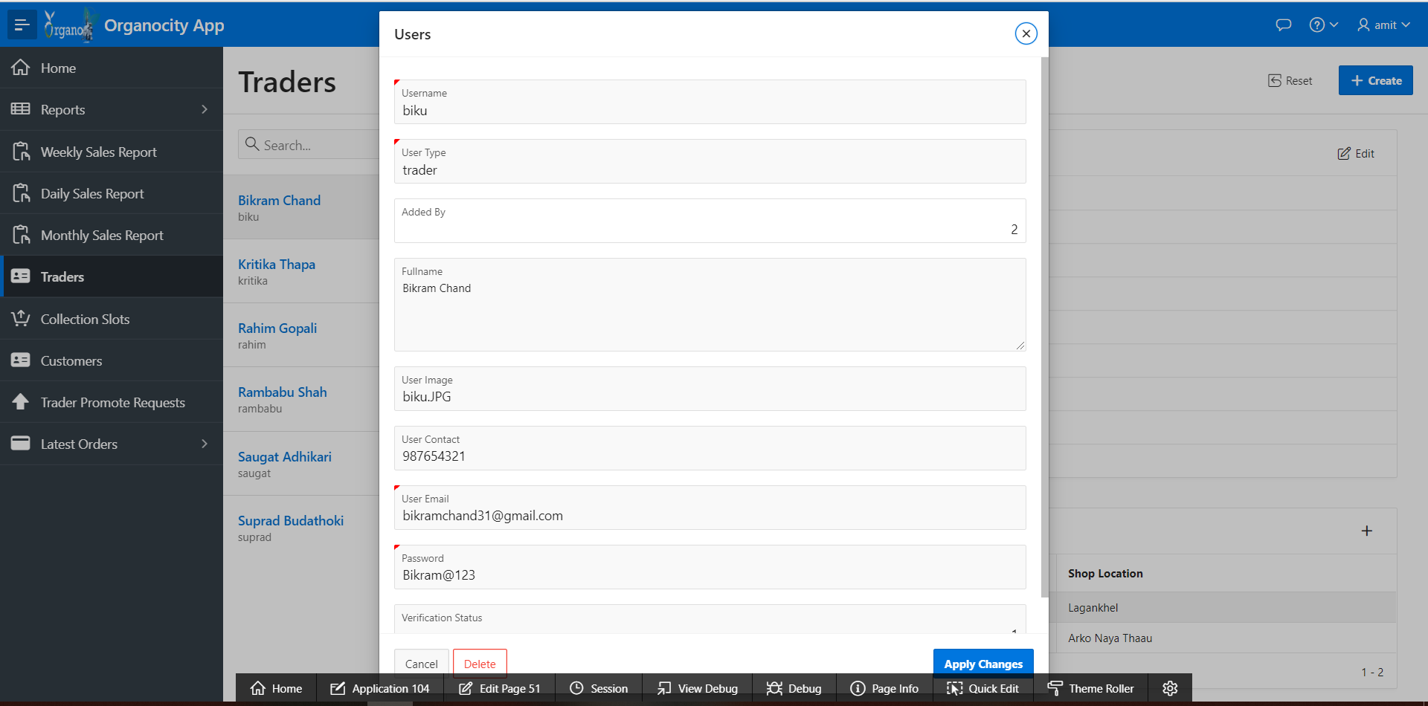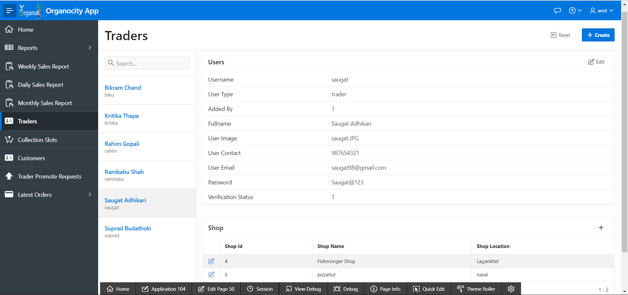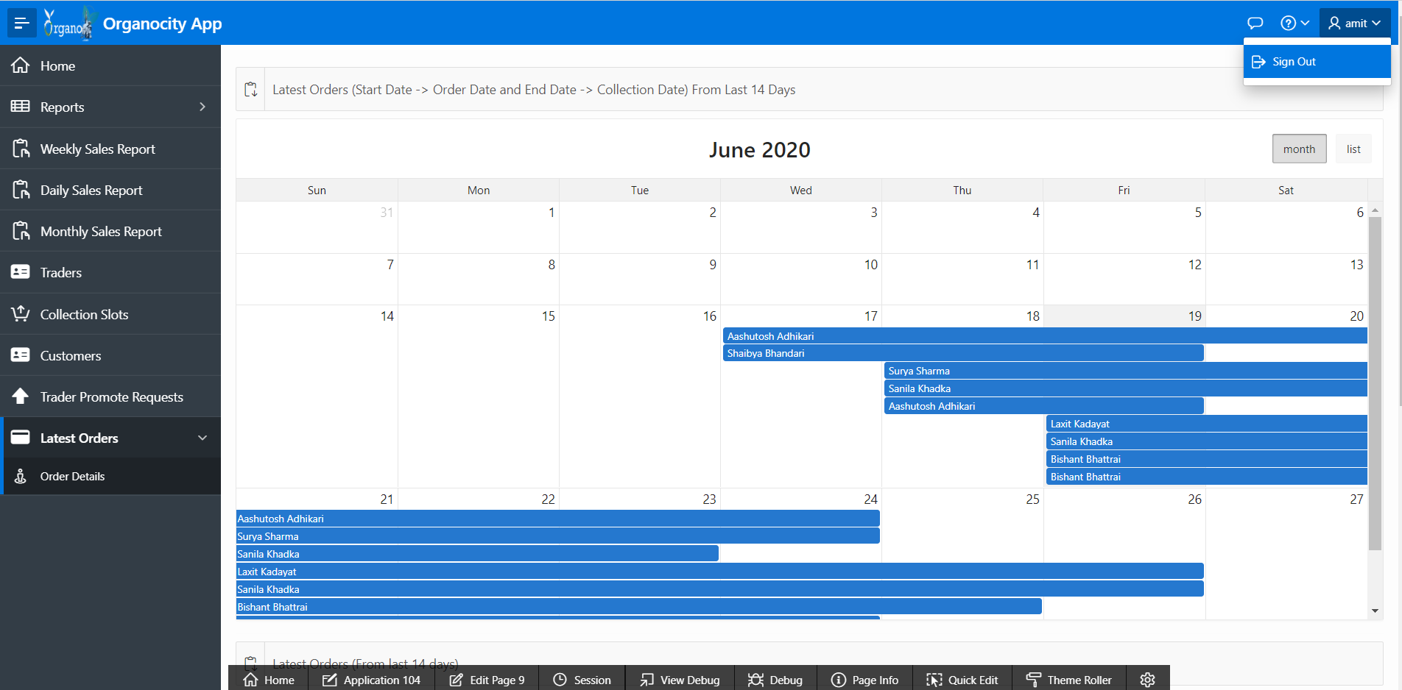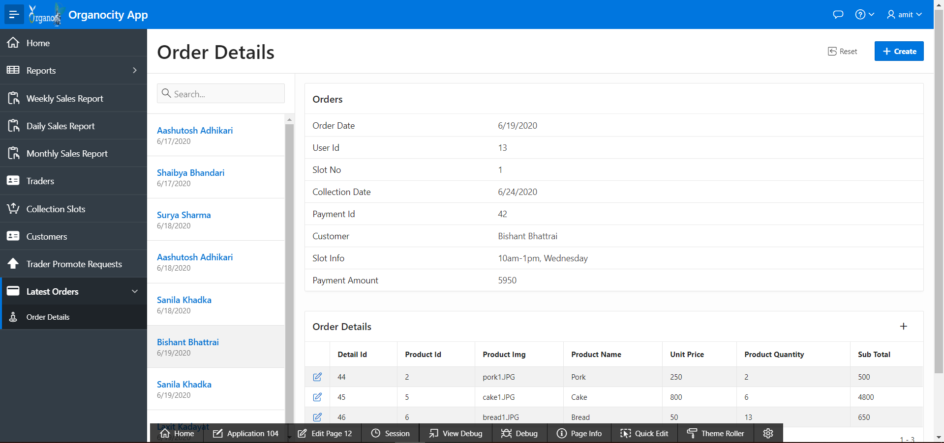

**Customer**

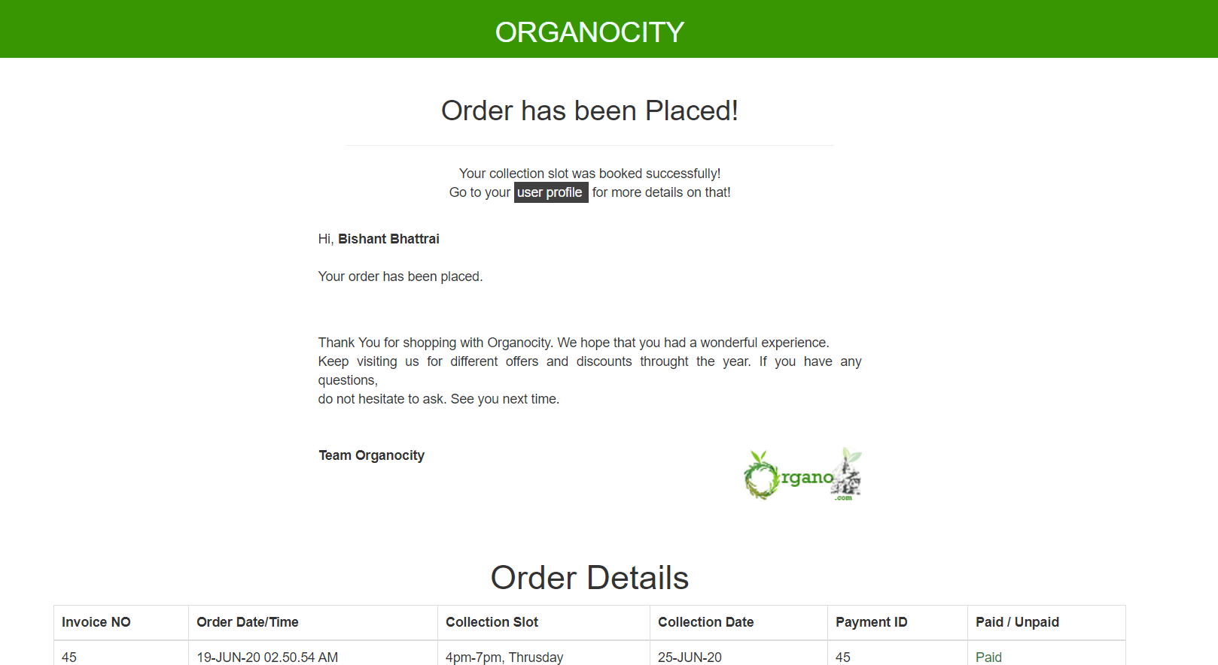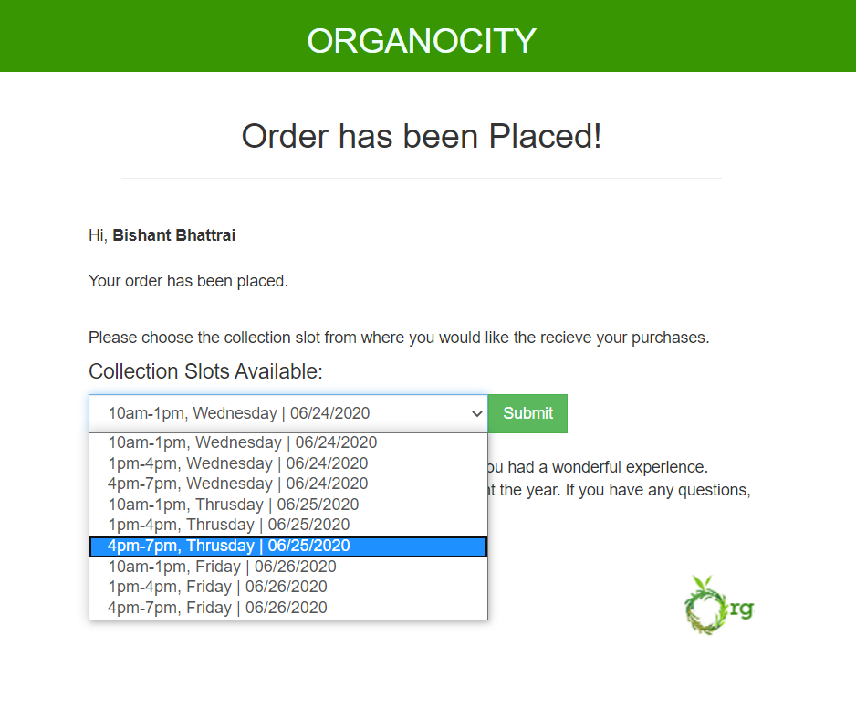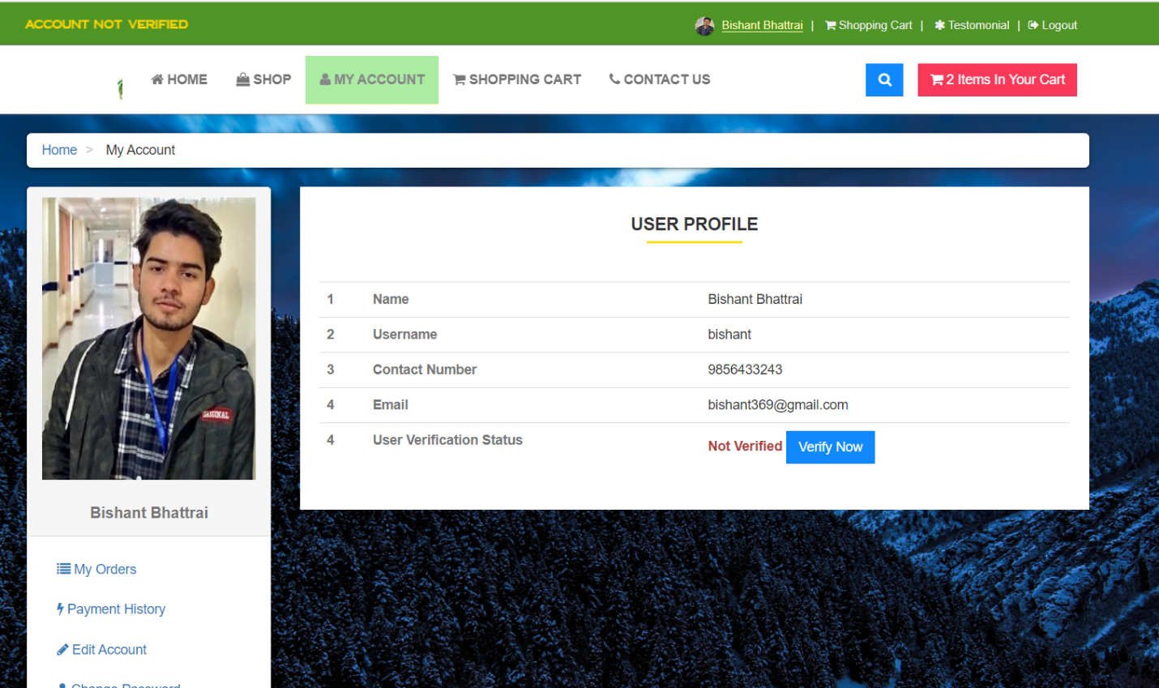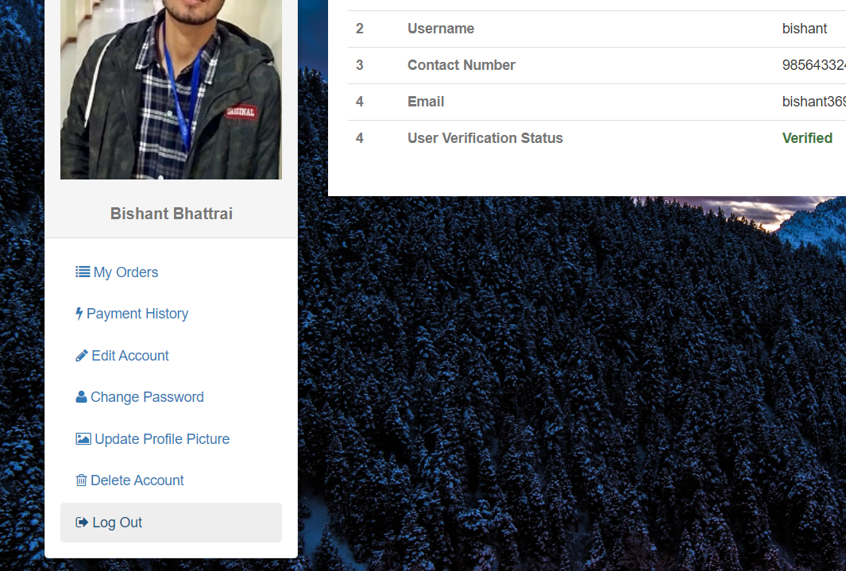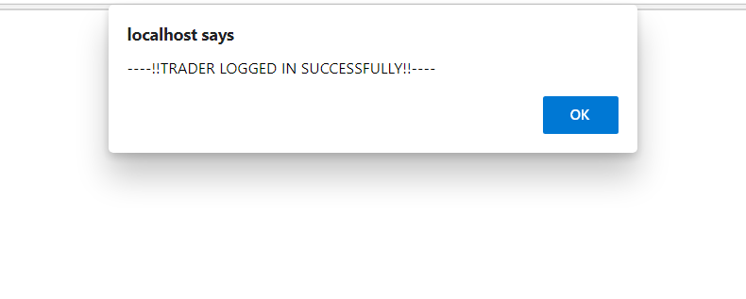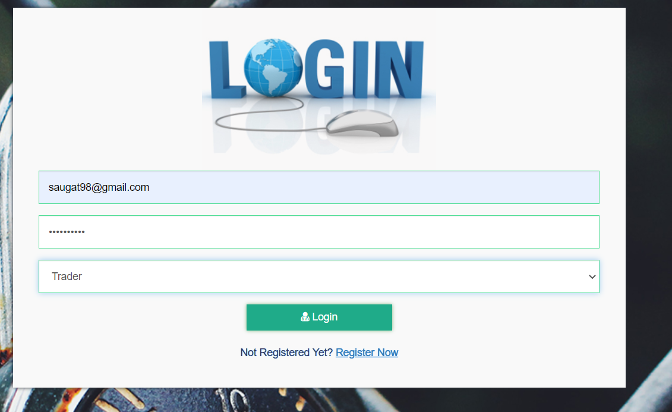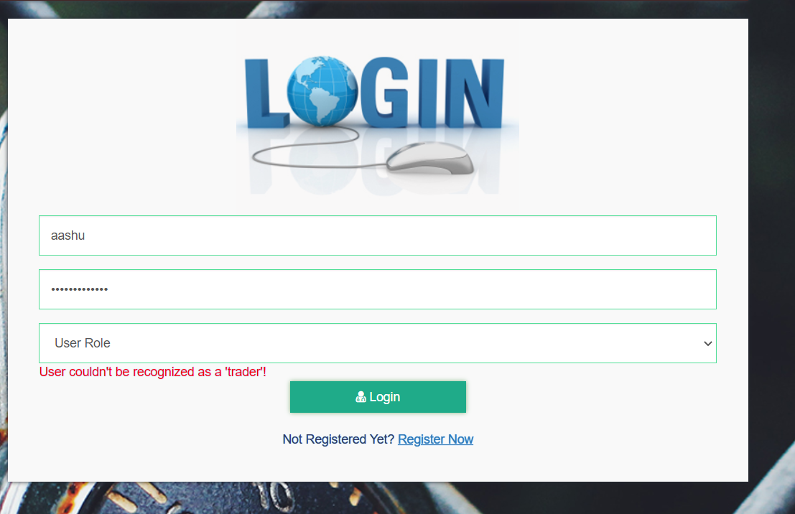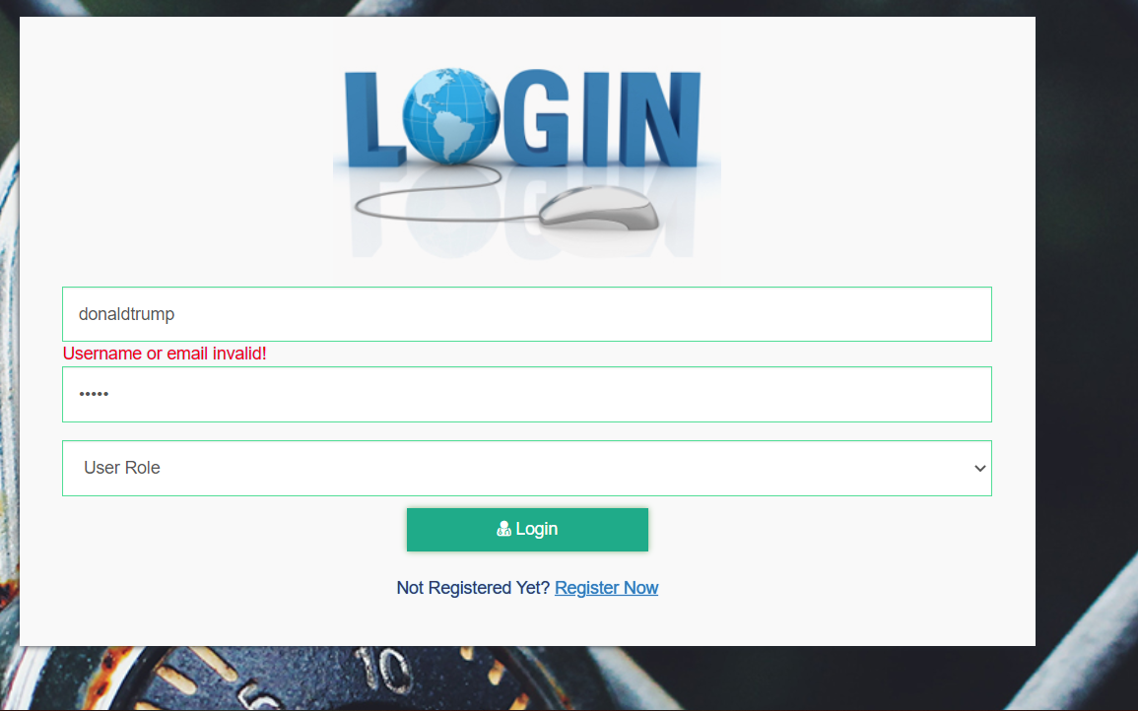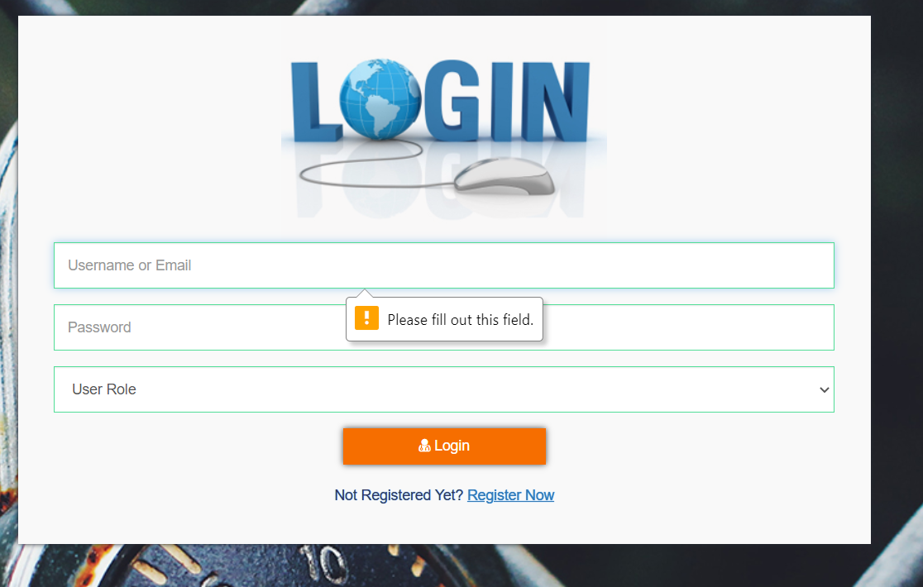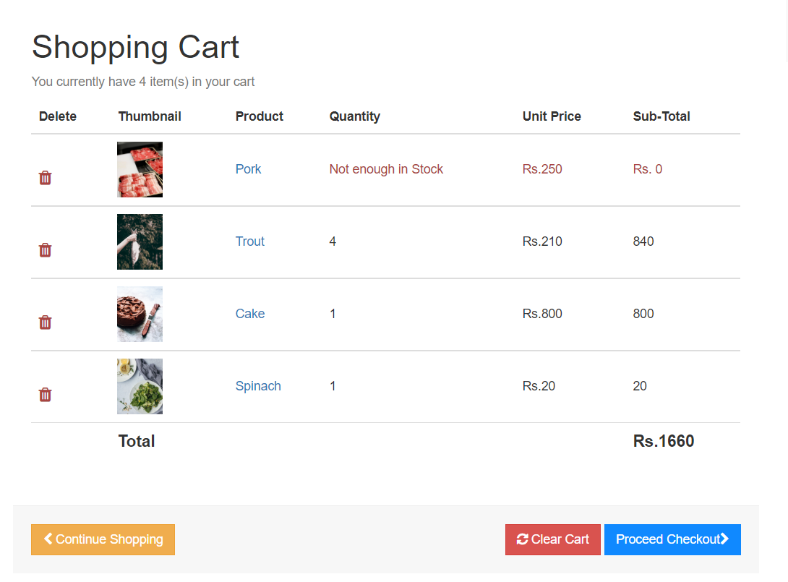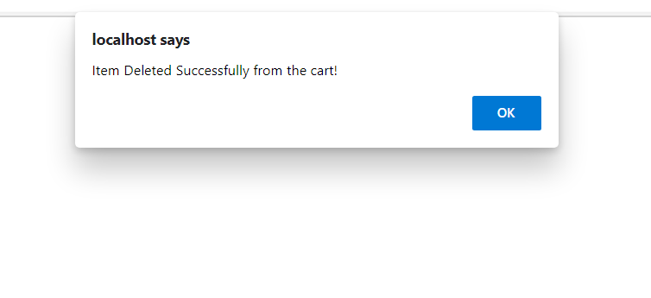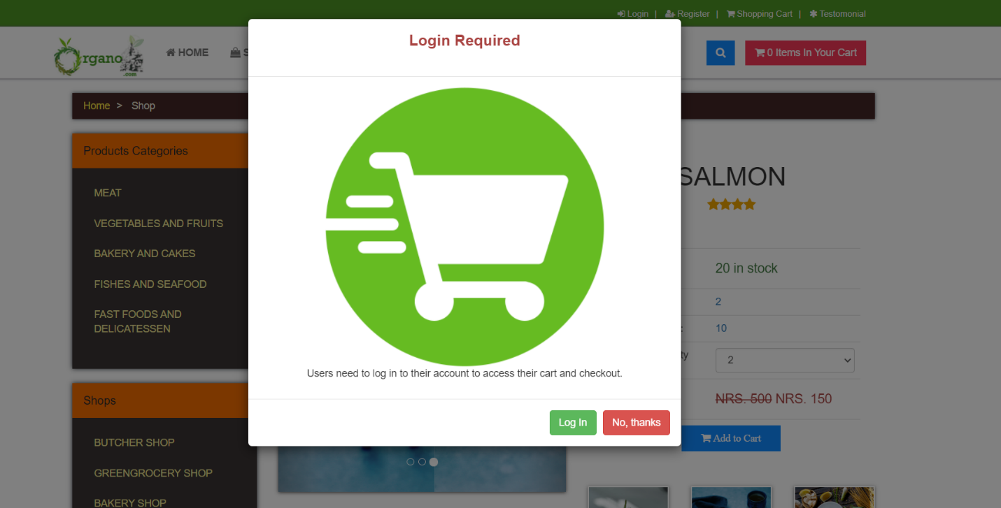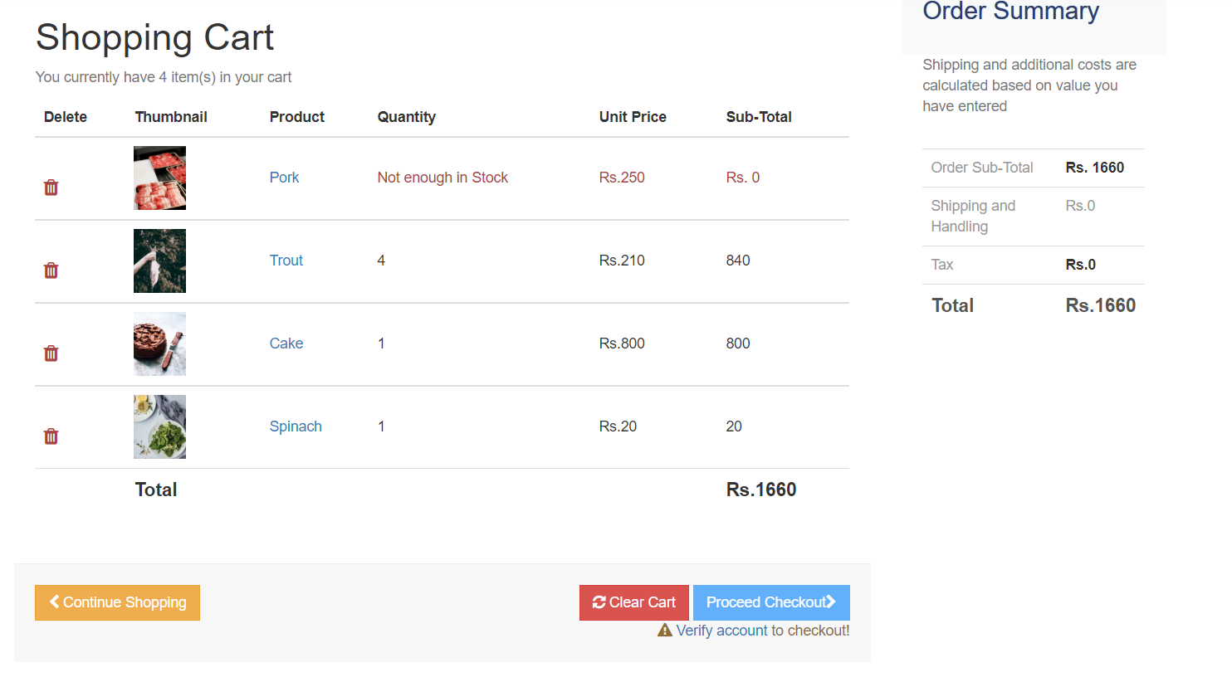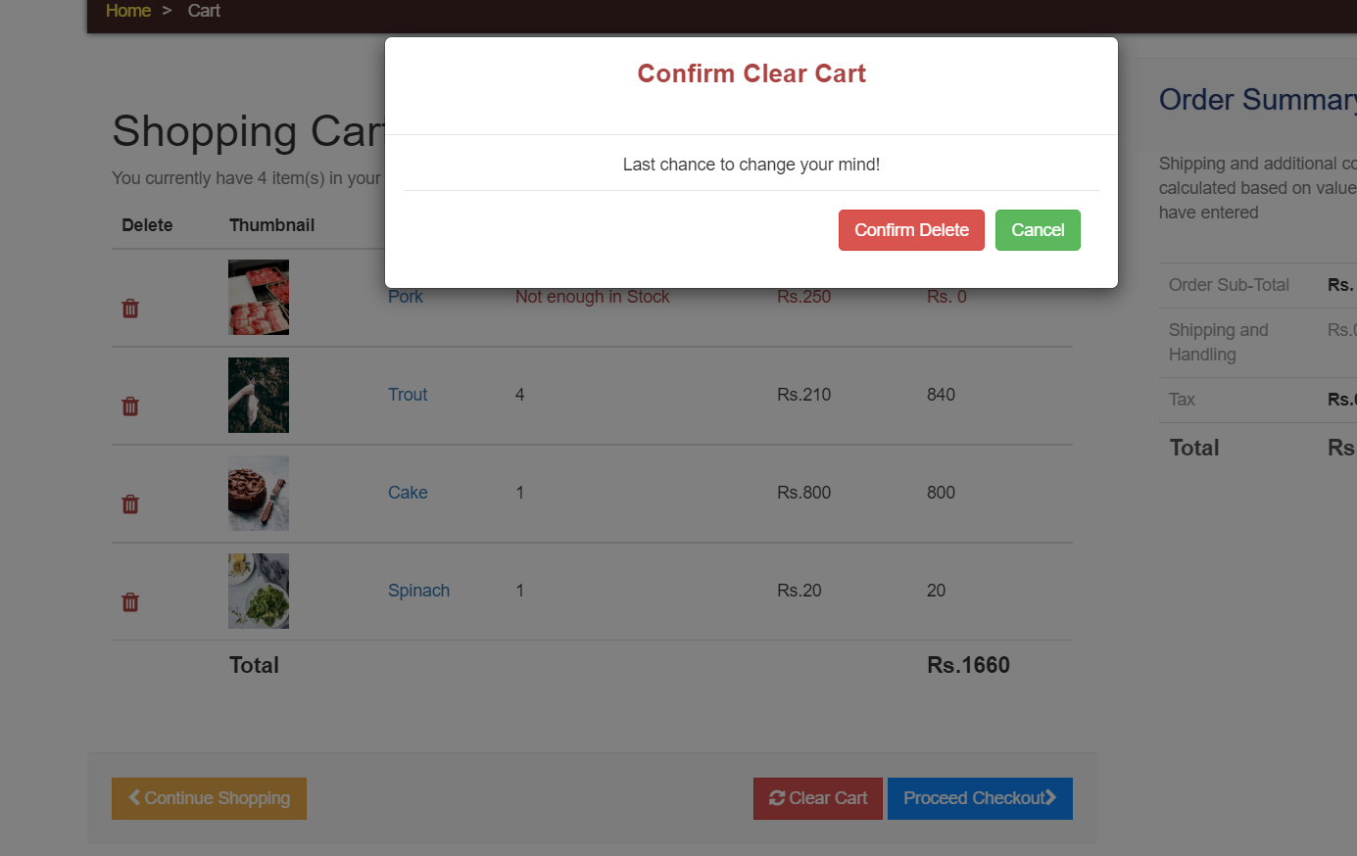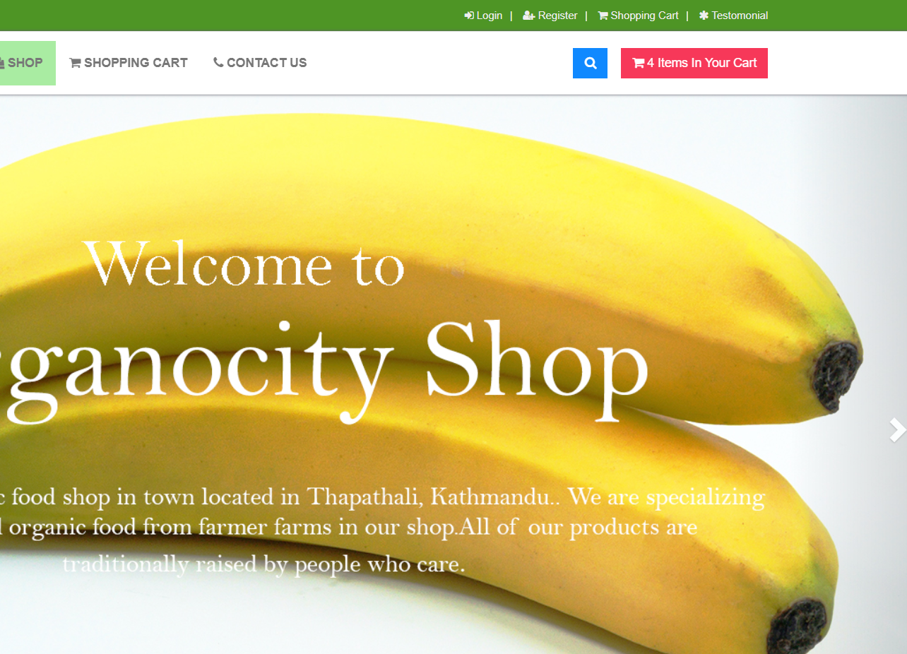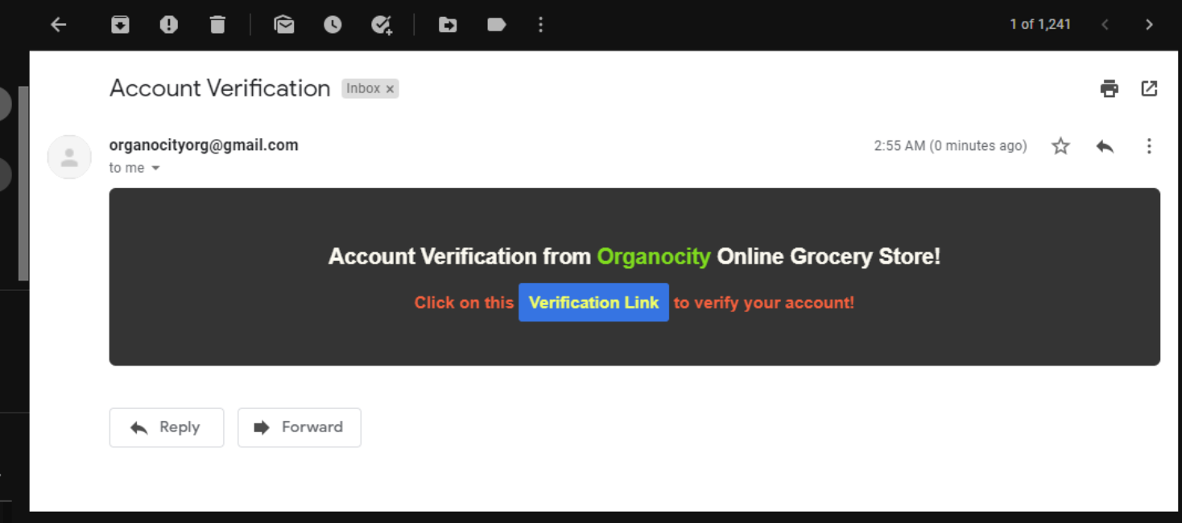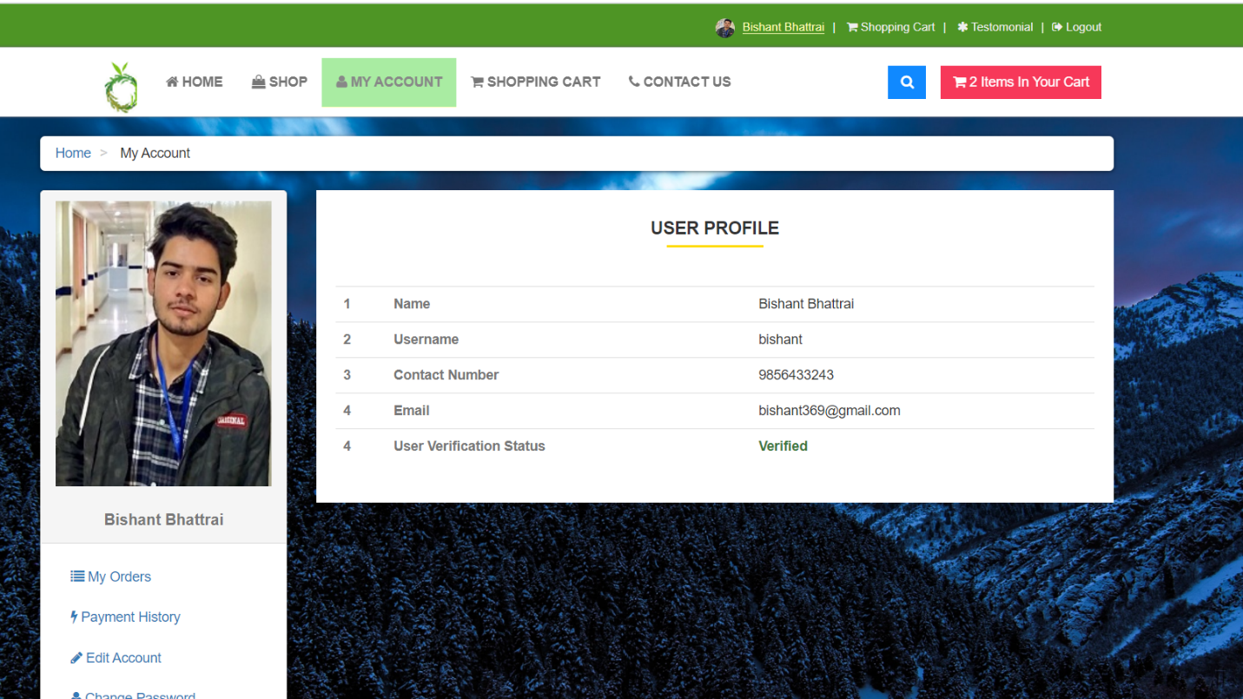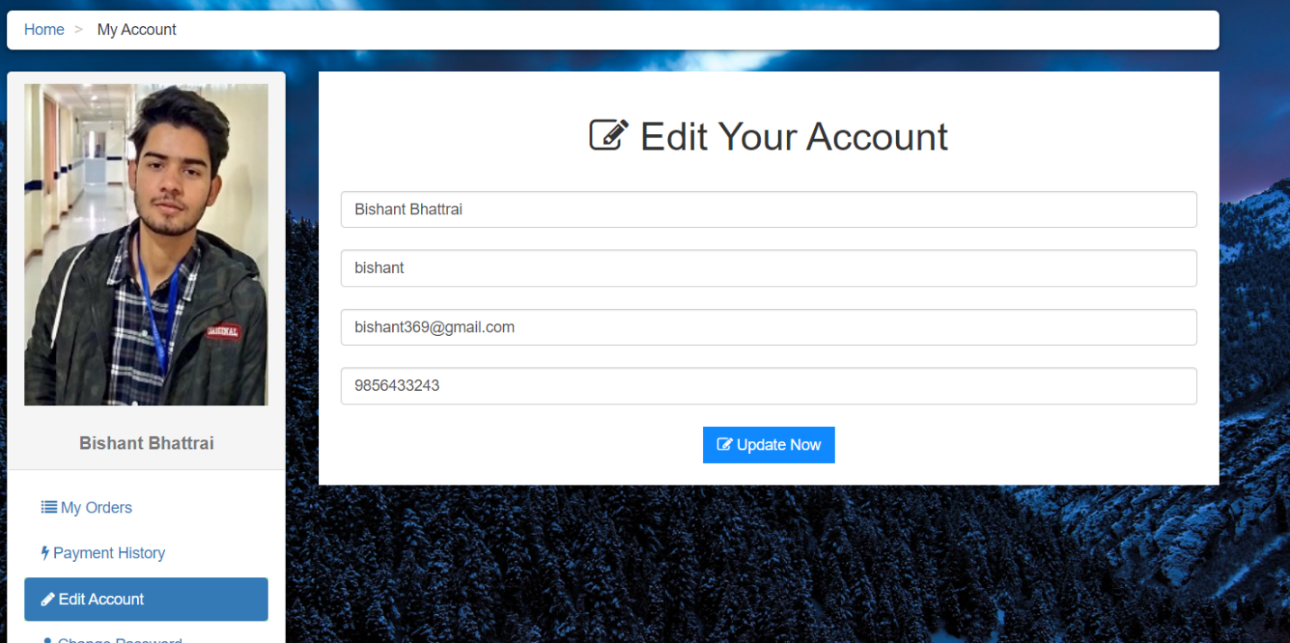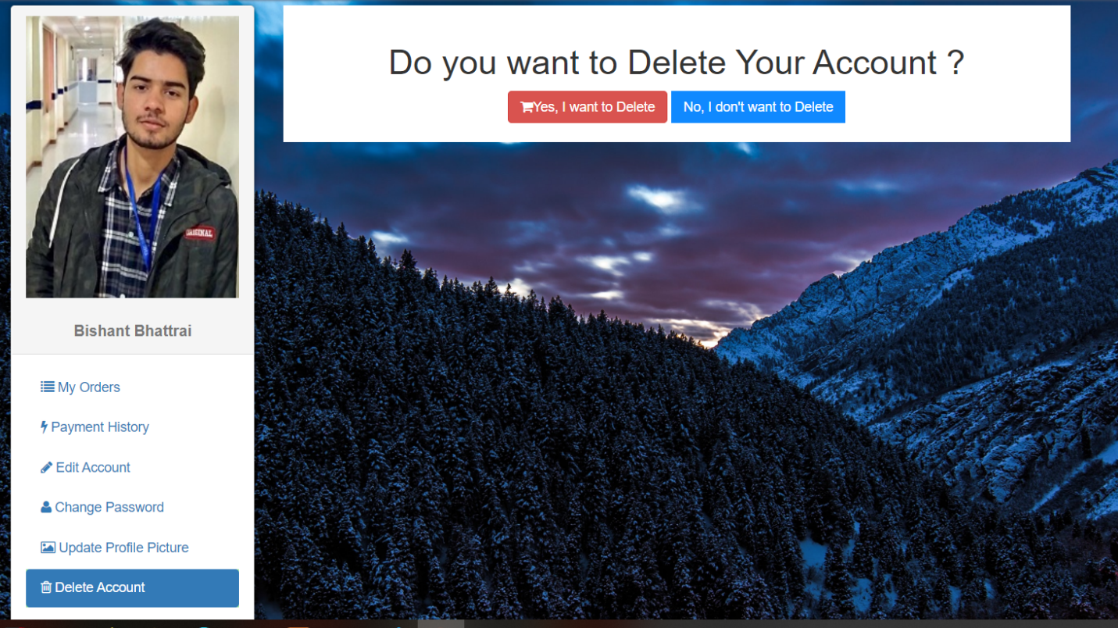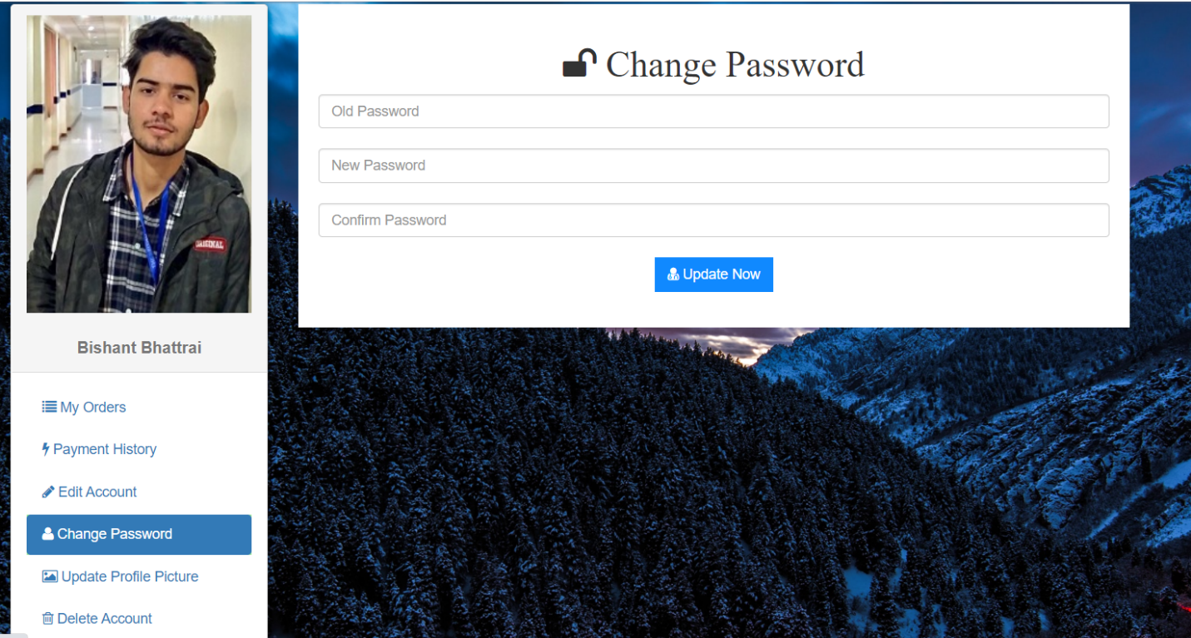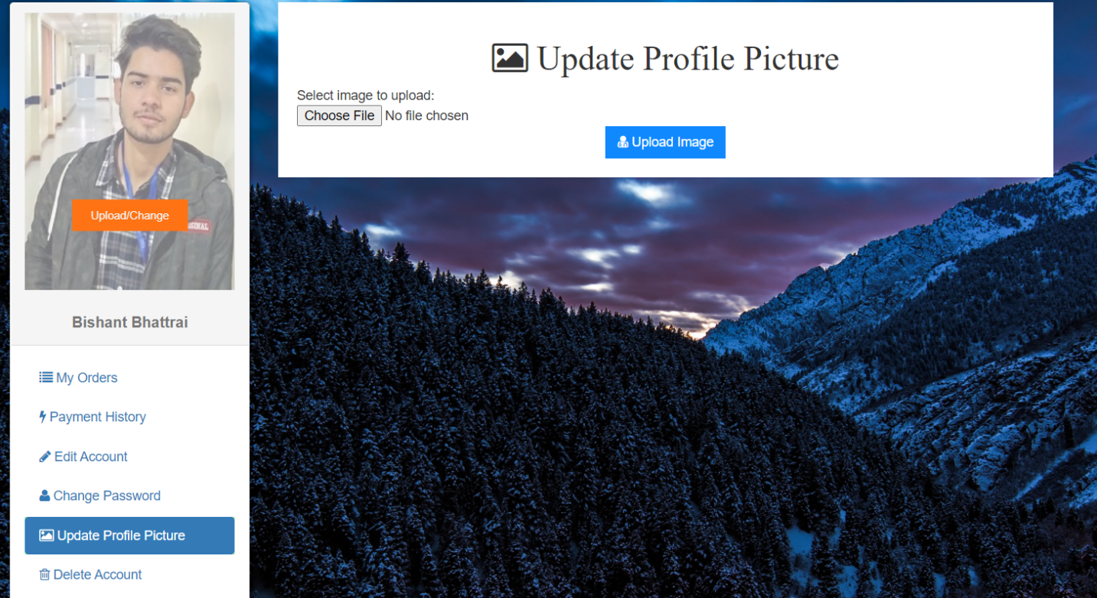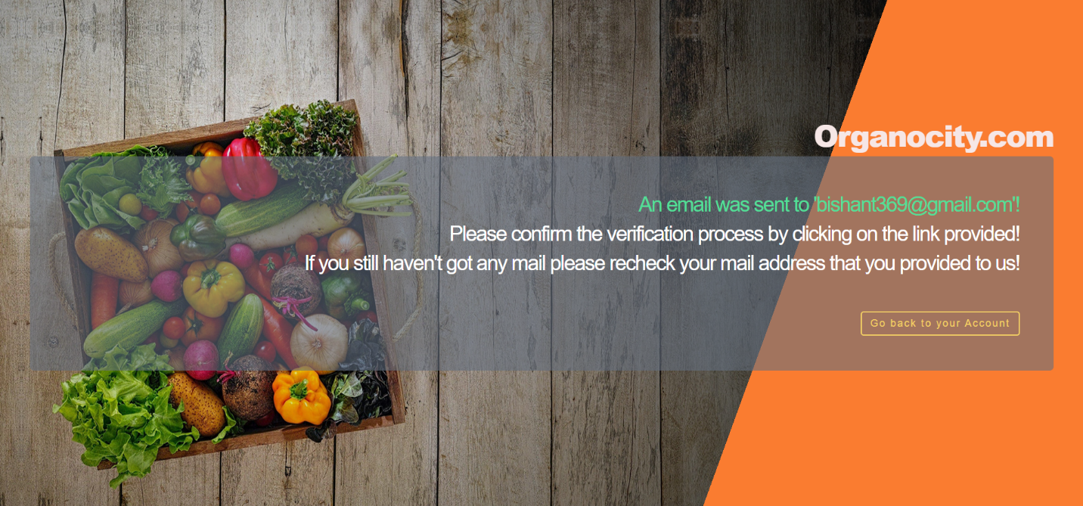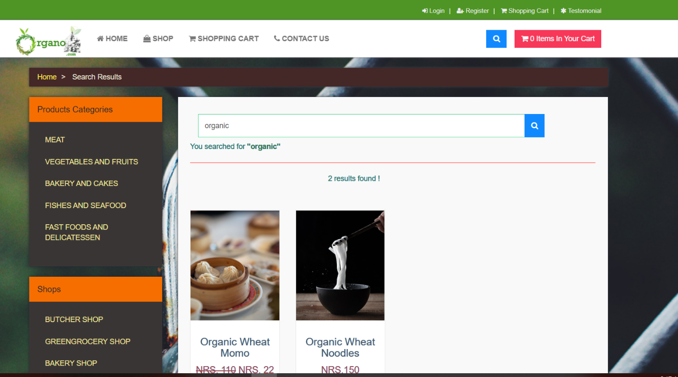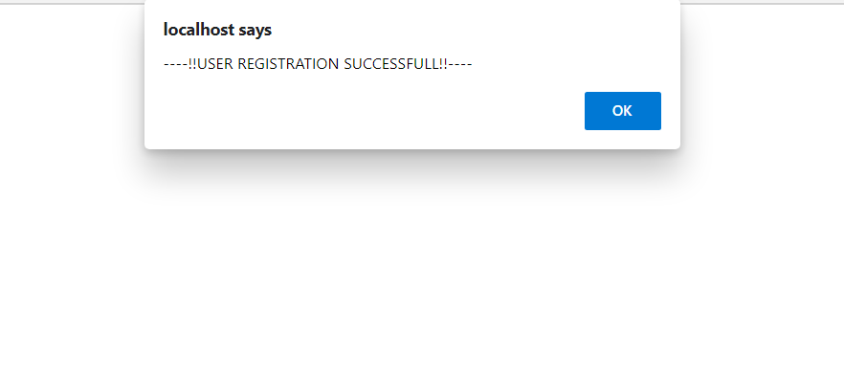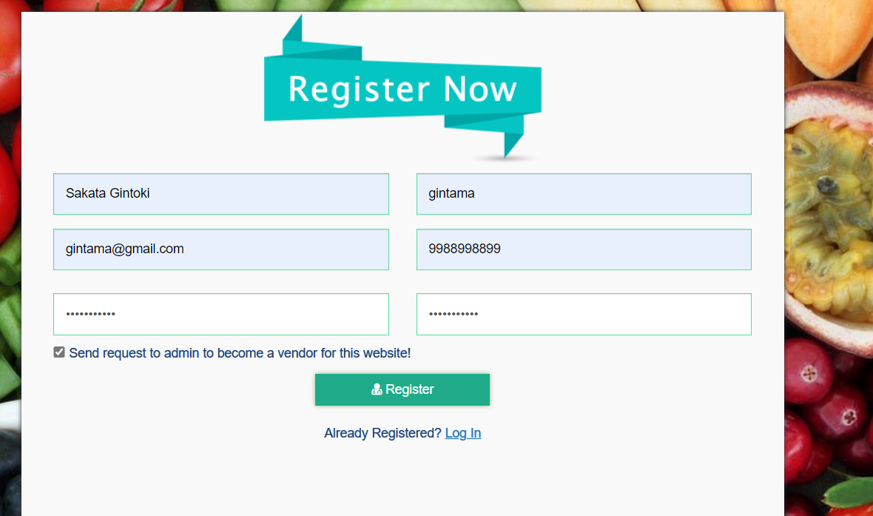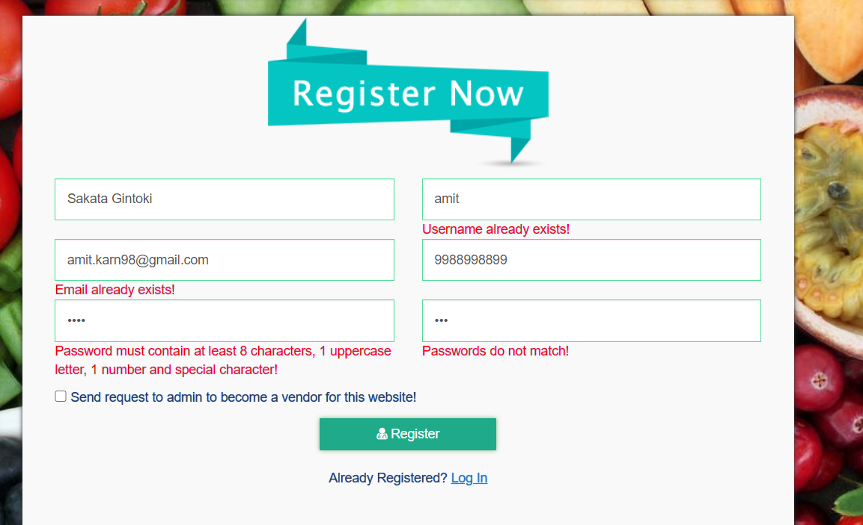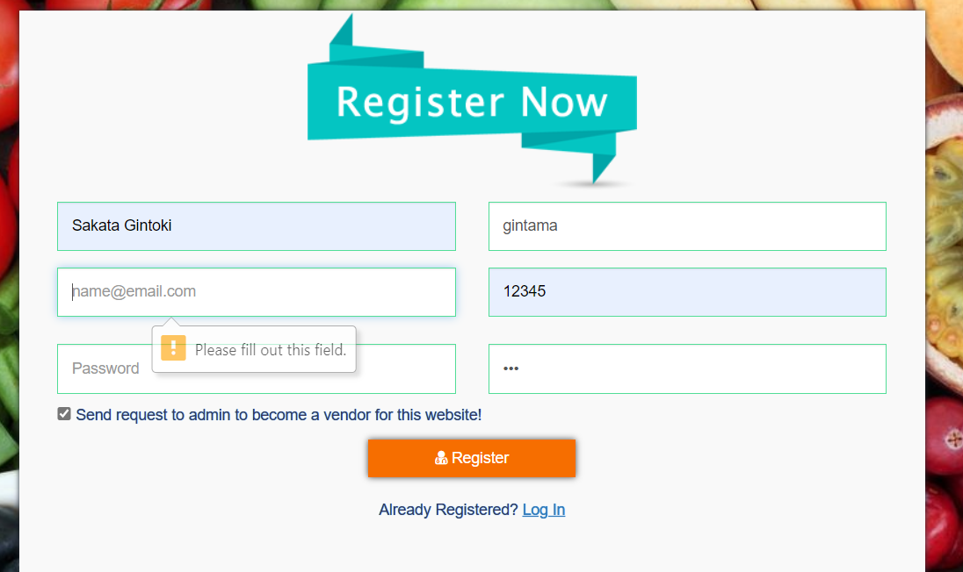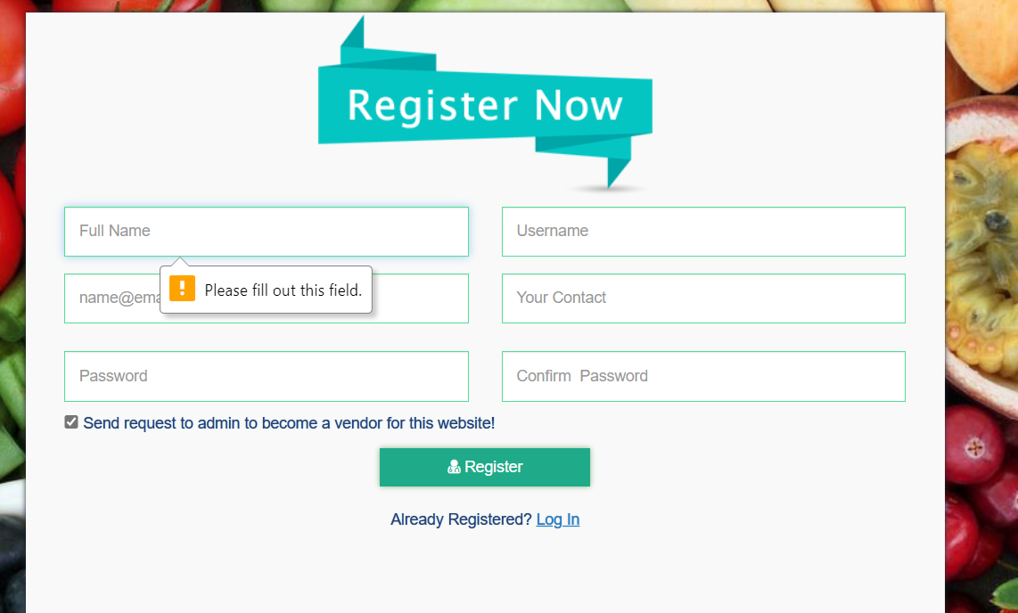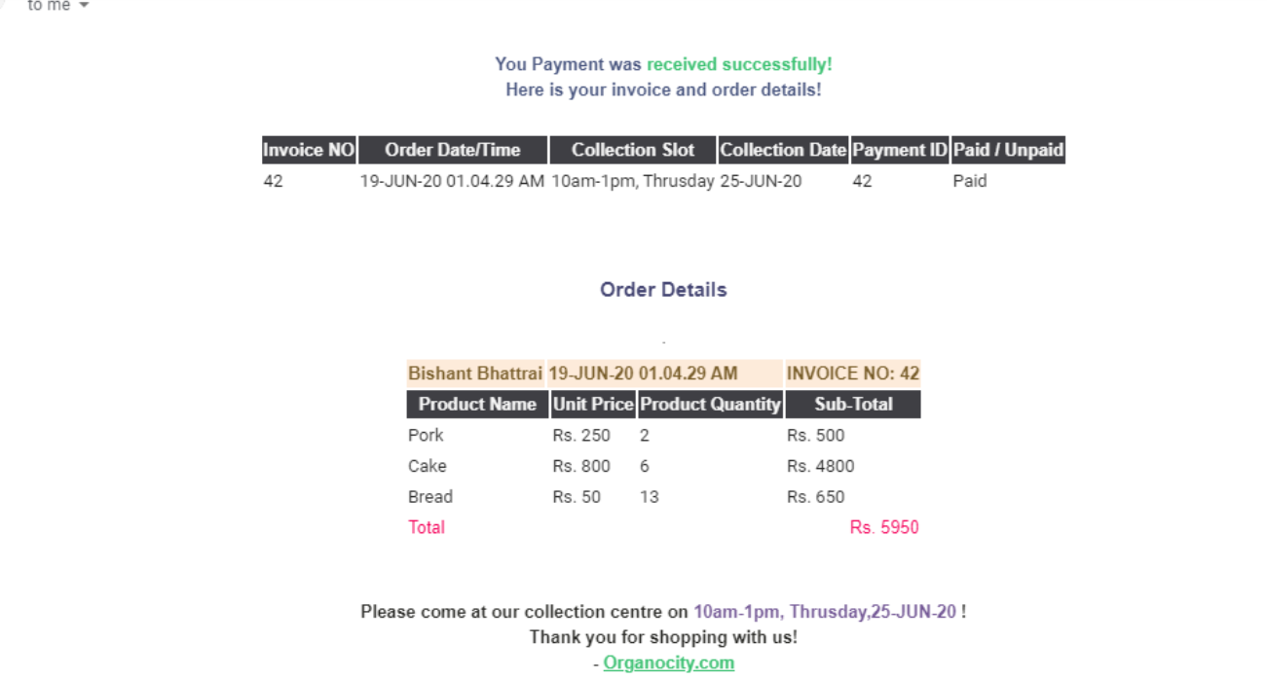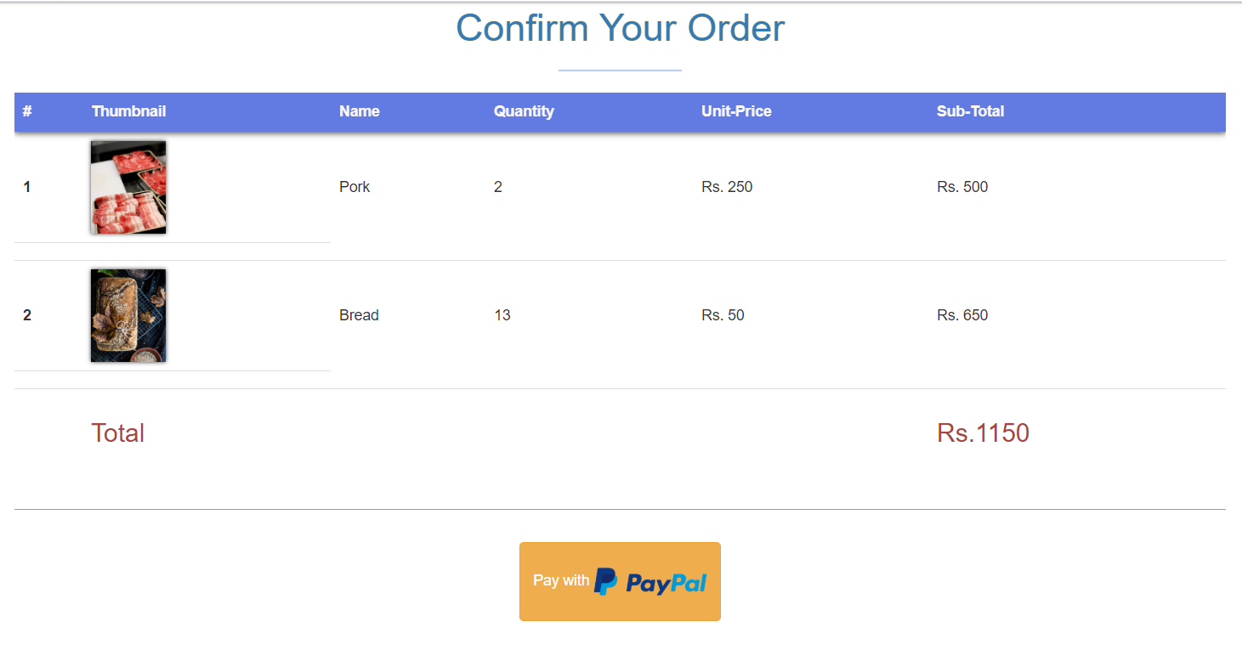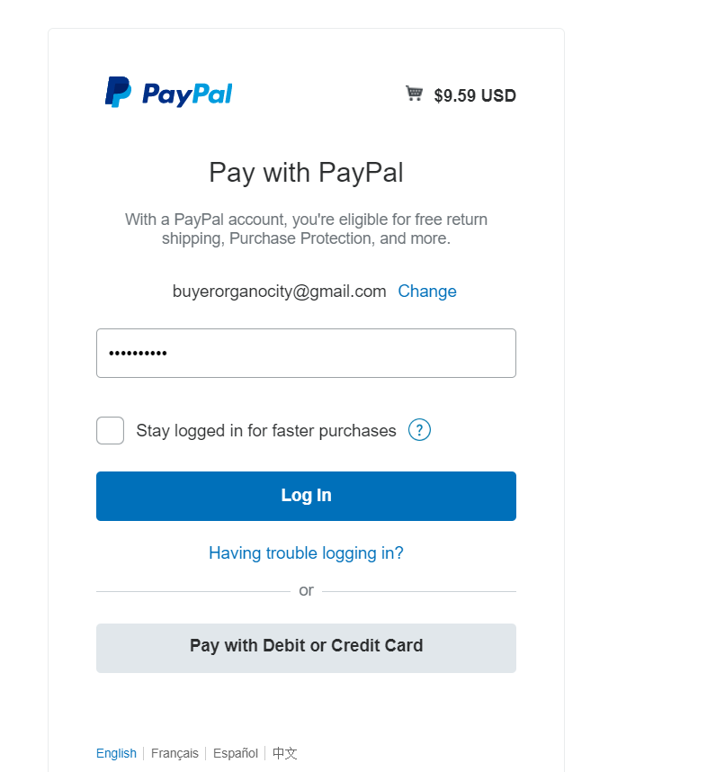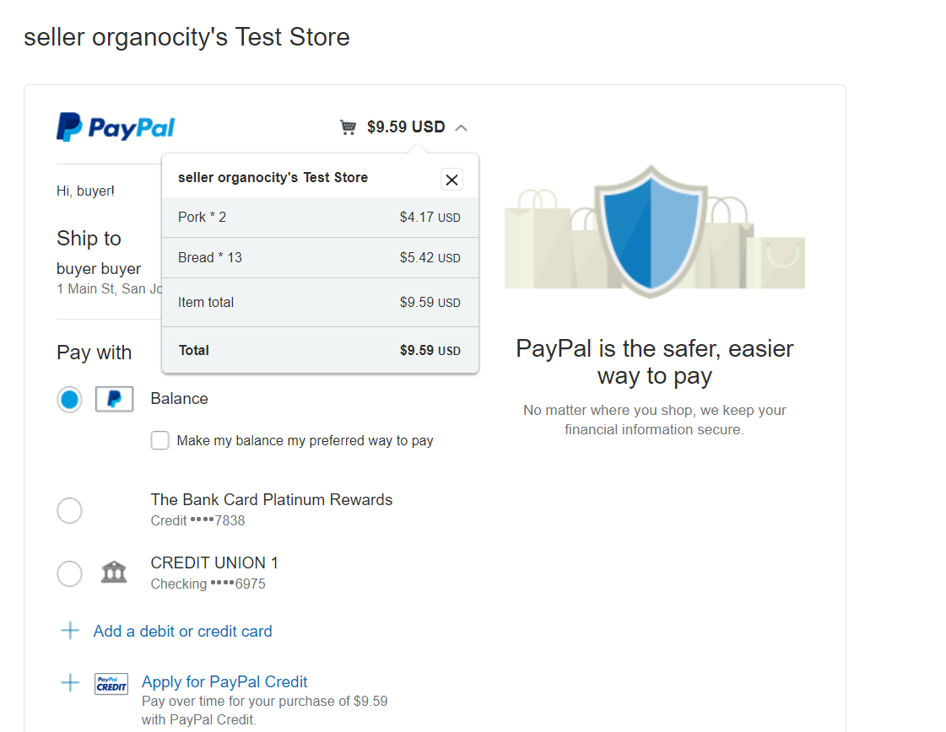

**Trader Oracle**

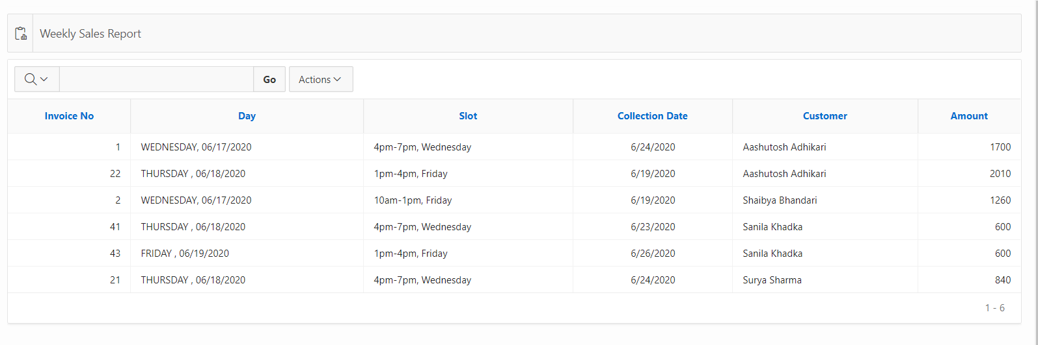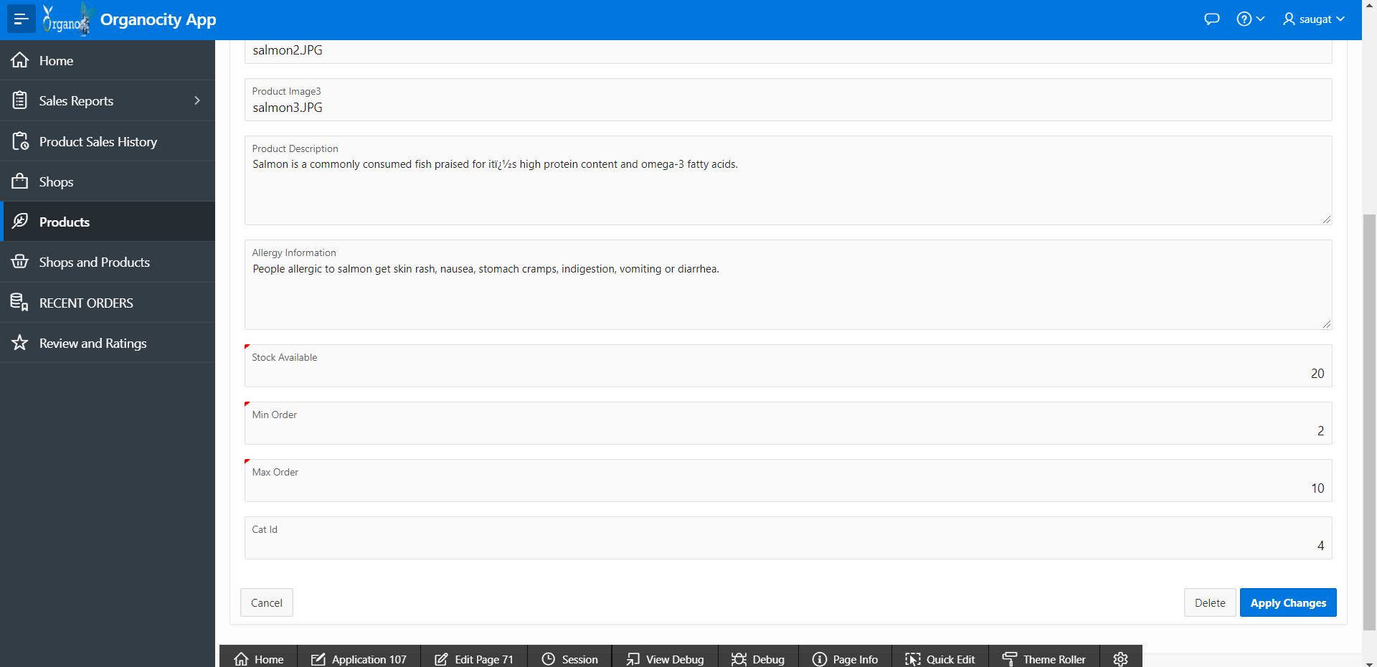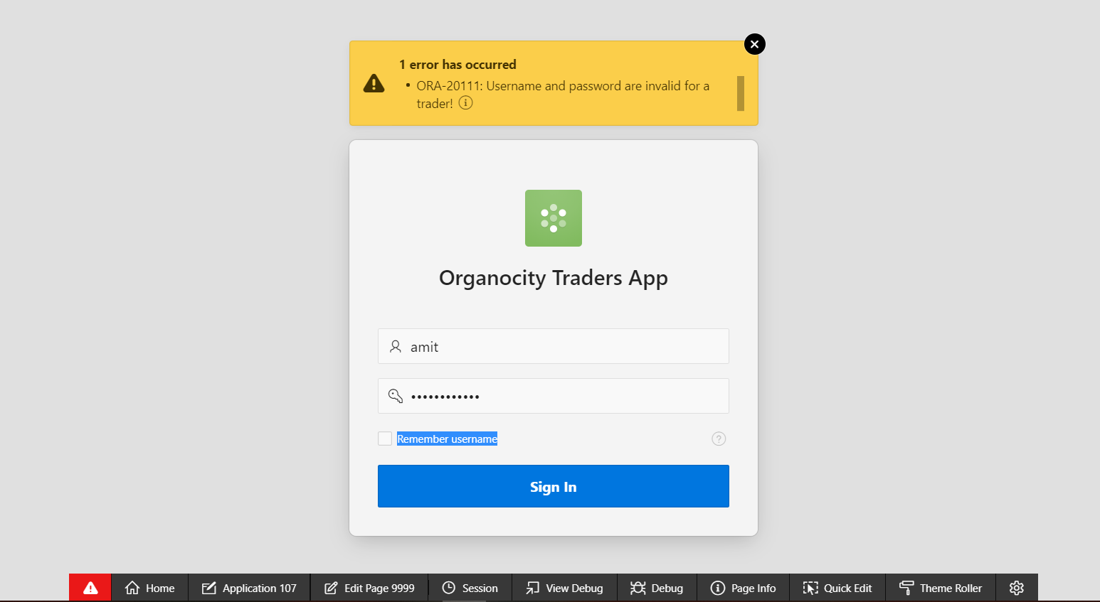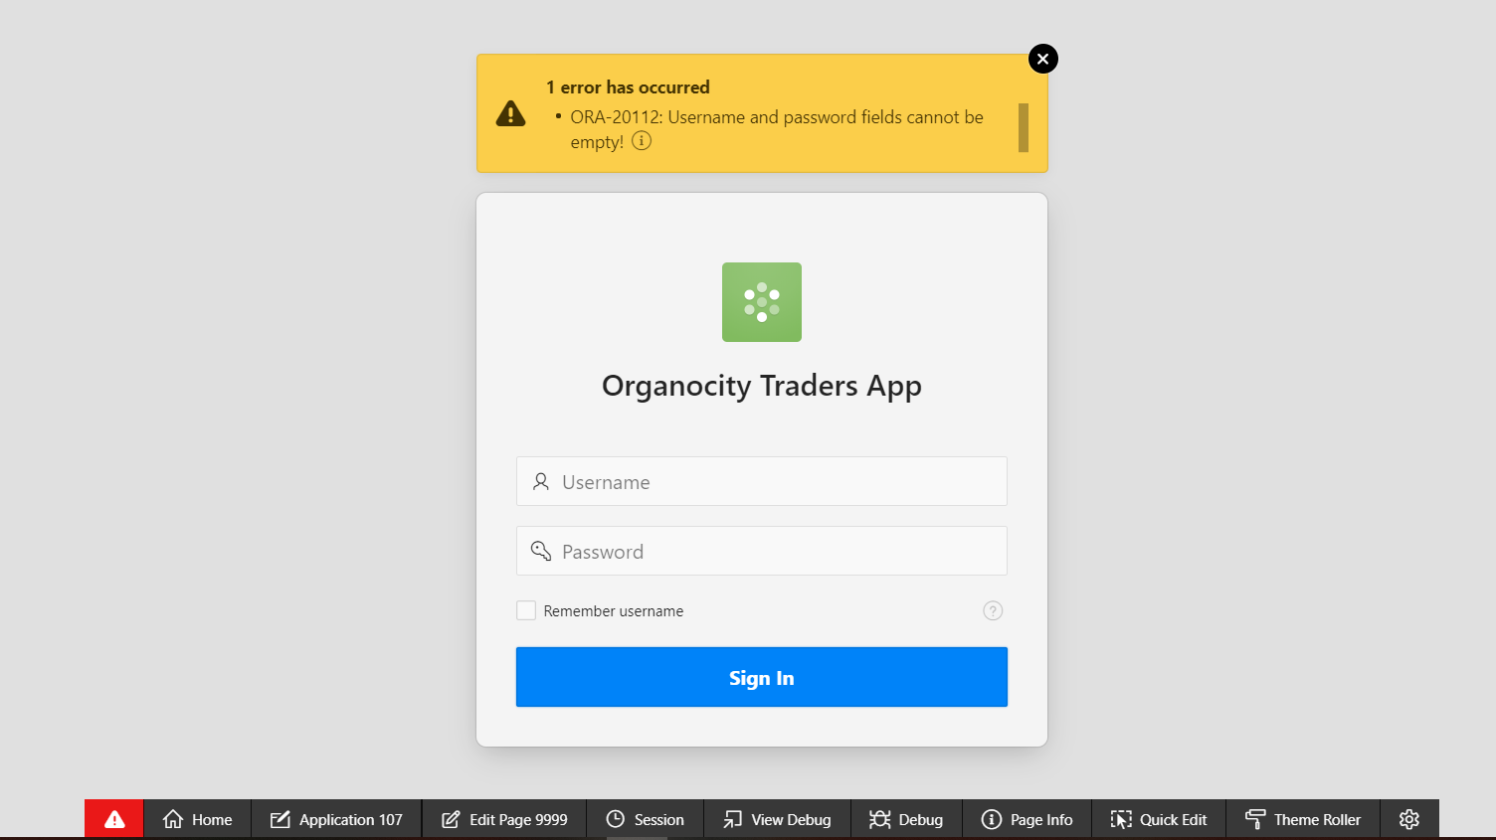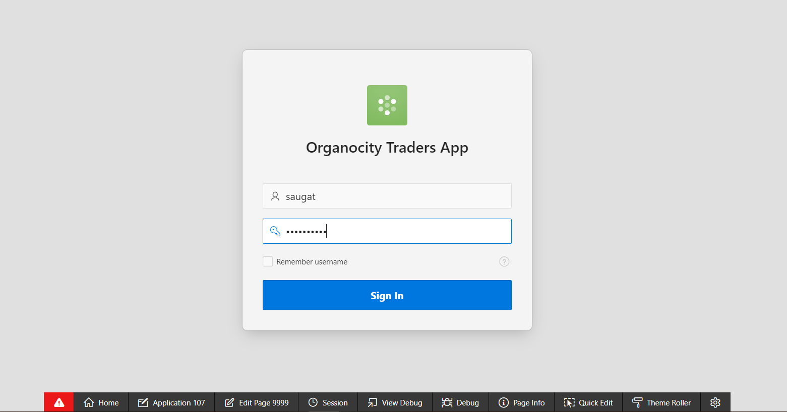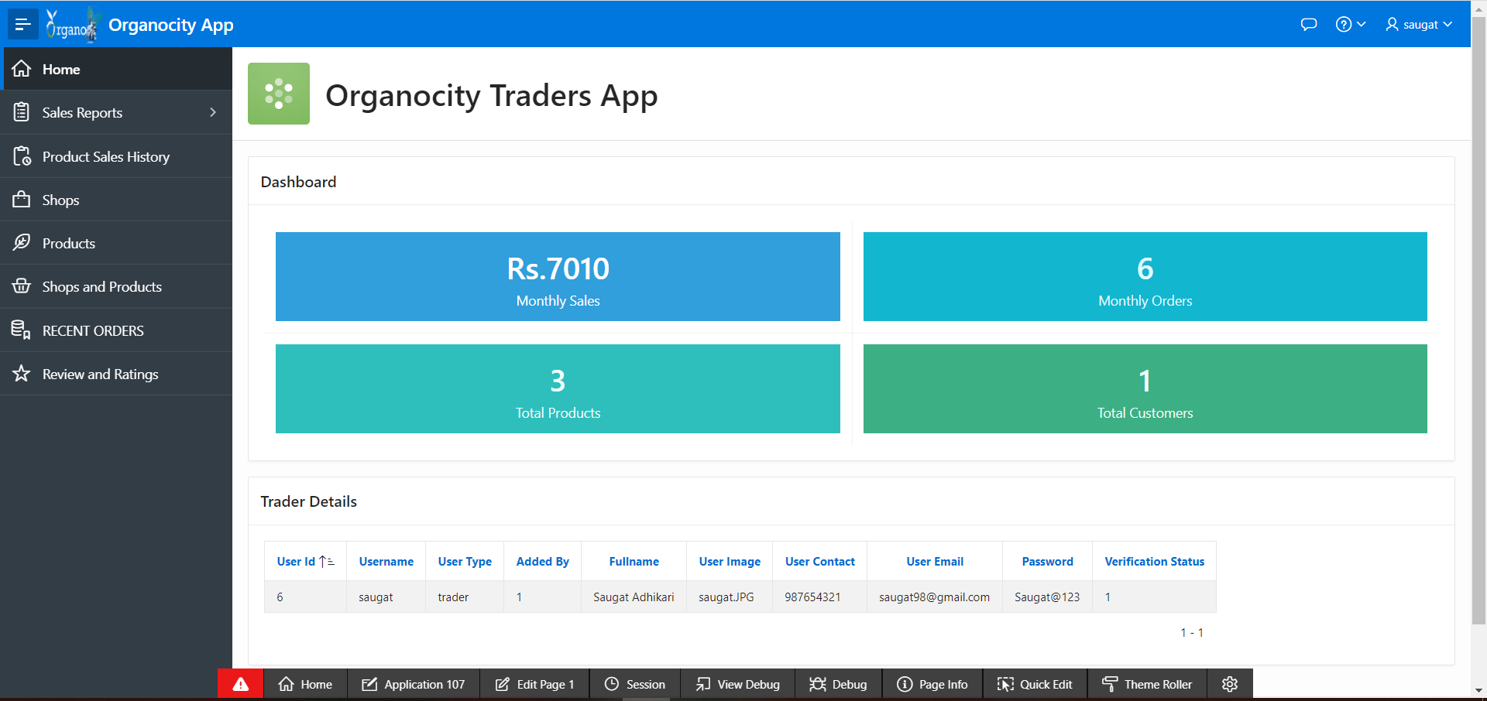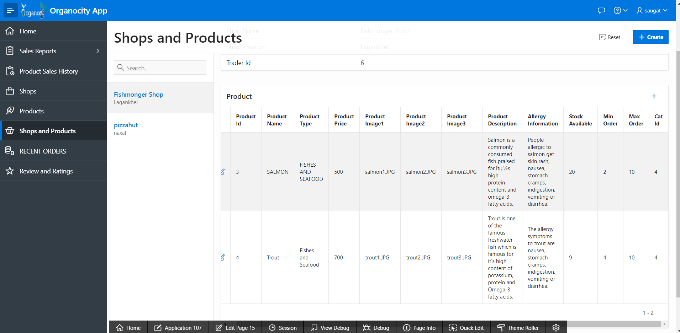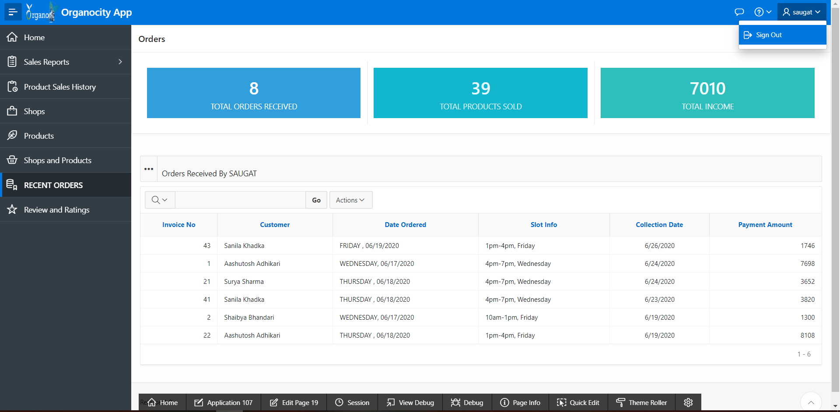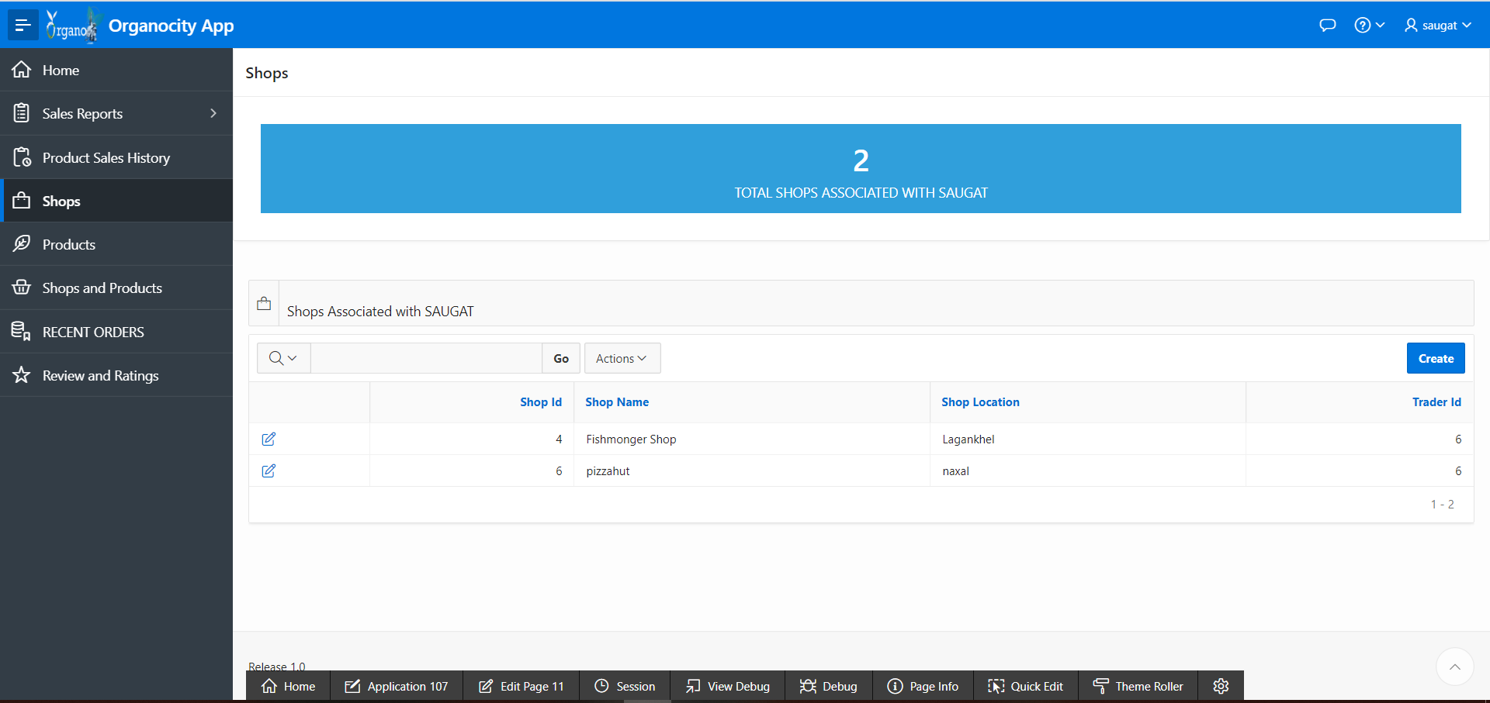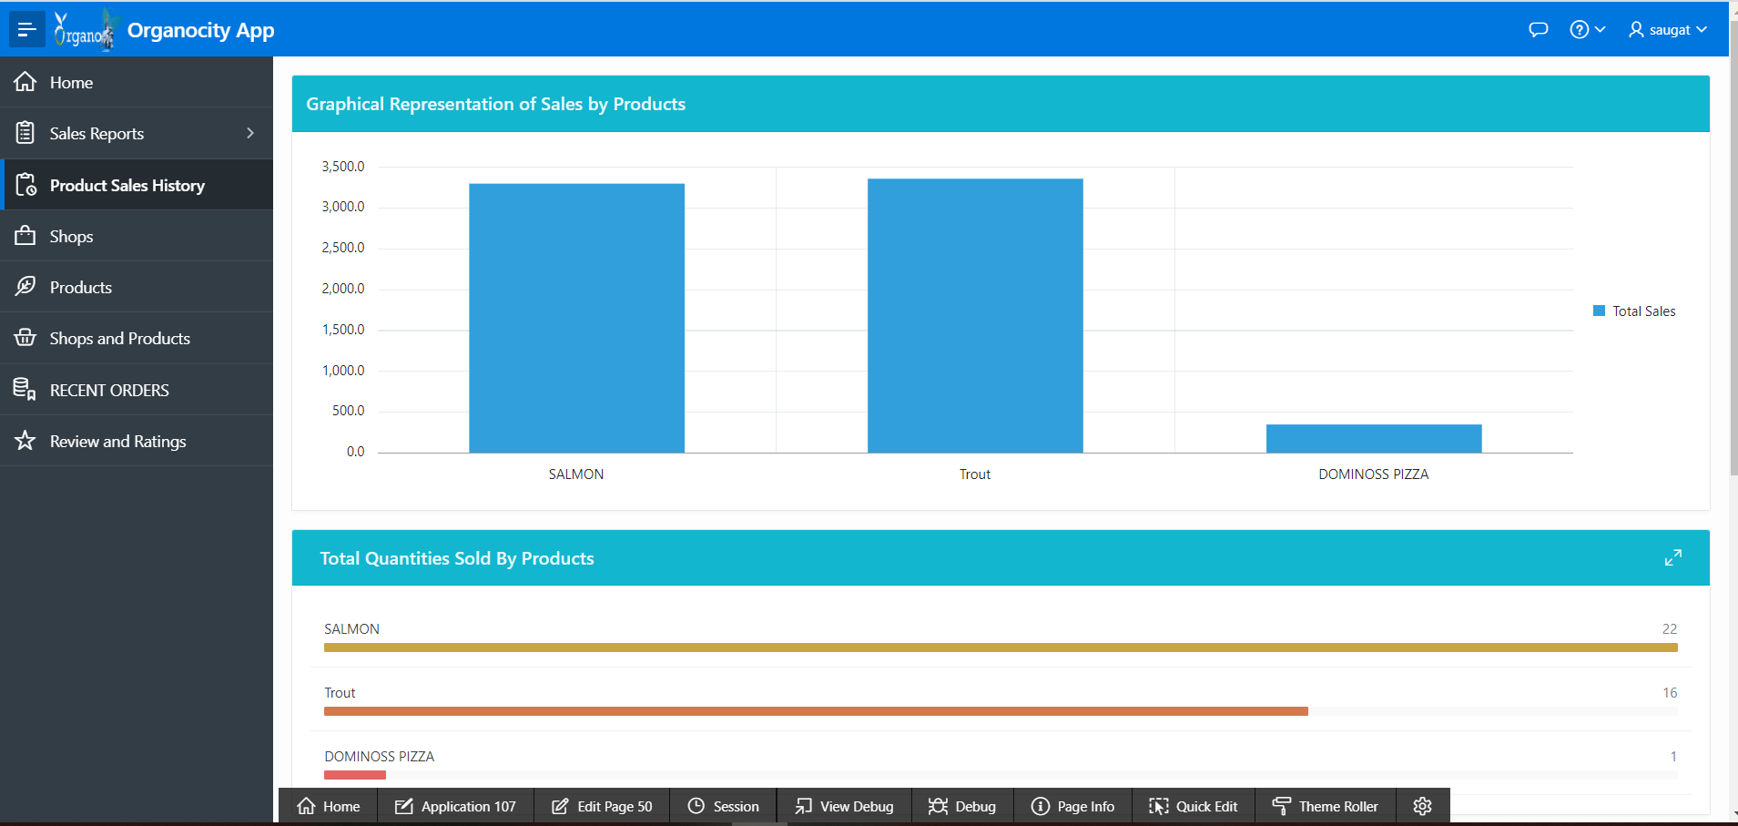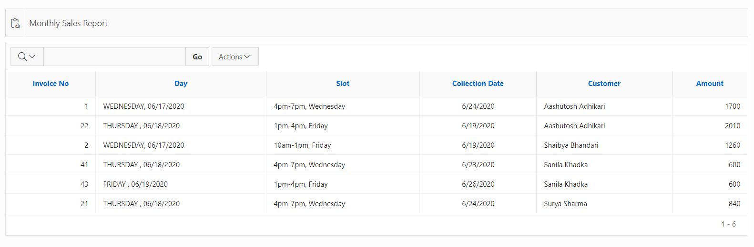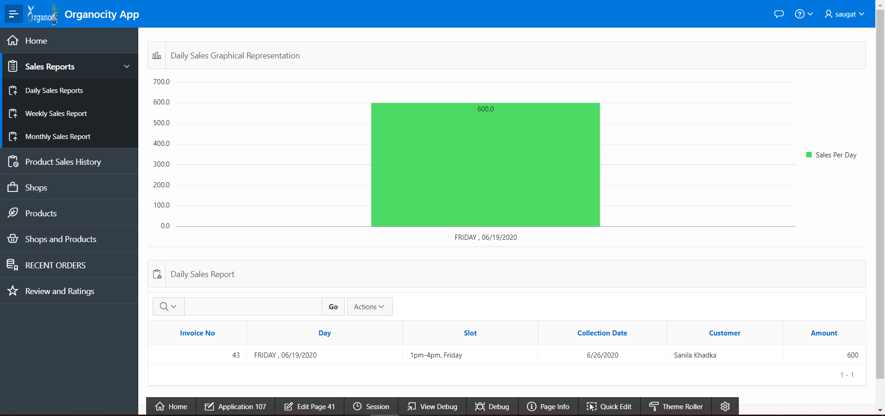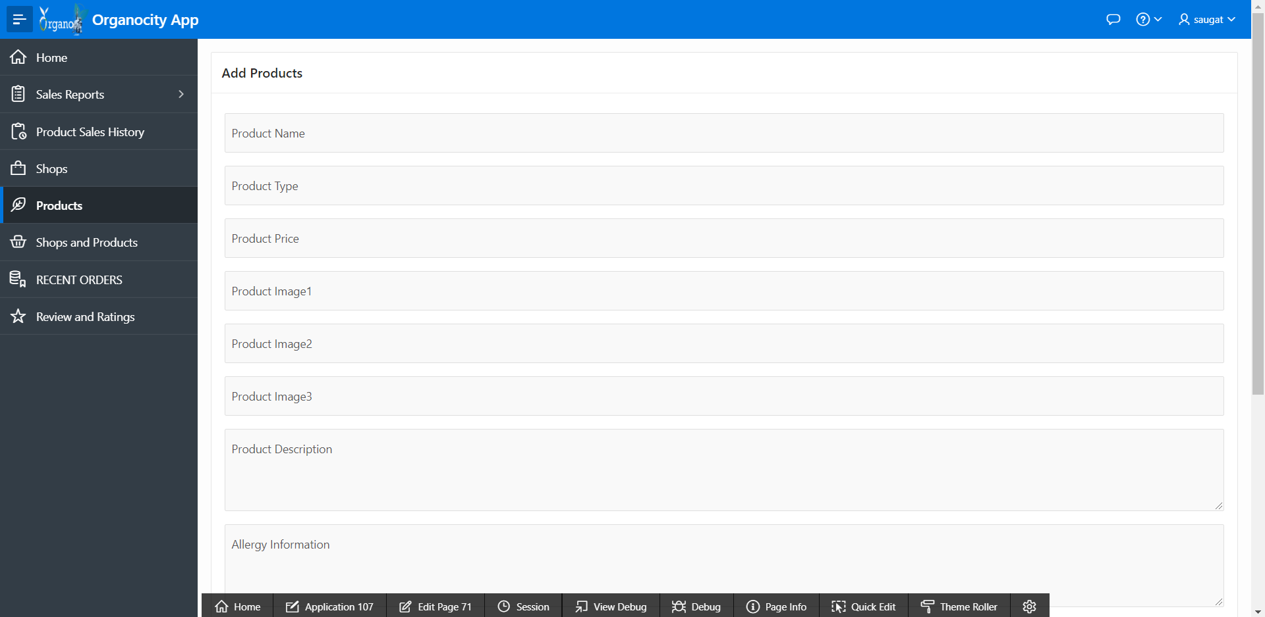

**Trader PHP**

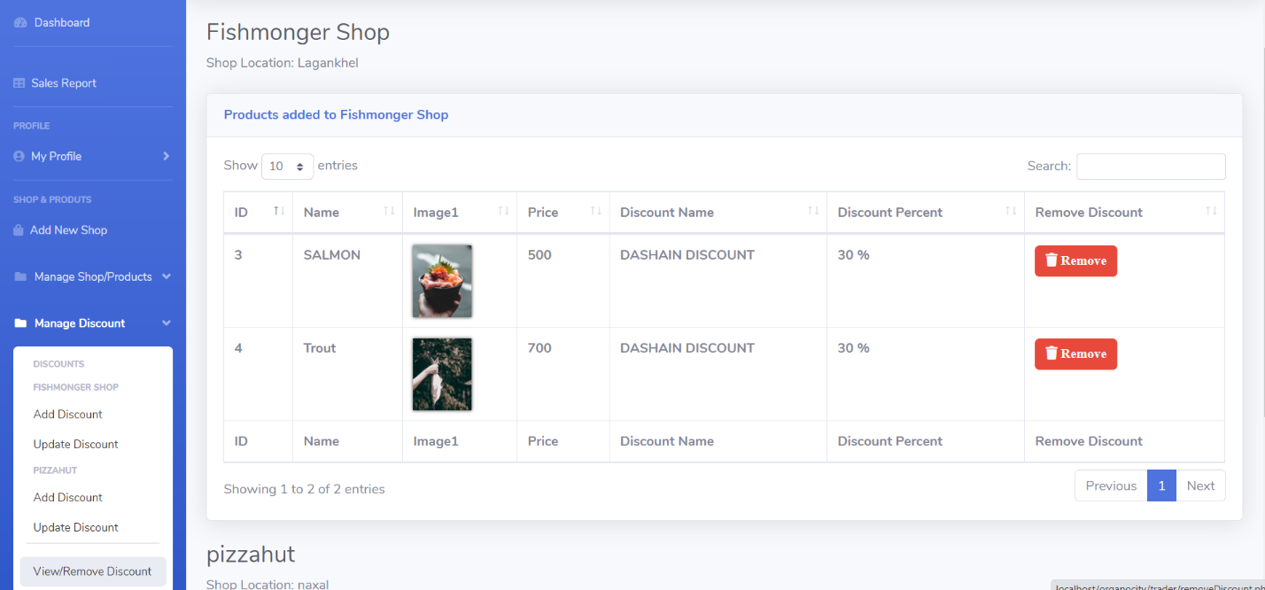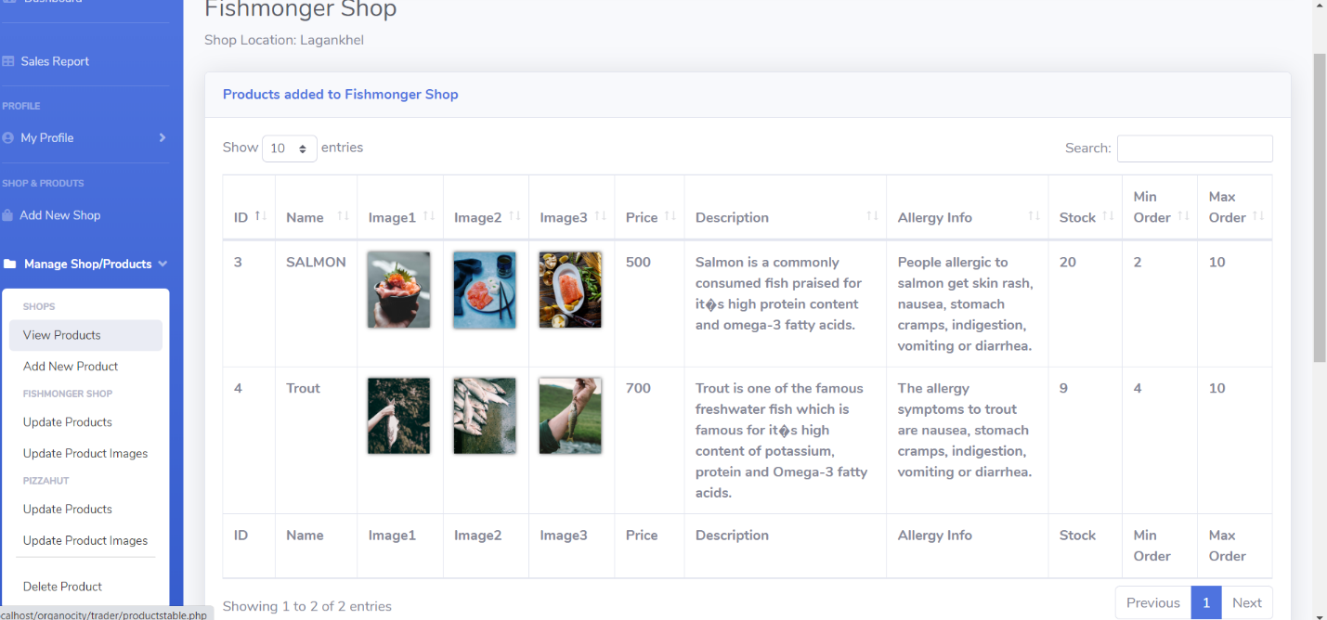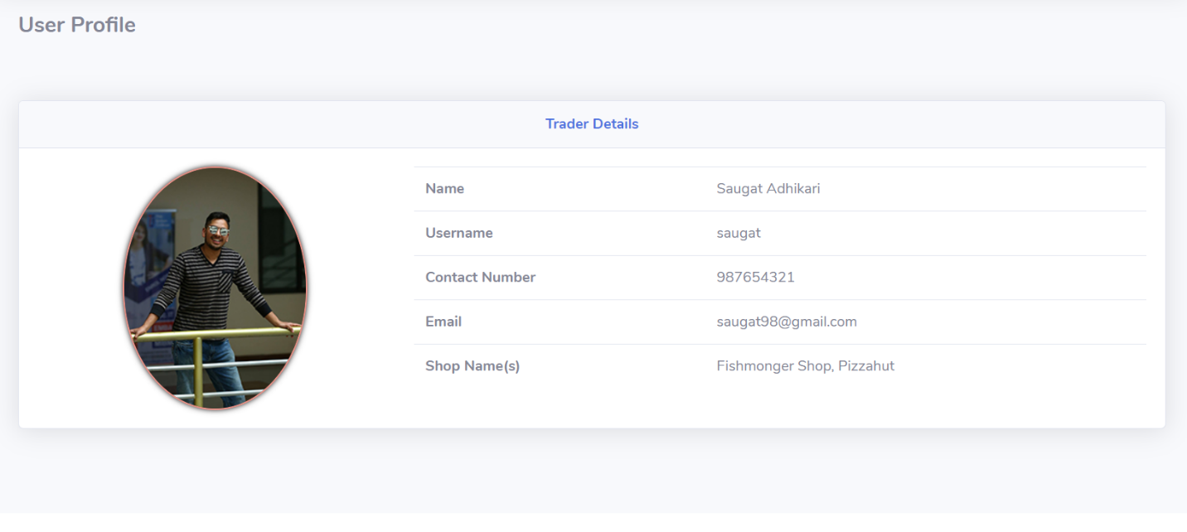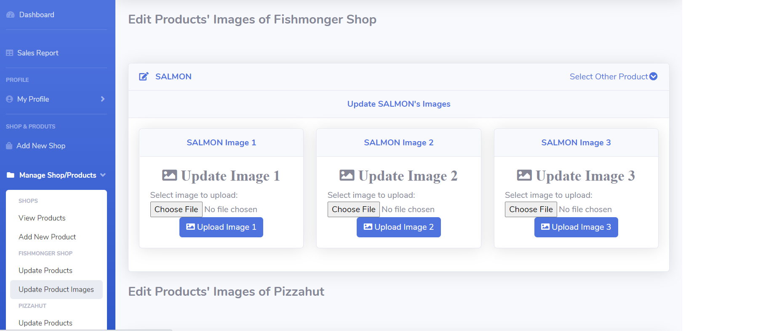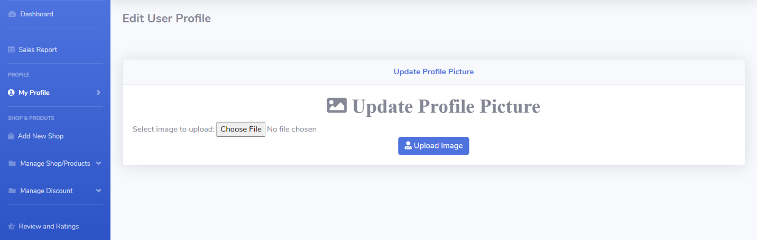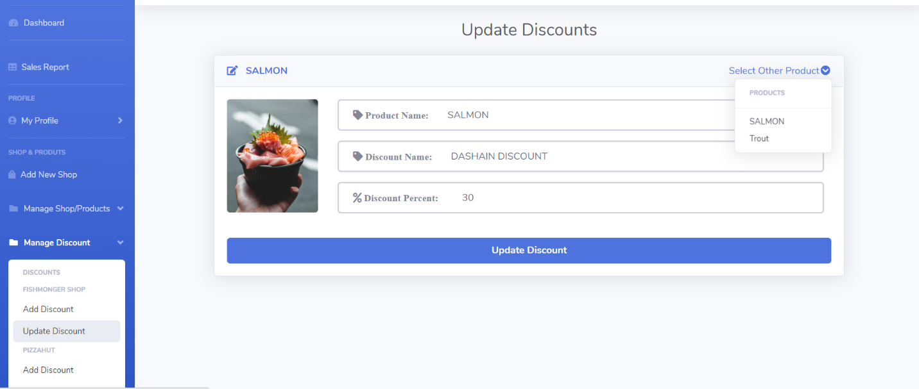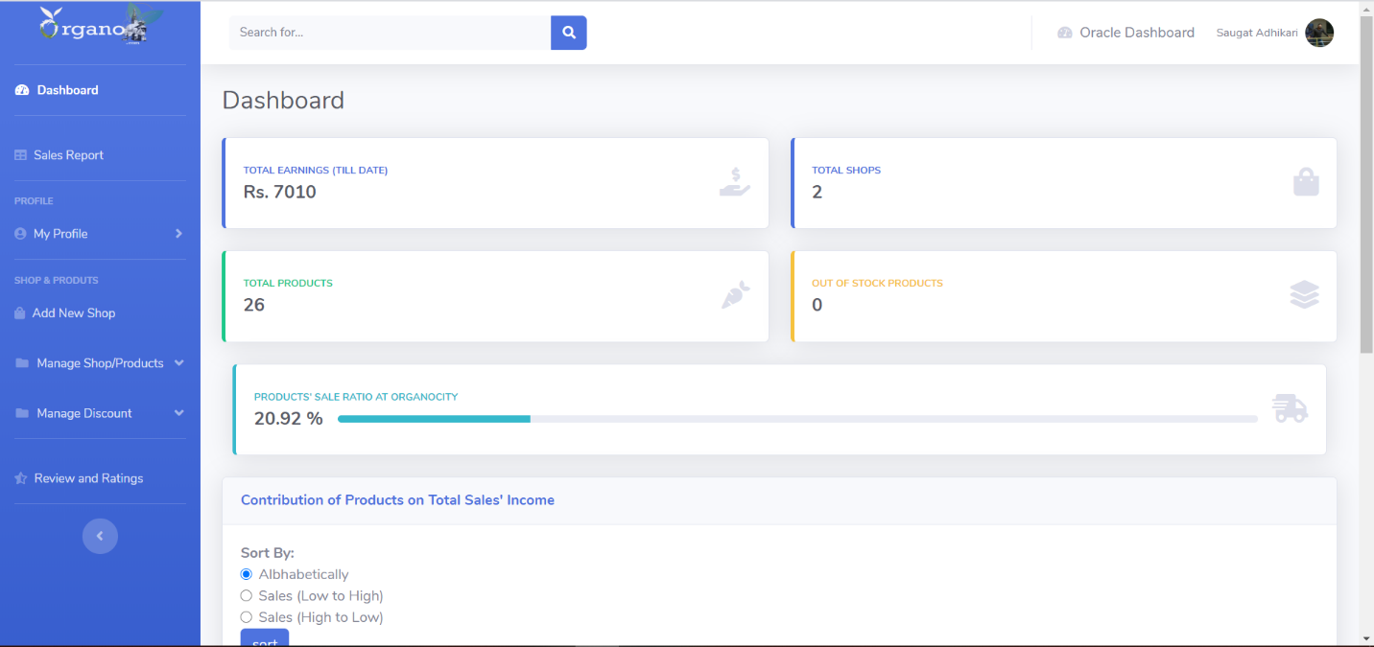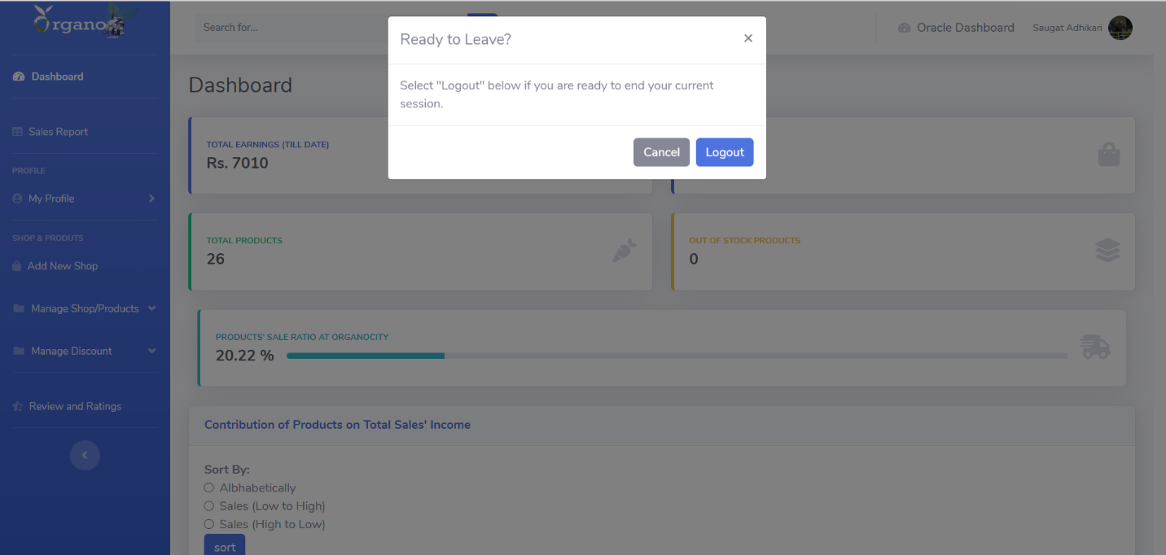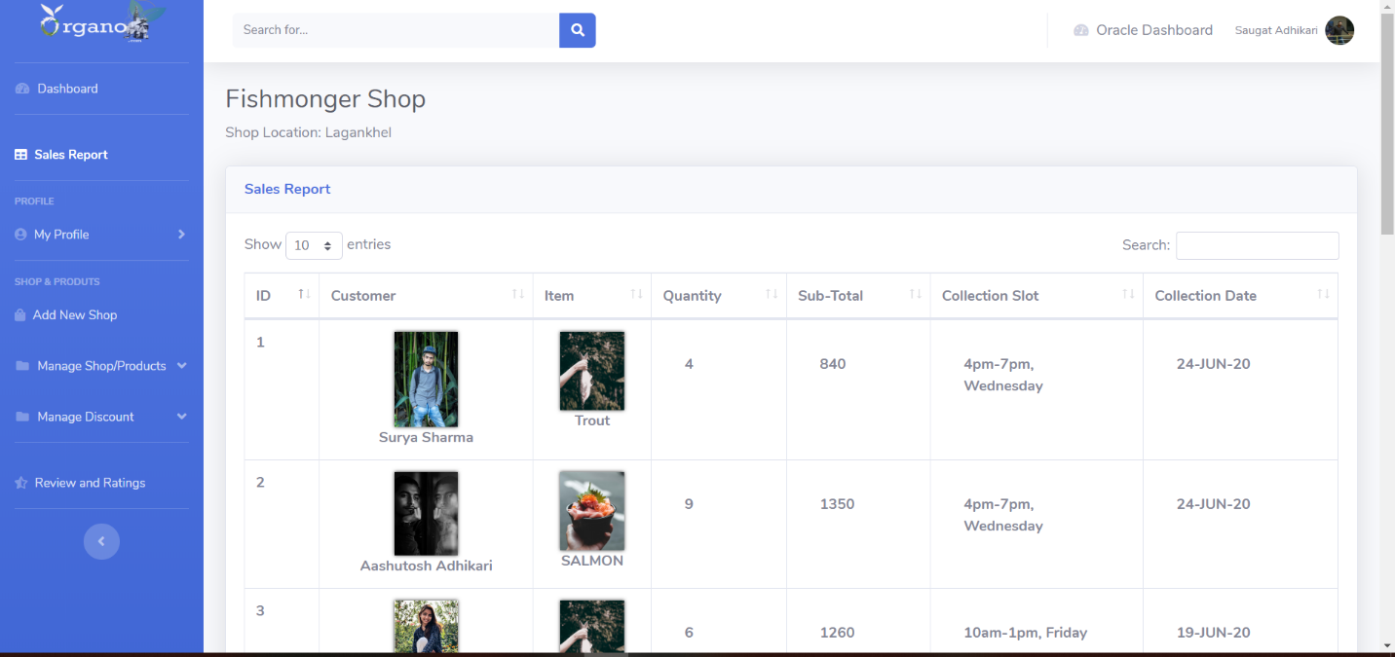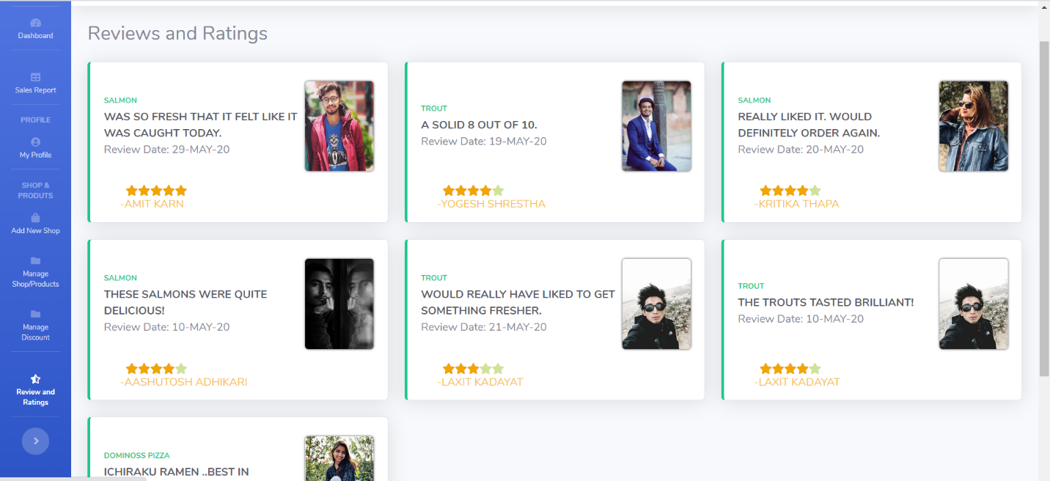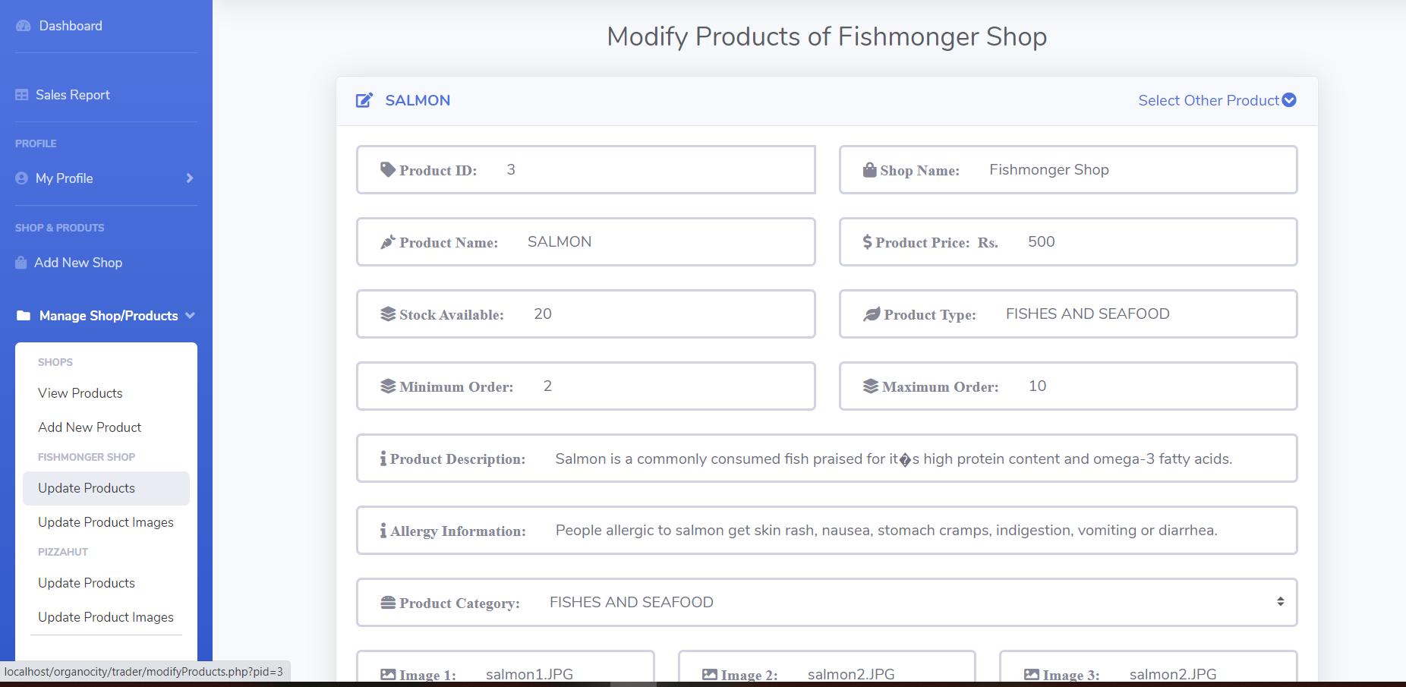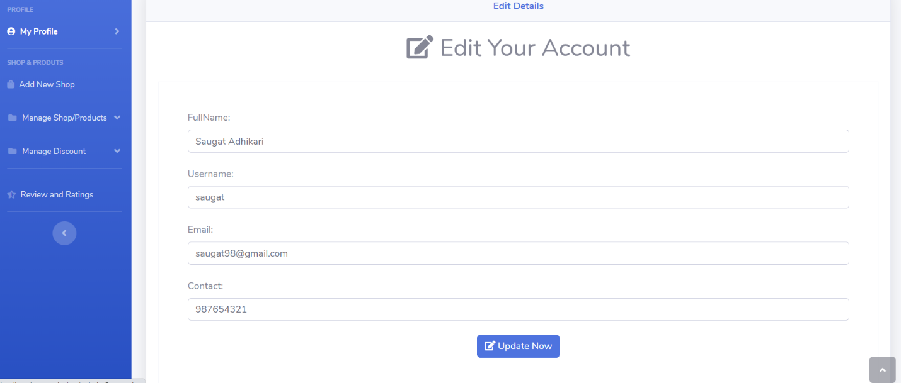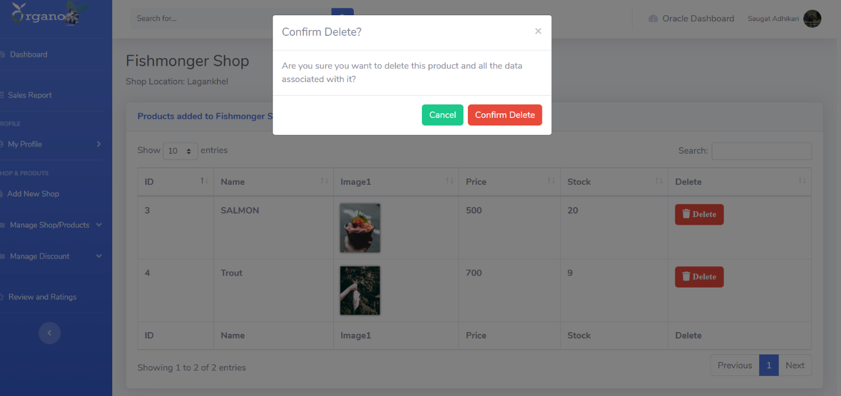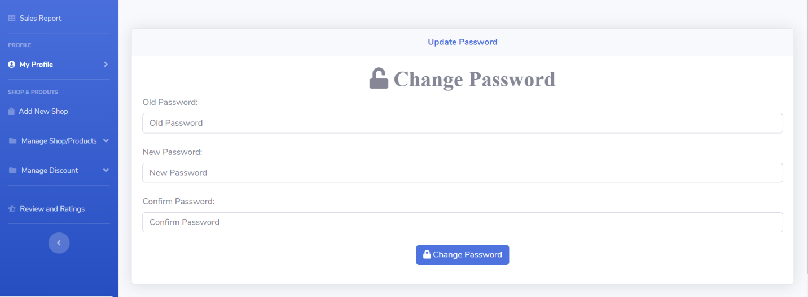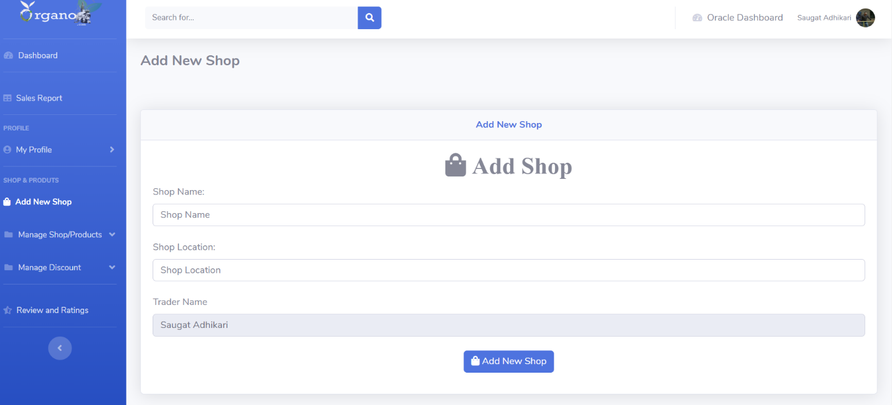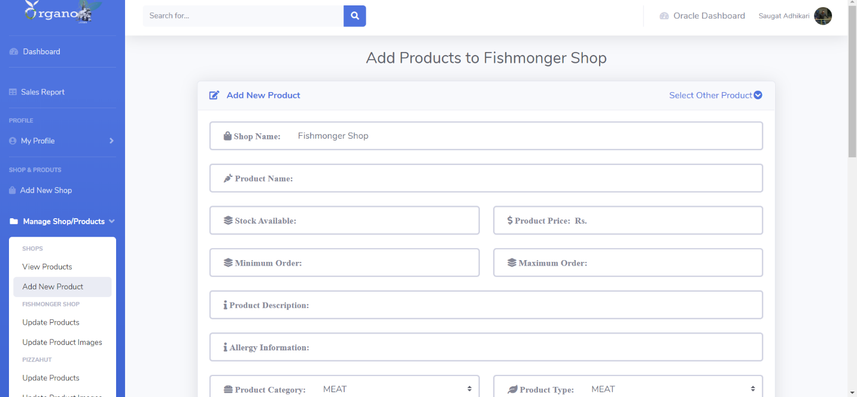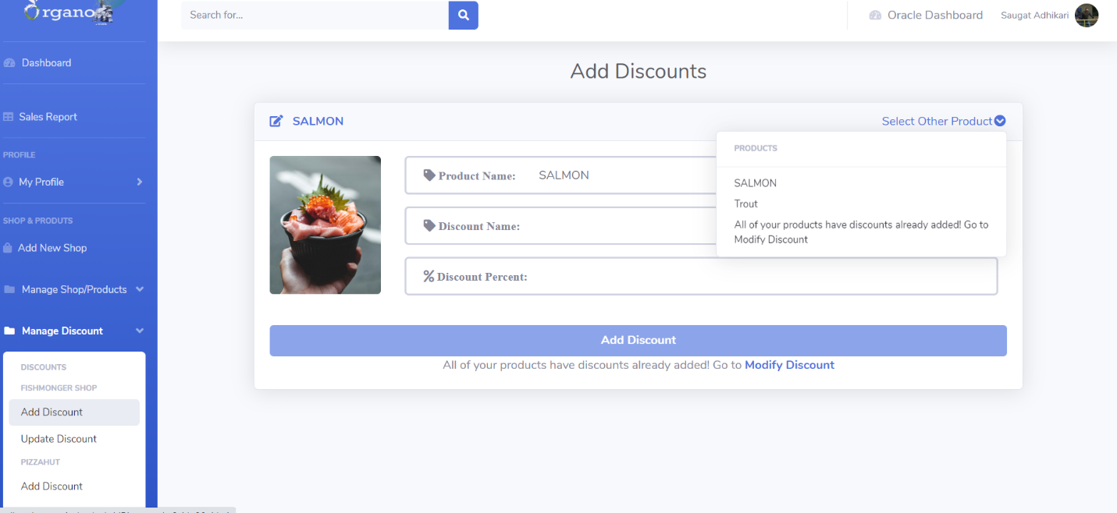

* + 1. **Website Homepage**

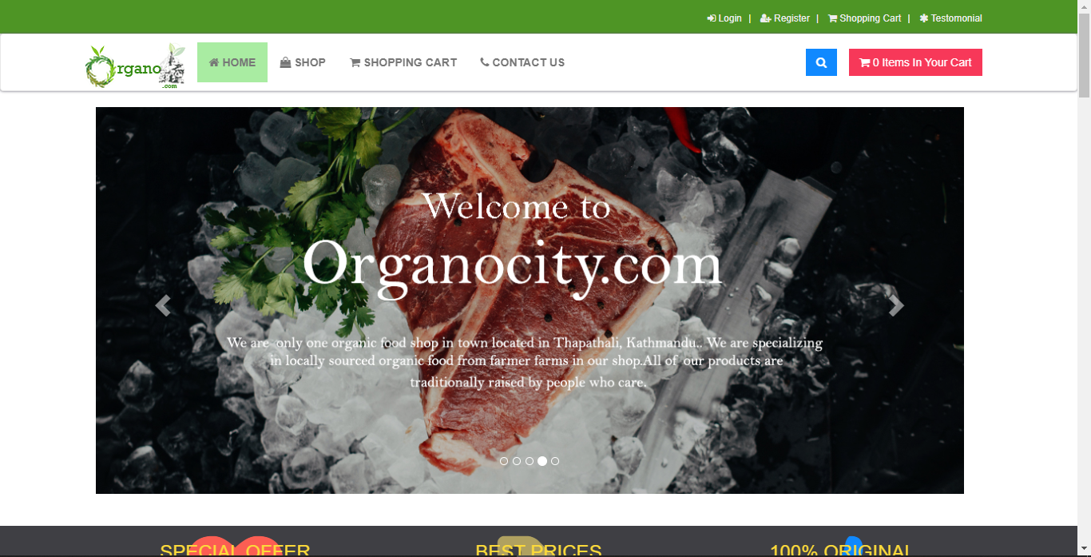



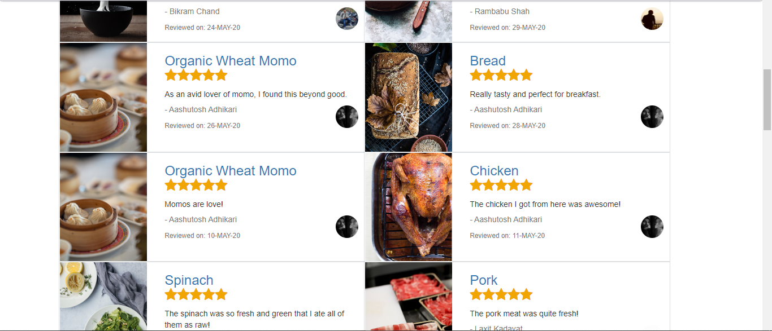



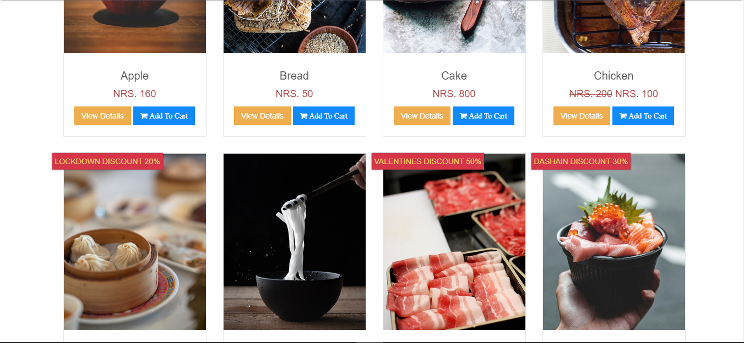

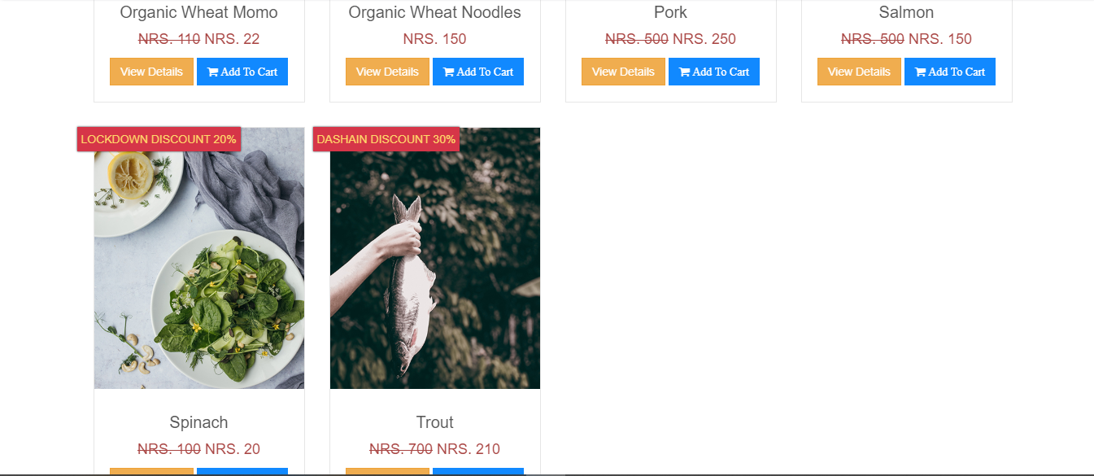

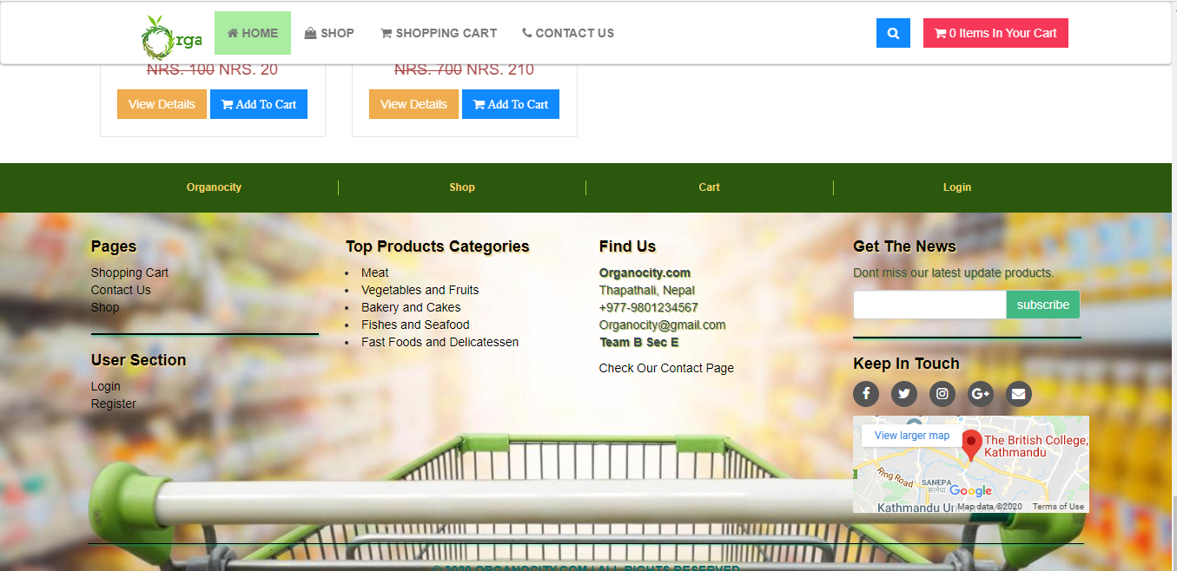

This is the homepage of the website of our website. It contains different elements which show different available items in the store. Some banners are also available which display discounts on some items. It also contains contact information of the store with a map as well.